KOSTA P. MANOJLOVIĆ ON ALBANIAN MUSIC

by Dr. Eno Koço

Kosta Manojlović (Manoylovich) was a Serbian composer, musicologist, choral conductor, folklorist and educator, who in the mid-1930s harmonised and arranged for mixed choirs and solo voices several Albanian choral songs. He published them in 1933 as a collection of choral songs based on traditional and urban songs from Albania and titled it The Songs from the Land of Skenderbeg (Alb. Këngë të tokës së Skënderbeut/ Serb. Песме земље Скендербегове).
Manojlović was born in 1890 in Krnjevo near the town of Velika Plana. In 1912 he received a scholarship to attend specialised studies in Moscow and then in Munich, but his studies were interrupted twice because of the Balkan Wars. In 1915–16 Manojlović started composing his Liturgy for Male Choir, completing it in 1916 during his convalescence at a military hospital in Fier, Albania. In 1917 Manojlović began his studies on the analysis of early music at Oxford University graduating in 1919 with his work ‘On the Rivers of Babylon’. During the 1920s and 30s, Manojlović became the conductor of the first Belgrade Singing Society and served as the executive secretary of the Belgrade Philharmonic Orchestra. He was instrumental in the establishment of the Belgrade Music Academy (serving as its first rector in 1937–39) and working as a teacher there until 1946. For political reasons, he was removed from the Academy and was forced into retirement. Manojlović died in Belgrade on November 2, 1949.
With his enthusiasm for the Balkan music that anchored his prolific music career, Manojlović became a powerful voice in the 1930s collaborating with numerous journals and writing for many other publications. He had a good friendship with one of most renowned Albanian poets, Migjeni, who developed his creativity in the 1930s. Being associated with the Albanian music life, apart from arranging Albanian choral songs and hymns, Manojlović also organised conferences in Belgrade and wrote critic reviews on Albanian theme, and even prepared manuscripts together with music examples on the same topic. He dealt with the Albanian musical protagonists of the 1930s such as composers, singers and instrumentalists for whom an extract of his article taken from Albanian newspapers will be given here to indicate his contribution on the field of music criticism. Presenting a view on Albanian music in 1933, Kosta P. Manojlović wrote:

Among the first contributors in the music field are Lec Kurti, the Albanian delegate at the League of Nations, who graduated before the war [WWI] in Venice and has written an opera which he did not finish. Otherwise, Kurti would have been the first composer of Albanian opera. Nasi Dardha [Thoma Nassi] from Dardha, near Korçë, had his own Band and was also the band master of the Royal band in Tirana. He now lives in America. Sotir Kozmo from Korçë, involved with choral music, is the founder and conductor of the mixed choir in Korçë. Ludvik Naraçi, from Shkodra, graduated from the conservatory in Prague. Lola Aleksi, a pianist from Korçë and music teacher in the Female Ecole Normale in Korçë, has given many concerts in the Albanian colonies and this year took part in the Vienna competition. On the eighth of October she had a concert in Albania with the tenor, Kristaq Antoniu.

In another article published in the ‘The Korçë Gazette’ with regard to a conference which was held in Belgrade in 1934, the Albanian choral conductor Sotir Kozmo writes:

A powerful example which comes to confirm our words, is the choral concert with an entirely Albanian programme, performed by the famous mixed choir of this city [Belgrade] and conducted by the energetic composer, Mr. Manojlović. This concert was held in Belgrade on the occasion of the 28th November and was broadcasted all over the world. On this occasion the above-mentioned composer has shown special interest and affinity for our old melodies by harmonising a number of them and performing with his mixed choir.

In the ‘Besa’ journal of the 1st of May 1935 it was published a review under the heading: ‘The Albanian traditional songs harmonised by the composer and teacher in a Music School in Belgrade, Kosta Manojlović’. This review was written by the Albanian Ilija Banushi, who makes mention among others that the songs ‘Come with Me’ (Alb. A vjen me mue/Serb. Дал’ ћеш доћ) and ‘The North Wind’ (Alb. Fryn veriu/Serb. Север дува) left e lasting impression on the Belgrade audience. Then he continues: ‘After the interpretation of these songs, the hall filled with the Belgrade elite kept applauding for almost 10 minutes and had been asking for ‘encore’ and were looking for the composer to appear [on stage] and thank him for bringing such beautiful melodies. The audience could not imagine that Albanians would have such refined music and for this the appreciation would undoubtedly go to Mr. Manojlović’.
As far as Manojlović’s compilation of the Albanian urban traditional songs and hymns are regarded, I’ll include here their titles: ‘The Flag Anthem’ (Alb. Himna e Flamurit), Албанска Државна Химна; ‘The King’s Anthem’ (Alb. Himna e Mbretit/Serb. Албанска Краљевска Химна); ‘Half of your forehead, covered with forelock hair’ (Alb. O, gjysmën, o moj, të ballit, ta mbuloj ballukja moj/Serb. Коса црна ти чело краси); ‘Remove Your Celibate Clothing’ (Alb. Xhvishi rrobet e djalërisë/Serb. Скини рув(х)о бећарско); ‘The Maids Went Out’ (Alb. Hajde duall çupat/Serb. Пошле моме цвеће брати; ‘O That Dark Eye’ (Alb. As aman o syr'i zi/Serb. Ох око црно, аман); ‘Come with Me’—Albanian Love Song (Alb. O, Ji, A vjen me mua—këngë dashurie/Serb. Дал’ ћеш доћ—Албанска љубавна песма); ‘O My God’ (Alb. O Zot’i im/Serb. О Боже мој—Албанска Божићна песма); ‘Gentlemen and Ladies’, (Alb. Zotërinj e Zonja/Serb.—Господа и Госпе— Албанска Божићна песма). The other song, ‘The North Wind’ (Alb. Fryn Veriu, Serb. Север дува), which is not included in the compilation of nine above-mentioned songs, is perhaps the most popular living of Manojlović‘s arrangements for choral singing.
It is important to stress that all the songs of this compilation, including ‘The North Wind’ that stands on its own, are given in both languages, Albanian and Serbian. This fact shows not only Manojlović’s commitment to translate the lyrics into Serbian, but also to carefully put each syllable lines up vertically under the note on which that syllable in both languages is sung. It’s worth noting that the lyrics translated into Serbian were done and notated by Pandi Papanastas, an Albanian student of theology in Belgrade, in the 1930s. This process was finalised between the years of 1932 and 1933, and Papanastas’s full signature appears at the end of each song. That is how it appears: ‘Pandi Papanastas – Stud. Theologisë – Belgrad, 16-10-1933’ (see the last page of the notated song ‘The North Wind’). The lyrics in Albanian are written in a pure Korçë dialect and for writing them down Manojlović & Papanastas have meticulously placed dotted lines to separate syllables within the same word.
‘The North Wind’ (Alb. Fryn veriu, Serb. Север дува) was composed by Dhimitër Kovaçi, an active member of the Albanian community in Bucharest, while the words were written by Lasgush Poradeci, a renown Albanian poet. Kovaçi’s song based on Poradeci’s poem, takes its title from the first line of the well-known ‘Ballad on a folk theme’. The composer’s evocation of ‘The North Wind’ (Alb. Fryn veriu) recalls the atmosphere of the southern Albanian songs. Kosta Manojlović’s four voice choral harmonisation and arrangement in traditional style was published in Belgrade in 1933. It is a skilful and professional elaboration from the point of view of distribution of voices, the use of harmony and counterpoint lines, as well as the depiction of the cold atmosphere of the north wind.
Here are the lyrics:
It blows Fryn veriu Север дува на планину
on the bare mountain në mal të thatë Хладни ветар
Says the girl: Thotë vajza Сбори млада дева
I’m freezing, lele ngriva Леле боже, мен` је зима
Keep (up) strong girl Duro vajzë Трпи душо
We have to resist të durojmë Са мном драга, к'о што трпи
Like the mountain resists the snow Si duron mali dëborën Гора чарна сва у снегу
If I can to catch you Në të shtirsha dot në dorë Ако паднеш мен` у руке
I’ll melt you Do të tret Теб’ ћу ја истопит’
Like a piece of snow. Si cop’ dëborë. Као грудву бела снега.

The poem itself stands as an excellent model of Albanian verse, but either the composer, Kovaçi, or the choral arranger, Maynollovich, felt that it needed to be modified by adding a dactylic foot (haj-de dhe ho) in order to relieve the inherent regularity and, probably, to emphasise the expression. The original version of the poem:

It blows on the bare mountain Fryn veri(u) në mal të thatë
Says the girl, I am freezing Thotë vajza lele ngriva
Keep strong girl, we have to resist Duro vashë të durojmë
Like the mountain resists the snow Siç duron mali dëborën

is changed to:

It blows, come on and ho Fryn veriu, hajde dhe ho
It blows on the mountain, Fryn veriu në mal të thate
Says the girl, come on and ho Thotë vajza, hajde dhe ho
Says the girl, I am freezing etc. Thotë vajza lele ngriva etj.

The orchestral accompaniment made three years later by an Italian orchestrator and used in Tefta Tashko-Koço’s soprano version of this song, was obviously inspired by the mood and harmony of Manojlović’s choral arrangement. I still possess the original choral score published in 1933 in Belgrade, which was used by my mother as a guide for her recording of this song in Milan, Italy, in 1937. Eight years later, in 1945, Manojlović was present at Belgrade Opera where my mother, Tefta Tashko-Koço, performed principal roles of La Traviata and La Bohème, however, although a recital was scheduled, it was not made possible that he would listen to his favourite ‘The North Wind’ in a soprano version!
The song’s harmonisation with the raised sixth degree (F sharp, see the notation below, page 4 of the song, bottom system) together with its upper neighbour, seventh degree (G sharp), tends to use an upward melodic minor scale which does not correspond to the genuine non-diatonic (chromatic) tetrachord of the song and which is involved only below the tonic. Manojlović intentionally uses his own principles and not the specific traditional modal harmony (augmented second); for instance, when going up, the sixth and seventh degrees are raised and when going down the same degrees are flattened, as in Western melodic minor.
As far as the Manojlović’s ‘King’s Anthem’ (Alb. Himna e Mbretit/Serb. Албанска Краљевска Химна) is regarded, it is obvious that it is about the Albanian King, Zog I. In the ‘Korçë Gazette’ of the 1st February 1934, Youry Arbatsky writes: ‘Kristo Floqi … has written the lyrics of the hymn of King’s Zog, which you will listen tonight’. It should be stressed that Thoma Nassi composed an anthem for King Zog I with lyrics by Kristo Floqi. For this reason, the latter was excluded from the literary list in the post-war periods, although he dominated Albanian drama in the early 20th century. For the same reason, the other Manojlović’s harmonisation, that of ‘The Flag Anthem’ (Alb. Himna e Flamurit), remained totally unknown simply because the words were not written by the Albanian poet Asdren, who is best known for writing the words to the Albanian national anthem, but by the ‘excluded’ playwright Kristo Floqi!
The song ‘Half of your forehead, covered with forelock hair’ (Alb. O, gjysmën, o moj, të ballit, ta mbuloj ballukja moj/Serb. Коса црна ти чело краси) is built in the atmosphere of a south-Albanian pentatonic mode, although in a hemitonic rather than unhemitonic pentatonic, the latter being more characteristic for the idiomatic pronunciation of the South Albanian region. One can sense flavours of the three-part polyphonic lines of traditional song versions, however, in this four-part choral version it is conceived by Manojlovic in a Western polyphonic context. The change of metre is another feature which characterises the elaboration this song; the metric alternation between 7/4 and 5/4 is based on the choral phrasing and it supports all the way through the rhythmic drive of the song. Thus, the ‘lopsided time-beating’ which is rhythmically uneven and its rhythmic impulse, create an emotional effect, over which the polyphonic lines of a beautiful traditional colouring round out the musical phrasing. Here are the lyrics to ‘Half of your forehead, covered with forelock hair’:

Half of your forehead O gjysmën o moj të ballit Коса црна ти чело краси
Covered with forelock hair Ta mbuloj ballukja moj Ока твоја ја не видех
I couldn't see it anymore Më s’ta pashë dot Сјај малка момo

I stared at you for hours Dy a tre sahat moj të mbajta sehir Ваздан душо, Ја те гледах
You drove me mad, girl Ç’më prishe nga mëntë, vajzë Ум ми смути чежња
I am thunderstruck Më le pa fiqir Којом горах малка момo

Half of your eye O gjysmën moj të syrit Трепавице крила шире
Covered with your eyebrow Ta mbulonte vetulla Ока твоја ја не видех
I couldn't see it anymore Më s’ta pashë dot Сјај целог дана

Half of your forearm O gjysmë o moj të llërës Руке те беле
Covered with your sleeve Ta mbulonte mënga Скути скрили не осетих
I couldn't see it anymore Më s’ta pashë dot Драж целог дана

‘O That Dark Eye’ (Alb. As aman o syr'i zi/Serb. Ох око црно, аман) is popularly known as a Korçare song (from the town of Korça), but my assumption is that it originated in Ali Pasha’s seraglio in Janina, and, according to Kristo Floqi, was composed by Muço, his court-musician. Muço is known for his inspired songs, but very few of them are accredited to him, while others are anonymous.
The iterative strophe which sets the pattern is the first, and it is an eight-syllable one, despite that Manojlović has changed the musical phrasing (the third and fourth verse-line) by making ten plus six syllables instead of eight plus eight. The first word of the title aman (in Turkish: for goodness sake!) is the emphatic expression which is so often used at the beginning of Albanian urban songs. In this song, the aman is used purely for the sake of expression, without any emphatic value.

O that dark eye As aman o syr’i zi Ох црно око
You have hooked me badly Ç’më ke bërë sevdalli-e Све због тебе севдах певам
Where do you come from Nga na vjen ti Севдах певам одакле дође
And where are you heading Edhe ku vete moj Kуда идеш сад
How lovely you are Hajde moj marshallah Хајде мој машала

O ri, ri my love O ri, ri, ri moj të keqen О ри ри как јад ме твој стигне
The youngest overtook the middle one Ç’e shkoj e vogla të mesmen Девоjку старију у свему
With her moods and her schemes Nga nazet dhe maryfetet Све због тебе севдах певам

The ambit of the song is a ninth (a combination of a pentachord and a tetrachord in conjunct position, plus a supertonic above the upper tonic) and Manojlović has rigorously respected the melodic line of a four-part vocal structure. He has given the introductory melodic line to a solo tenor voice and has built the entire song in a concept of his own, in a 6/8 metrical structure, and not in 7/8 or even 3/4 as was traditionally sung in Albania by the solo male voices. Manojlović’s composition conveys his own individuality and representation and carries a sincere message to the audience.
‘O My God’ (Alb. O Zot’ i im/Serb. Serb. О Боже мој—Албанска Божићна песма) is a church song from the Korçë city. It is one of the most creative and elaborate of Manojlović’s vocal arrangements. Its starts with a soprano solo by employing a purely triadic melodic line in a G major form arpeggio. On the seventh bar it is the alto solo voice which joins by lines of dialog with the soprano. Then the third of the four voices enters in the tenth bar in creating a vivid polyphonic expression. The remaining voices enter in successive bars echoing the triadic pattern (slightly altered) of the beginning. The chorus and the entire song close in the minor key (E minor) as if to confirm the last words ‘Why are you crying and mourning’? (‘Përse na qan e na mban zi’?/ ‘Што плачеш и што тужиш сад’?).
‘Gentlemen and Ladies’ (sic), (Alb. Zotërinj e Zonja/Serb. Gospodo i Gospje—Албанска Божићна песма), is and Albanian church song (like Christmas songs or Carols) and here are its lyrics:

Gentlemen and Ladies Zot’rinj e Zonja Господа и Госпе
We came to make you happy Arthmë t’u gëzojmë Дошли смо да
And the good news Edhe siariqnë Вас обрадујемо
We want to share with you Ne t’ja u tregojmë Награду нам дајте

Because in Bethlehem Se në Vithlejem Јер у Витлејему
A King is born U lint një Mbret sot Роди се Цар
Who will be above us I cili do të jetë Над земним шаром
The Eternal Lord Për mbi neve Zot Целим вечни Господар
Based on classical chord progression, it sounds like a Christmas carol and it is this that gives the song its characteristic sound. Text-writers tended to paraphrase biblical text, however, the ‘Gentlemen and Ladies’ song title seems to adapt to the Balkan mentality where the ‘Gentlemen’, of course, should be firstly respected!
‘Come with Me’—Albanian Love Song (Alb. O, Ji, A vjen me mua/Serb. Дал ћеш доћ’—Албанска љубавна песма) is one of the most elaborate of Manojlović’s choral songs. The modal mixture becomes an alloy of two basic modes, hemitonic pentatonic and non-diatonic (augmented second) within a single key. As far as the metrical patterns is concerned, Manojlović uses measures with different number of beats, such as 2/4, 3/4, 4/4, 5/4 and 7/8 metres, to create larger or smaller phrases when melody requires an expansion or contraction. Traditional music of the Balkans uses such metres extensively, however, Manojlović does not treat them as compound metres (7/8 or 5/8) but as simple metres, i. e. avoiding dynamic accents on the first note of each two or three note subdivision (2+3, 3+2, 3+2+2, 2+2+3 etc.).
Here are the adapted lyrics of this song:

Come with me, girl O, Ji, A vjen me mua, ti moj vajzë Дал ћеш доћ’ мени на груди
To give you the shotgun, O, të tap, moj dyfeknë, Да ти дадем пушку шару,
I’m not a girl, cheeky boy Unë s’jam vajzë more çapkën Ја нисам мома, младо момче
Who carries a shotgun O që mbanj, o mor dyfeknë, bandill Која носи пушку шару, бандил
I’m a young girl, boy Po jam një vajzë more bandill Jа сам млада малка мома, бандил
Who serves you the coffee O që ndanj o mor kafenë Која служи кафу црну
Come with me… A vjen me… Дал’ ћеш доћ…

‘The Maids Went Out’ (Alb. Hajde duall çupat/Serb. Пошле моме цвеће брати)

The maids went out Hajde duall çupat moj, Пошле моме цвеће брати
To harvest violets O për manushaqe Љубичицу хајде де
You may either go out Edhe në daç dilni moj Дали дошле ил' не дошле
Or may not doing so Daç o moj mos dilni Мени све је, све је једно
I’ll still be there for you Mua përpara më kini Ја сам увек ту пред вама

The genuine folk version of this song is a polyphonic type from Toskëria, Korçë region, played and sung by the saze group. Being an urban song, sung and played by a group of, at least, 5-6 people, it displays many idiomatic vocal and dialect features of this area. The song is built in the atmosphere of a south-Albanian pentatonic mode of a hemitonic movement. The multipart styles of the saze ensembles, in the way each instrument functions, correspond to the multipart singing styles of south Albanian music. Manojlović’s choral version seem to have explored some idiomatic elements which are commonly found in the saze group, however, the combination of melodic, rhythmic and harmonic textures he has adapted to his own taste and Western concept by preserving the essence and idiomatic expression of the south Albanian, Korçare, song.

‘Remove Your Celibate Clothing’ (Alb. Xhvishi rrobet e djalërisë/Serb. Скини рув(х)о бећарско)

Remove Your Celibate Clothing Xhvishi rrobet e djalërisë Скини ру(х)ово беђарско
O you Peter Bre Petri beje бре Петре беже
Put on your wedding suit Vishi rrobet e dhandërisë На себ стави одело ново
O you Peter Bre Petri beje бре Петре беже
Have you ever been to Shinjon (St. John) A ke kenur(ë) në Shinjon Јесил' био у свети Јован
O you Peter? More Petri beje? бре Петре беже?
Have you seen those cypresses A i ke pam ato selvija Да ли си гледа’ те кипарисе
O you Peter? Bre Petri beje? бре Петре беже?

It is the non-diatonic (chromatic) expression of this song that I wish to focus on. The interval of the augmented second, which lies between the third and fourth degrees of the lower pentachord, is not of such common occurrence in a folk or traditional song of Southern Albania. Based on its lyrics written in the dialect as spoken in the lower Gegëri (Elbasan) and frequent employment of augmented seconds in the lower pentachord and upper tetrachord, these types of songs are encountered in a vast area north of the river Shkumbin. The last two verses of the song: ‘Have you ever been to Shinjon (St. John)?’ and ‘Have you seen those cypresses?’, clearly imply that it is about Jovan Vladimir or John Vladimir (Cyrillic: Јован Владимир), who ruled during the prolonged war between the Byzantine and Bulgarian Empires in the 11th century. His remains were preserved in the Church of St. Jovan Vladimir, Shi(n)jon, near Elbasan. He is recognised as a martyr and saint, with his feast day being celebrated in Shijon, Elbasan, on 4th June.
In the harmonic context of the whole song, Manojlović has used as a typical feature (melodic formula) the interval of the augmented second situated in the main pentachord (see notation, bar three, D, C sharp, B flat) as well as in the upper tetrachord (see the penultimate and last bar), the latter would be similar to a harmonic minor scale (E flat, F sharp, G). This expressive device represents, in my view, a concept of the modal-harmonic vocabulary, where the use of modal scales is felt to be comfortably accommodated to the harmonic principles of the Western system that Manojlović has employed. Among the Albanian urban songs, there are several of them of the above-mentioned modal/tonal characteristics.
Manojlović believed in the Balkan common cultural traditions, similarities in the lifestyles and strong historical and geographical bonds of these countries and nations, an evidence which he accumulated through his travels and researches in Albania, Rumania, Bulgaria and Greece. He wrote papers on both subjects, traditional music and art music in the Balkans, but his ideas on the former topic—traditional—attracted a lot of attention in the musical community of Romania, Bulgaria, Turkey and Greece. The Music in the Balkans (Балканска музика), including religious music, was his main focus, his credo, a field of Music that he was fully dedicated.

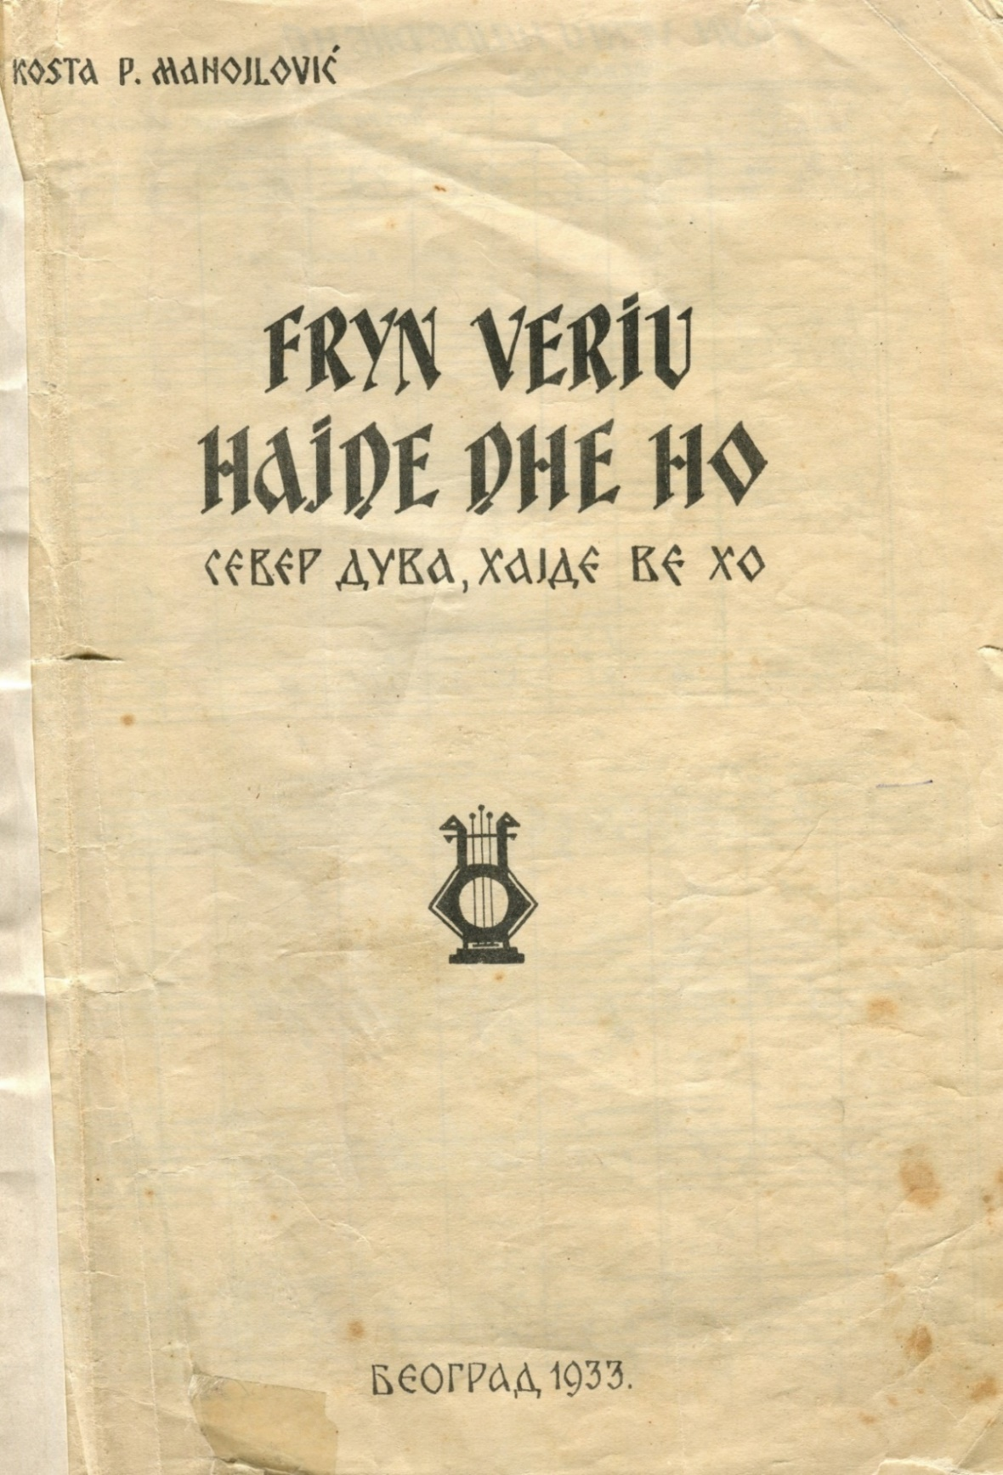
K. Manojlović, ‘The North Wind’ (Alb. Fryn veriu, Serb. Север дува)

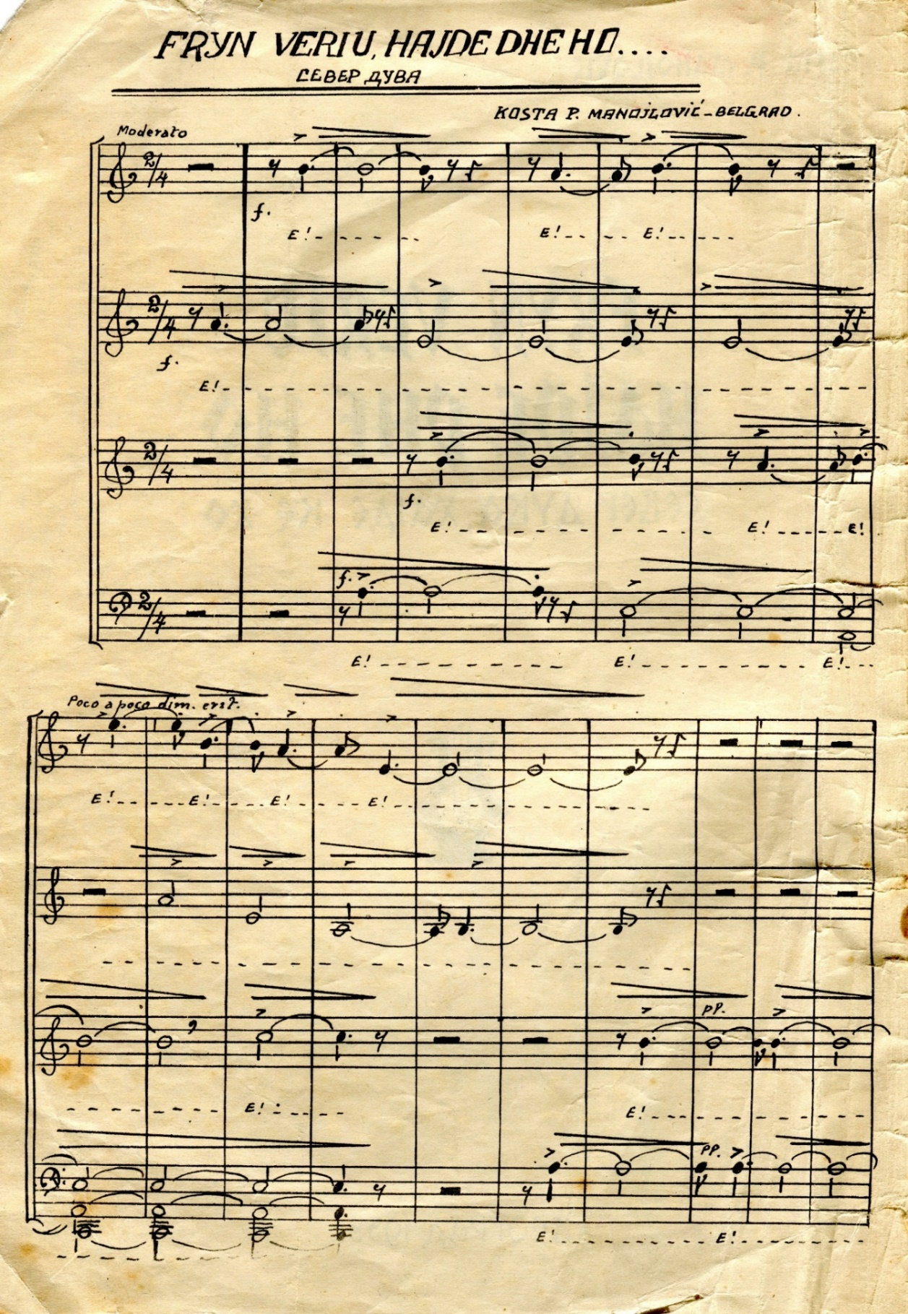
K. Manojlović, ‘The North Wind’ (Alb. Fryn veriu, Serb. Север дува)
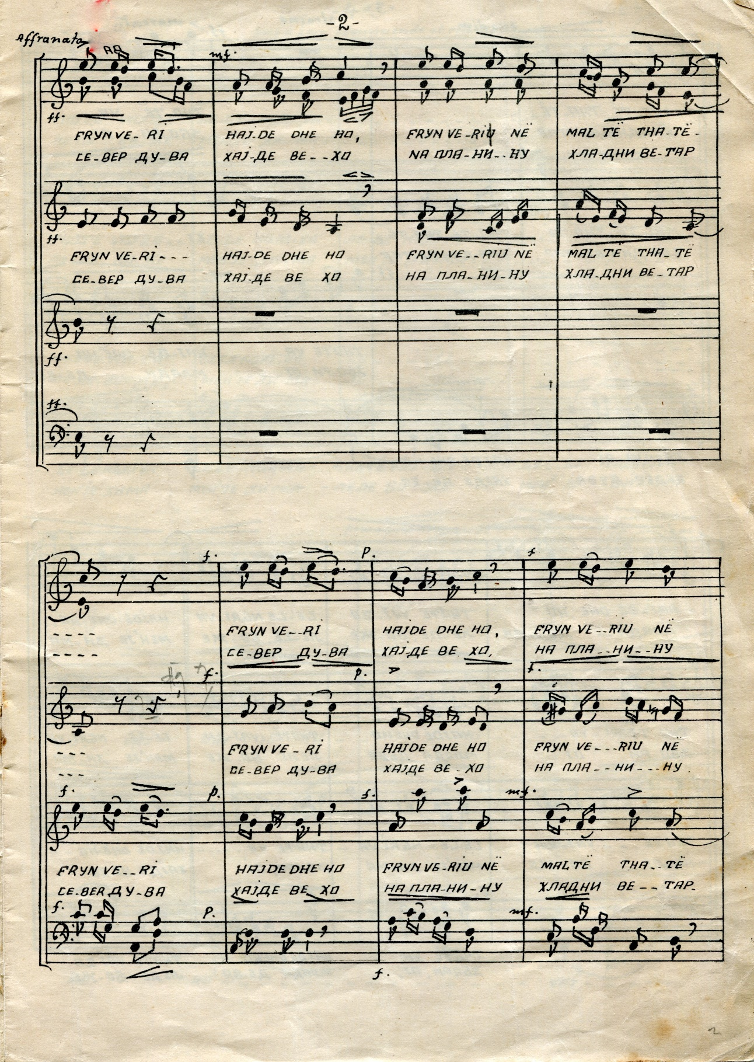
K. Manojlović, ‘The North Wind’ (Alb. Fryn veriu, Serb. Север дува)

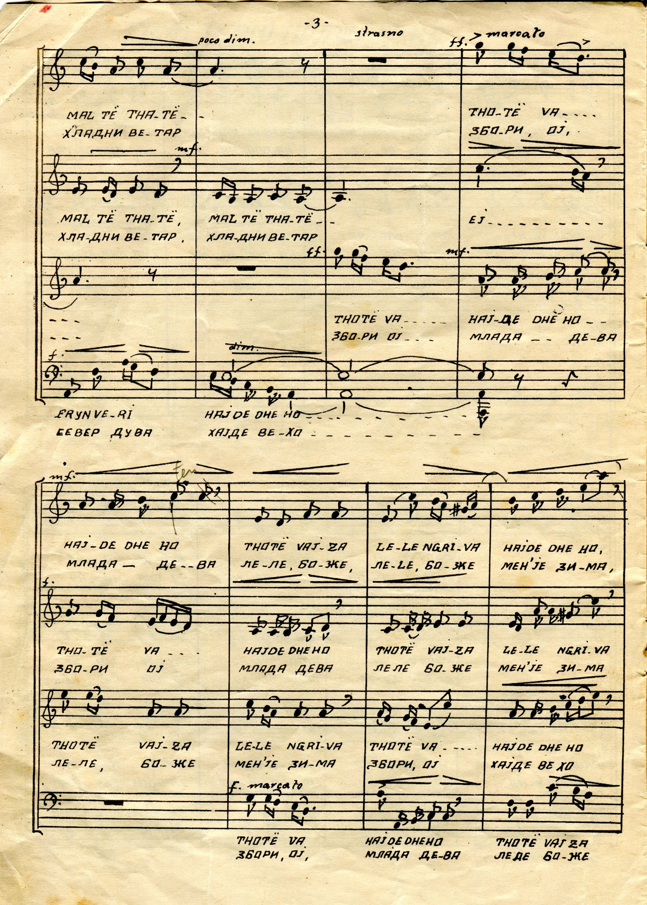
K. Manojlović, ‘The North Wind’ (Alb. Fryn veriu, Serb. Север дува)

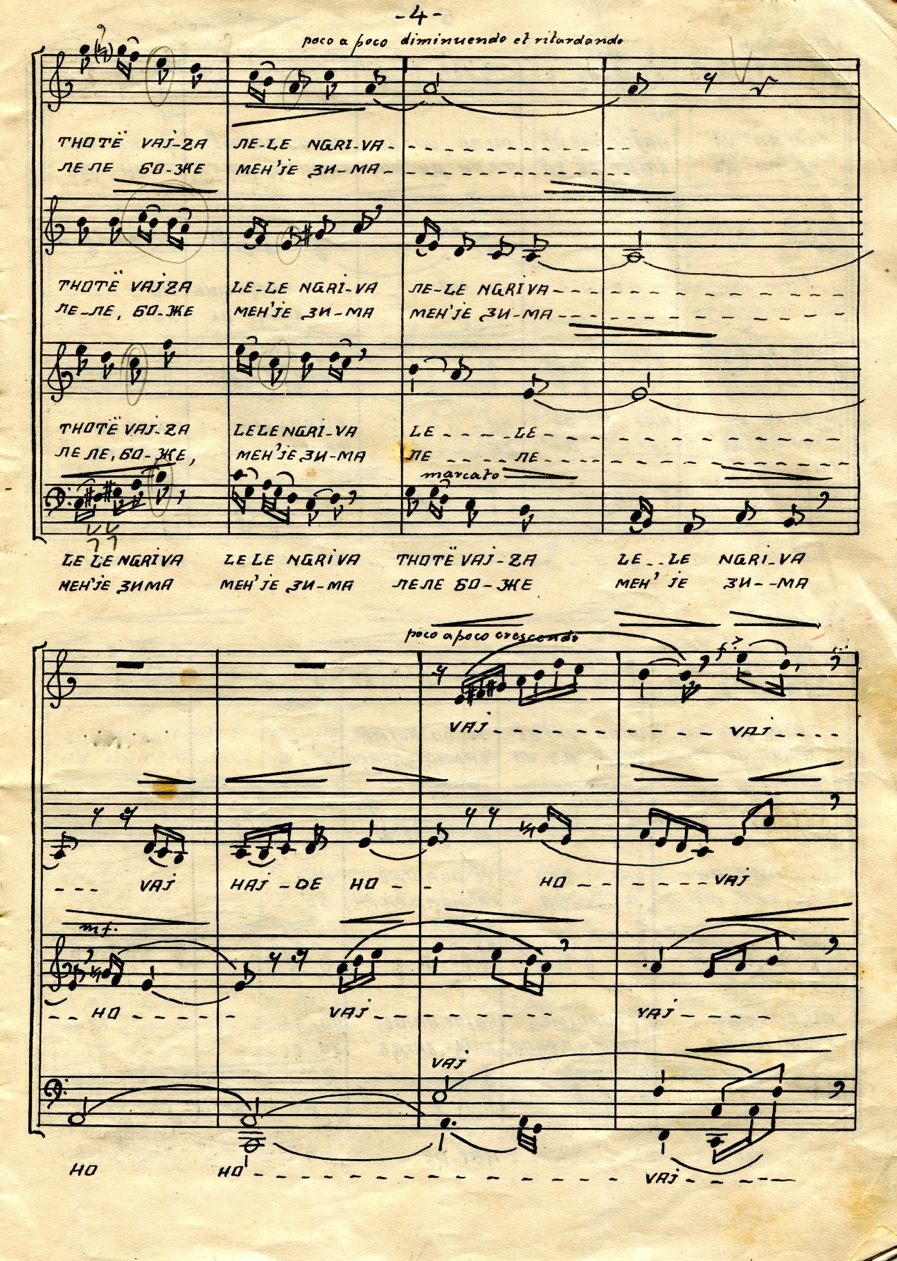
K. Manojlović, ‘The North Wind’ (Alb. Fryn veriu, Serb. Север дува)

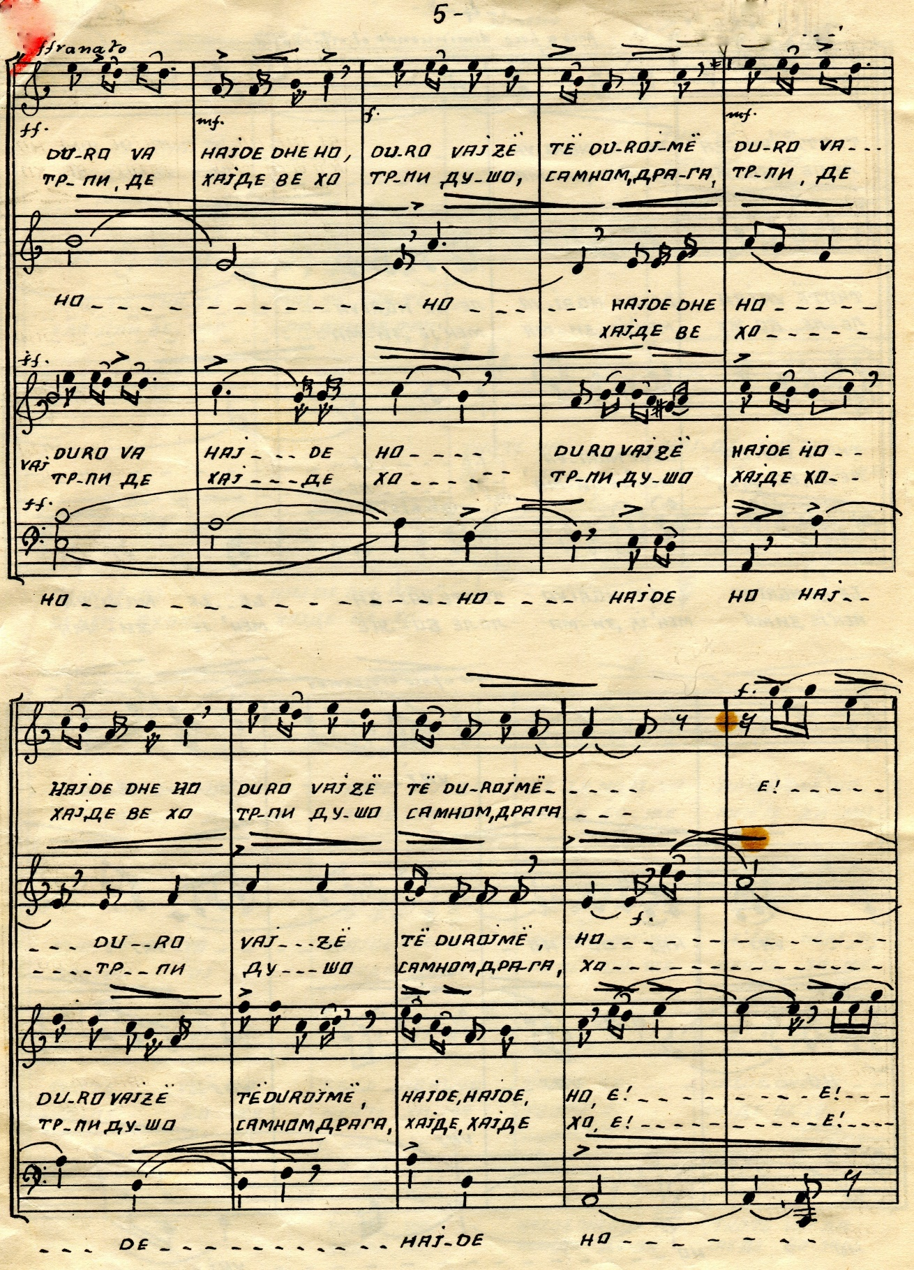
K. Manojlović, ‘The North Wind’ (Alb. Fryn veriu, Serb. Север дува)

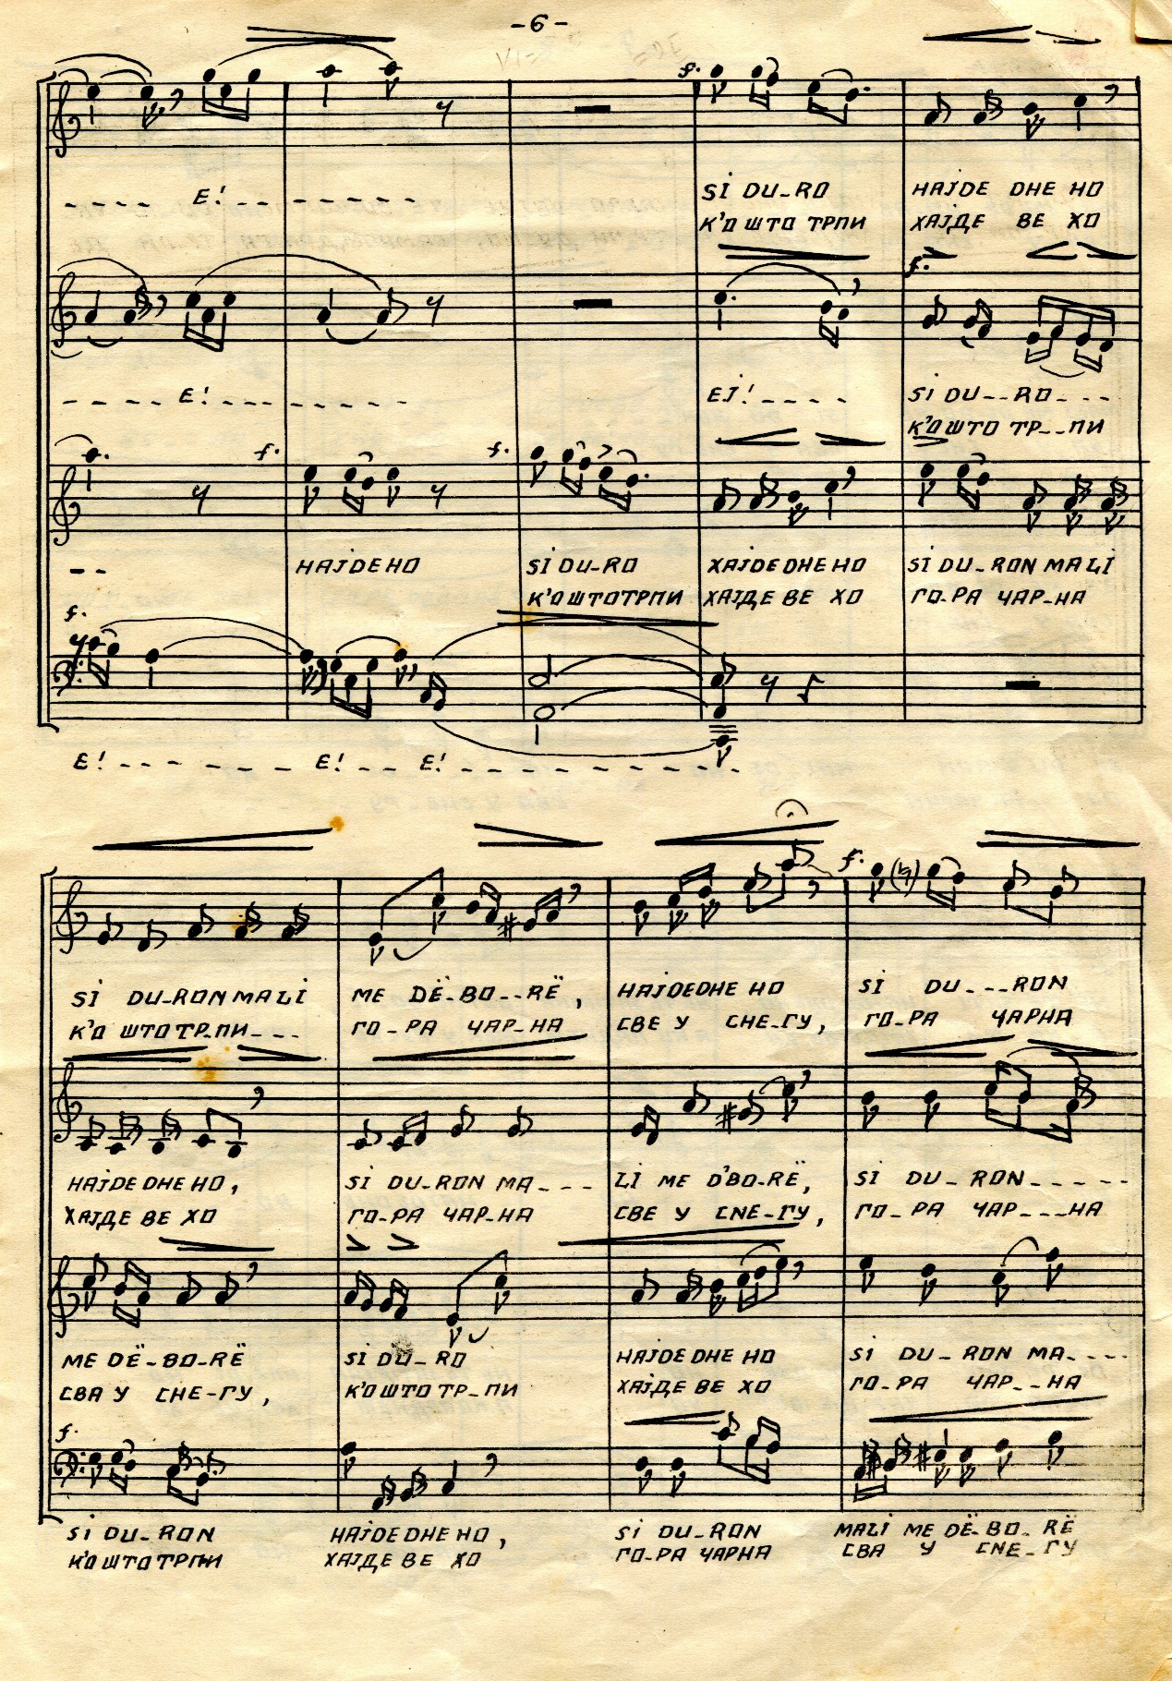
K. Manojlović, ‘The North Wind’ (Alb. Fryn veriu, Serb. Север дува)

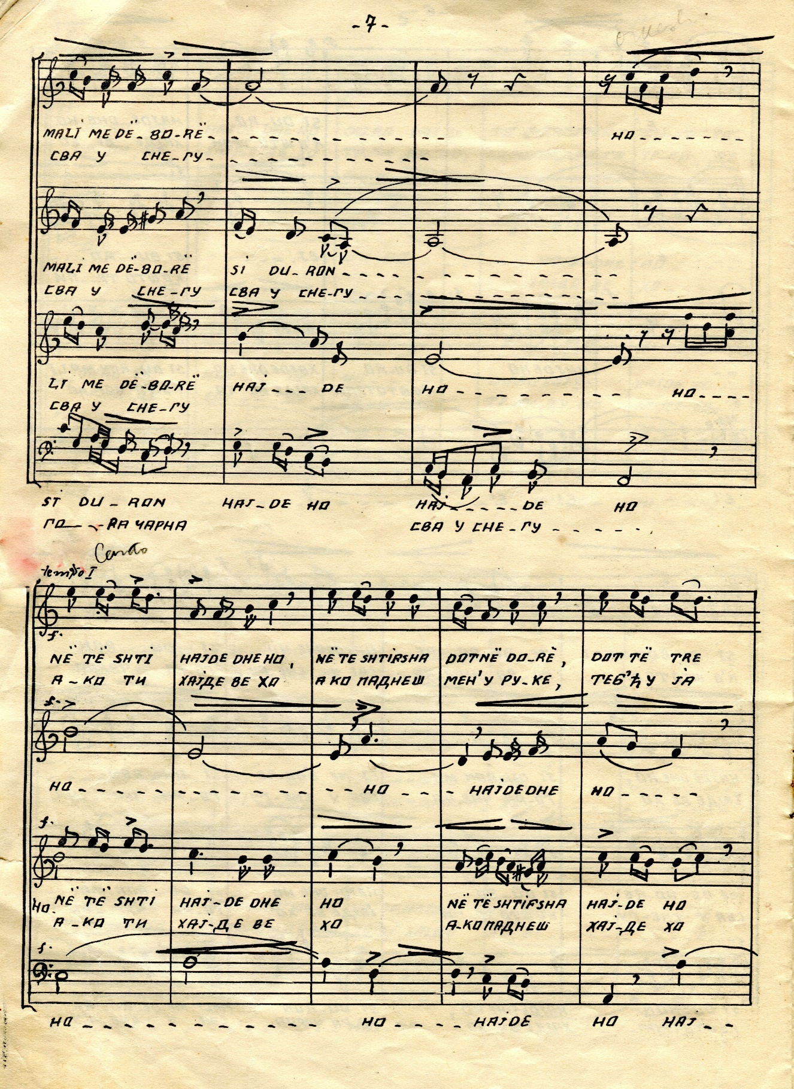
K. Manojlović, ‘The North Wind’ (Alb. Fryn veriu, Serb. Север дува)

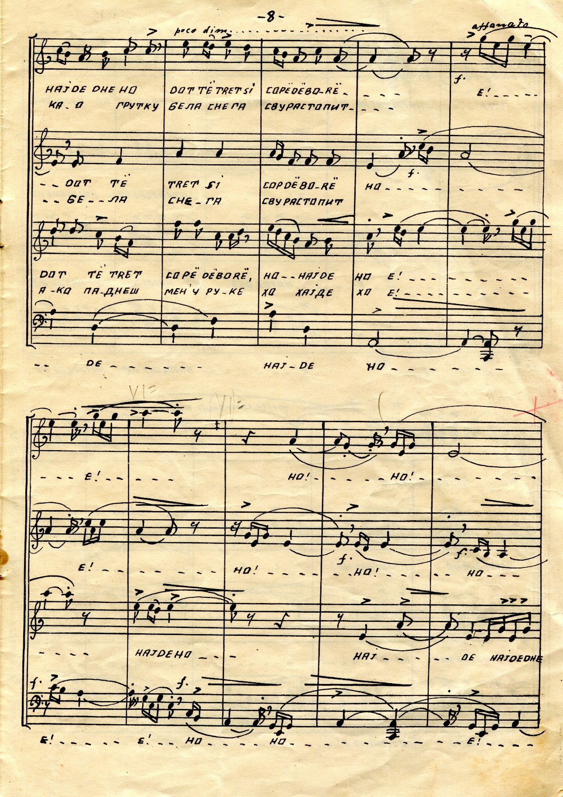
K. Manojlović, ‘The North Wind’ (Alb. Fryn veriu, Serb. Север дува)

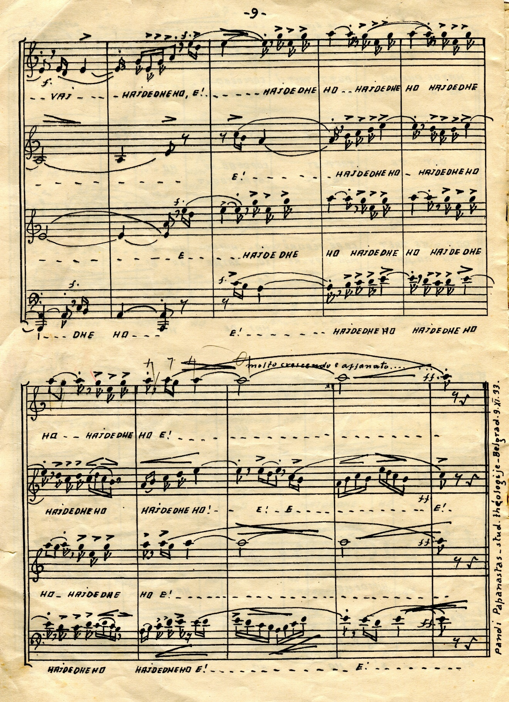
K. Manojlović, ‘The North Wind’ (Alb. Fryn veriu, Serb. Север дува)

K. Manojlović, ‘The King’s Anthem’
(Alb. Himna e Mbretit/Serb. Албанска Краљевска Химна), p. 1
K. Manojlović, ‘The Flag Anthem’ (Alb. Himna e Flamurit), Албанска Државна Химна), p. 1
K. Manojlović, ‘Half of your forehead, covered with forelock hair’
(Alb. O, gjysmën, o moj, të ballit, ta mbuloj ballukja moj/Serb. Коса црна ти чело краси), p. 1

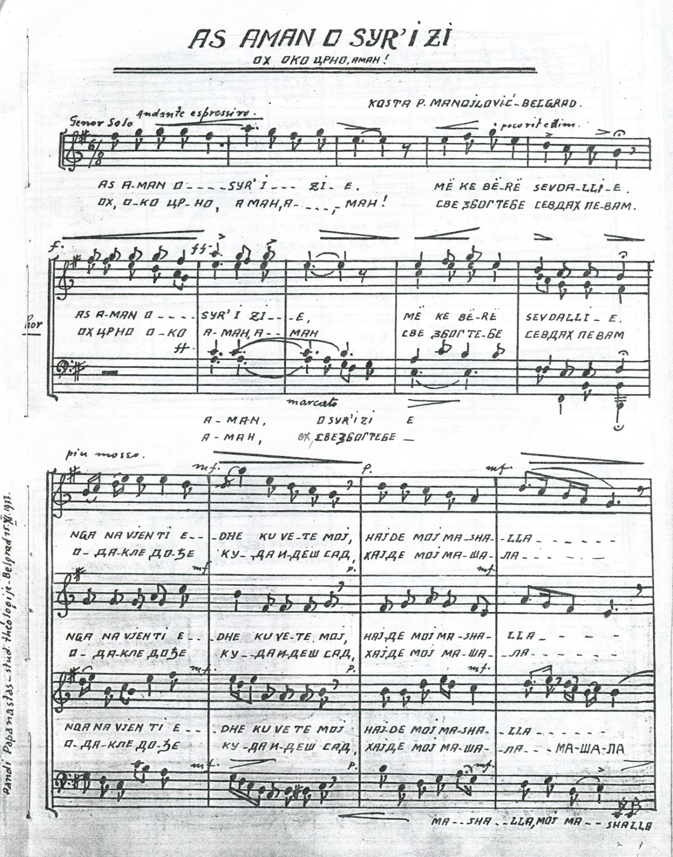
K. Manojlović, ‘O That Dark Eye’ (Alb. As aman o syr'i zi/Serb. Ох око црно, аман), p. 1

K. Manojlović, ‘O My God’—Albanian Church Song
(Alb. O Zot’i im—këngë kishtare/Serb. О Боже мој—Албанска Божићна песма), p. 1

K. Manojlović, ‘Gentlemen and Ladies’—Albanian Church Song
(Alb. Zotërinj e Zonja—këngë kishtare/Serb.—Господа и Госпе— Албанска Божићна песма), p. 1

K. Manojlović, ‘Come with Me’—Albanian Love Song
(Alb. O, Ji, A vjen me mua—këngë dashurie/Serb. Дал’ ћеш доћ—Албанска љубавна песма), p. 1

K. Manojlović, ‘The Maids Went Out’
(Alb. Hajde duall çupat/Serb. Пошле моме цвеће брати), p. 1

K. Manojlović, ‘Remove Your Celibate Clothing’
(Alb. Xhvishi rrobet e djalërisë/Serb. Скини рув(х)о бећарско)

Kosta P. Manojlović, Besa, October 1933.
Sotir V. Kozmo, ‘Albanian Music in Belgrade’, ‘The Korçë Gazette’, 23 January 1934.
Youri Arbatsky collected Balkan rural music, folklore and customs, and, after securing a fellowship from The Newberry Library, published the treatise Beating the Tupan in the Central Balkans, in 1953. The study observes chiefly the music of the tupan (big drum) as played by folk-artists from eastern Albania, through Macedonia, to western Bulgaria. Arbatsky also discusses the influence of the gypsy peoples in the Balkans, Turkish and Arabic influence, the metre and folk musicians.
The translation from Albanian to Serbian is taken literally from the notated score, whereas translation from Albanian to English I have adapted myself. All English verse translations are based on the original language—Albanian. It’s worth mentioning that the Albanian and Serbian translations do not match to each other exactly, however, the overall feeling, I assume, might be more important than pure accuracy.
As far as the Saze group is concerned, it consists of one or two clarinets, a violin, a llauta, an accordion and a dajre or def. The group is supposed to support each emotional outburst of its inspiring leader and to articulate with him the tune, particularly the climaxes and the ends of phrases. It should be pointed out that the Saze members sing as well as play.
Geg or Geg-s are the northern ethnic group of Albania (Gegëria).

