KËNGA KARAKTERISTIKE KORÇARE
(KORÇARE DISTINCTIVE SONG)

In the second half of the 19th century and mostly around the beginning of the 20th, apart from the Korçë traditional songs mostly of a pentatonic melodic organisation, as well as rural and stylised urban songs, a distinctive type of song was developed in Albania; Kënga Karakteristike Korçare (KKK), the songs of the Korçë area. There were in Korçë, of course, instrumental ensembles of a Middle Eastern style (Saze), which played mainly at weddings with the Albanian characteristics of multipart songs and music.
Between 1870 and 1900, in particular, the Italian and later Greek influence of the song types kefalonitika (named after the island of Kefalonia or Cephalonia) or the kantadha (Gr. Καντάδα (urban serenade song, pl. kantadhes), became stronger and very popular. Kantadhes were performed by male singers accompanied by mandolin or guitar. These choral songs of a romantic character developed mainly in Kefalonia in the early 19th century but spread throughout Greece in the decades to come. They were also adapted by the local Korçë temperament and introduced into the local idioms and culture. Apart from the traditional musical metres, such as 7/8 and 2/4, which already existed as part of the regional musical tradition, ‘new’ musical metres in 3/4, 6/8, and slow-tempo choral songs in 4/4 metre were introduced. Chianis states:

Generally speaking, island folk music is of a ‘lighter vein’ and chordophonic instruments such as the lyra, santouri, violin, and laouto predominate. Musical metres used are primarily those of 2/4, 7/8 and 9/8. Folk songs are set in both diatonic and chromatic modes. On the island of Corfu, the cantadhda [sic] has all the earmarks of Western musical traditions, namely Italian (Chianis 1967, 4–5).

The ‘new’ music, assimilated by Korçë’s inhabitants, gradually became naturalised. This instinctive music to some degree became typical of the music of Korçë. Loni Logori and Thoma Nassi were at the forefront of this musical trend.
Patriotic or light late-Romantic choral songs of the kantadha type, with music adopted from foreign composers, were sung in a way that evoked the spirit of the Korçë region. Although this type of song has no inherent relation to the other traditional songs, and was not developed by the traditional urban and folk singers, Kënga Karakateristike Korçare (Korçare Distinctive Song), a term adapted to the local culture and environment and sung in and around Korçë, has its lyrical inclination, its amorous content and its development in an urban area, however, it is based on an entirely different culture and inspiration as well as on tonal (not modal), melodic and harmonic (not pentatonic) principles. The most distinctive feature which brings together the two different cultures or branches of urban songs is the influence of the former on the latter. The features which some of the karakteristike (distinctive) songs have absorbed from the local idioms and folk character of the traditional songs (urban and folk) can be clearly observed in the borrowing of some metric patterns as well.
As far as KKK (Korçare Distinctive Songs) are concerned, despite their existence in Korçë since roughly the end of 19th century, they came to even greater prominence in the beginning of the 20th century, and more specifically in the 1920s with the arrival of Thoma Nassi from America. The above attributes of the karakteristike (distinctive) songs has left a unique mark on the musical history not only of Korçë, but on the whole of Albania, and among Albanian emigrants in America or elsewhere in Europe. It reached one of its highest peaks in the 1920s, a decade earlier than the emergence of the Albanian Urban Lyric Song, which started developing as a new genre around the 1930s. KKK differ substantially from the other urban popular music. That they are so widely disseminated and loved seems to demand an explanation in terms of the environment, that is, towns, in which they were created. The people of Korçë embraced a foreign musical tradition and adapted it to their own culture. Vasil A. Ballauri’s A Window on the History of the Music of Korçë (1994) chronicles musical events in his town during the 19th and 20th centuries. Certain evidence comprised in this book was extracted from Ballauri’s aforementioned title.
After the first demolition of Voskopojë (a town about 15 km west of Korçë) in 1769 and the dissemination of its inhabitants in various directions, mostly moving towards Korçë, this city began to prosper both commercially and culturally, particularly during the second half of the 19th century. As far as musical ensembles were concerned, the only musical instruments commonly used before this period were the buzuk (bouzouki), dajre or def (tambourine) and fyell (kaval). On special occasions, wealthier families hired musical ensembles called Saze from other parts of the southern region, particularly from nearby Leskovik, further south, Kosturi and even from Ohrid (in the present-day North Macedonia). These ensembles named themselves after the musicians who ran the Saze. The musicians introduced their tunes and instruments to the native people and even taught them how to sing and play. New Saze ensembles were then formed in the Korçë area. New songs were usually adapted by the Romani members of the Saze, but these songs were based on regional modes more than on the traditional Gypsy music which was widespread throughout the Balkans.
Between 1850 and 1880, groups of youngsters from Korçë gathered in companies to enjoy themselves singing; these parties were called pare-a (παρέα, in Greek means company or party). Some of the παρέα which were named after their organisers became well-known among the people of Korçë. The youngsters used instruments such as the buzuk (bouzouki) and fyell (kaval), while other instruments such as gërrneta (clarinet) and llauta (a kind of lute) were only considered fit for Romani people to play. The violin was one of the latest instruments to appear, not so much as an instrument belonging to the Saze group, but as an ‘aristocratic’ instrument that could be learnt in the Western musical tradition.
By the end of the 19th century, there was a gradual increase of interest in contemporary urban music, particularly after the opening of the Greek Gymnasium in 1856. The Greek teachers and other members of staff, most of them from Athens, not only brought Greek popular music with them, but also a wider range of song types, including the kefalonitika. The kantadhes, accompanied by guitars, mandolins or flutes, which were fashionable at that time, stimulated the creation of karakteristike (distinctive) songs with Albanian texts. KKK style was also affected by Korça emigrants in Romania and Bulgaria who were in permanent contact with their home town and country.
The mandolin was one of the most common instruments used for producing tunes and accompanying songs, particularly during the carnival festivities. Groups of mandolin players reached a level of skill which is remembered as the peak of the musical life of Korçë in the first half of the 20th century. Some of these groups were permanent and also had names. Initially, the mandolin groups emerged as societies associated with the ‘Greek cultural inspiration’ (Ballauri 1994, 5), then they became part of the Albanian choral society, Banda e Lirisë (The Freedom Band), set up between October 1908 and early 1909. This society, Banda e Lirisë, which ‘sang Albanian patriotic songs, love songs, Italian melodies and melodies composed by Albanians’ (Ballauri 1994, 5) in 1909 consisted of 25 people playing on the flicorni, pistons, basses, double-basses, a flute, two percussion and four clarinets. The authors and the general public did not care too much about creating original melodies or about borrowing tunes; they fitted the words to the songs randomly and just as they came (Idrizi 1990, 356–373).
A series of songs of the same period, composed or adapted in exile by Albanian emigrants in the USA, was brought to Albania by its performers, along with musical instruments. Although WWI created enormous difficulties for Albania, and particularly Korçë, the youth of the town continued to show interest in learning new instruments, such as the guitar (in addition to the mandolin) and, as a novelty, the violin, which was introduced through its classical playing method rather than in its rudimentary practice.
The serenata songs, derived from kantadhes or urban serenade songs, emerged as a new and popular form of entertainment and were sung in the evenings in the sokak-s of Korçë, usually by the most distinctive male voices of the pare-a (παρέα), while providing their own guitar or mandolin accompaniment. As for the serenata (serenade), this term is still preserved today, but it is used differently from its general meaning, that of a musical performance in someone’s honour or a form related to the divertimento. The serenata (Ital.) songs, used in the Korçare sense, were probably closer to the original meaning of the term, which ‘signified the musical greeting, usually performed out of doors in the evening, to a beloved person’. The subjects covered by serenatas were mainly love, but also migration, melancholy, humour, etc., and later on (in the late 19th and early 20th century) patriotism. The musical language of the serenata songs is associated with what in this work will be categorised as the late Romantic style. KKK (Korçare distinctive songs) of the late Romantic style or late Romantic KKK are, more or less, the same as their counterparts in other Balkan countries, and further afield. The late Romantic KKK or Korçare serenatas represent a less precise field, and as a genre display fewer original regional characteristics; they are not discussed fully here.
Meanwhile, the traditional Saze ensembles encompassed a much broader repertoire than the parea (παρέα) groups, including both rural and urban regional music. These ensembles increased their activities all around the district of Korçë and beyond.

⁂⁂⁂

Styles of KKK (Korçare Distinctive Songs)

The repertories covered by the KKK and lyrico-patriotic songs, which could be categorised in a more general way, such as Korçare songs, comprise two main styles; one used in choral songs of a light-hearted nature which will be called the ‘light’ style, and the other which may be classified as ‘late Romantic’. Nassi’s songs (see later), embrace both these styles. The abbreviation of Kënga Karakteristike Korçare (KKK) or Light KKK, will be used throughout this part of the book. The KKK were not based on traditional styles, except the tradition of kantadhes and serenatas, but rather created their own tradition.
The light style songs (Light KKK) may be subdivided into songs of entertainment (or the light entertainment songs) and patriotic songs. The majority of the songs included in KKK are anonymous, and some of the composers’ names were neither printed (with few exceptions), nor broadcast. It is important to point out that the people of Korçë used to associate both types of song, the light and late Romantic respectively, with their kantadha and serenata songs. The kantadhes, a term which was used less, represented songs sung by groups of people, pare-a, of different social classes, rich, poor, educated people or workers, and nearly all of them used to have an instrument in their hands to accompany their songs. As time passed, under the influence of a more internationalised terminology, these songs began to be called ‘këngë të lehta’ (light songs) whilst by the people of Korçë, they were known as ‘këngë karakteristike’ (distinctive or peculiar songs). I repeat that the term distinctive is an odd name for a genre. This is because I was trying to achieve a translation as close as possible to the original Albanian title, denoting the characteristic songs of Korçë, or the characteristic choir (group) of Korçë (Grupi Karakteristik i Korçës), which sings these songs.
Surviving mainly in its oral form, the light entertainment songs were extremely flexible and easy to combine in all sorts of forms; the community of Korçë, by cultivating these songs as with the right of an author, had also the right to re-create them. It is of special importance to stress that, because of these combinations and changes, it is now difficult to be clear on which version is closer to the original, and to what extent the continuous changes are to be taken as positive developments of the song. The notated examples of the melodies and harmonies of the Light KKK songs presented in this study are based on the book ‘Songs sung by the Korçë Distinctive Group, SH. K. K. P., Korçë, 1972’ (Këngë të kënduara nga Grupi Karakteristik i Korçës, SH. K. K. P., Korçë, 1972) as well as on some recordings made by amateur groups and soloists from Korçë. However, these notated examples do not indicate that this was the way the songs were sung at the beginning of the 20th century. At that time, multipart chorale harmonisation and voice-leading rules were much simpler and continued to remain as such despite new approaches in musical scholarship after WWII. Amateur singers of the Grupi Karakteristik i Korçës (Korçë Distinctive Group) learned their vocal parts by ear, and this is how the songs were transmitted through succeeding generations. At a time when a new sense of nationalism was taking root in Korçë, interest was fostered in the region’s local and national heritage. There were good reasons for the people of Korçë to name their songs karakteristike korçare (Korçare distinctive/peculiar), although they knew that many of them had been adapted from other countries or regions to suit the Korçë sensibility. They could have called the choral songs ‘serenata’ (serenade), a more probable origin of the word kantadha (a derivative of cantata), but they wanted to use their own distinctive Korçare term. The male choral group who sang these karakteristike songs named themselves Grupi i Pleqëve (The Elders Group). Thus the people of Korçë proved able to absorb this foreign music into their institutionalised local culture by basing their labelling of it on perceptions of their own identity.
The Light KKK (Këngët Karakteristike Korçare) are of a light-hearted musical nature which is different from the late Romantic KKK. Generally, Korçare songs were remembered as tunes played on the bouzouki, and at later stage particularly on the mandolin and the guitar, to accompany the community singing in Korçë or in holiday villages like Dardha and Drenova, where these songs were commonly sung. Although the Light KKK were adapted or born in Korçë and were much loved by their own people, with the growth of towns and communications, they reached urban dining room tables and gained popularity even in Shkodra (where the local song tradition was one of the most powerful in Albania), because they were conceived in a simple and spontaneous way. A strong reason for their spread to other urban areas was that the people were hungry for this sort of entertainment and it could be held anywhere; in homes, streets, sokak-s, or on the greens of Mitropolia or Shëndëllia. This type of song also carried the flavour of western tonal music and people of Korçë were inclined to absorb this change of spirit which felt much more modern and current than previously well-established traditional music. It is important to stress that the aim of the Light KKK was not the stage or the commercial market; even publishing in the form of sheet music was not thought necessary.
The Light Style—In the early years of the 20th century the styles of KKK were in a process of crystallisation. The type of song or the current fashion of the song was more important than the styles of the individual composers. Although they were imported from different countries and cultures, the songs were apt to be absorbed, more or less, into a unified style; the Korçare style. The Light KKK which were based on the entertainment element of the choral, declamatory or clearly cheerful fragments of musical comedies, were particularly inclined to favour the light style. Many of the titles of light entertainment songs can be mentioned here, such as ‘One Time I passed by Drenova’ (Një dit’ shkova nga Drenova), KKK–Example 3, ‘Let’s go’ (Vemi, o s’vemi), words and music by Loni Logori, KKK–Example 6, ‘The Beautiful Korçare’ (Korçarja e bukur), KKK–Example 2, ‘The Goddess of Beauty’ (Perëndesh’ e bukurisë), KKK–Example 4, ‘The snow bleached the mountains’ (Dëbora zbardhi malet-ë), KKK–Example 15, ‘At Tasi’s shop’ (Në dyqan të Tasit), KKK–Example 10, and many others, while of Nassi’s songs, ‘Your Eyes Enchant Me’ (O moj ti me syt’ e zinj), KKK–Example 24, would be the closest to this style.
The Late Romantic Style—It should be stressed that the late Romantic style was not predominant in KKK (Korçare Distinctive Songs) around the 1920s, and, although it had a specific local character, it was only later that it gained more prominence. The direct and optimistic messages of those songs, whose words suggested that Korça was a pleasant place to live, were preferred to those of a nostalgic tone. It was the time that the people of Korça, not only because of their tradition of light-hearted songs, but also because of the circumstances after independence and WWI, were inclined to entertain themselves by playing and listening to music divorced from the difficult realities of the time. However, a certain dearth of contemporary sentimental music, with nostalgic texts of ‘personal dramas’ suited to the late Romantic style, was compensated for by foreign music. Nassi intended to fill the gap with songs of this style sung in Albanian, which were probably closer to his way of thought. KKK which tend to embrace the ‘late Romantic’ style, were closer to the sentimental solo serenades and ballads of an earlier period than to the above-mentioned types of entertainment. Nassi’s song style, in general, was closer to late Romantic inspiration, and the texts which also characterised the style usually had sentimental themes, nostalgic and naive, which suited the musical language: see later Nassi’s ‘Love Dream’ (Ëndër Dashurie), to Kreshpani’s words:

Forgotten in the corner, Tek në një qoshe si i harruar,
For a glance of hers, I cry, Për një vështrim të saj unë qanj,
I have never forgotten her, Që kurrë nuk e kam harruar,
She will never be absent from my heart. Nga zëmra kurrë nuk do ta ndanj.
..................
Refrain:
Love me, hug me, Dashuromë, përqafomë,
Soothe my pain, Dhëmkat time pakësomë,
O heart, don’t be poisoned, Pra moj zëmrë ti mos u helmo,
For one day I may see you. Se donjë ditë munt të të shoh.
...................
My dreams may come true Endrat time realizohen
And both hearts may be reunited. Dhe të dy zemrat munt të bashkohen.

KKK (Korçare Distinctive Songs) of the late Romantic style (sometimes of the Korçë serenata type) are predominantly in minor keys, and the harmonic language is slightly more elaborated, through the use of more expressive devices, than in the light style; in a few songs, intervals of augmented seconds are used as part of the melodic structure. The repertories of the late Romantic style consisted of both formal structures, strophic and refrain, but predominantly strophic. An element which frequently occurred in the western songs of the late Romantic style and also in Nassi’s songs was a characteristic refrain: see ‘The Summer Came Again’ (Prapë ardhi vera), KKK–Example 23, and ‘Love Dream’ (Ëndër Dashurie), KKK–Example 22. A sentimental minor section (strophe-verse) usually followed a modulation into a major refrain (based on an 8–12– or 16–bar structure) in a happy mood, where all the expressive elements such as melody, harmony and particularly the text, shone.
Formal structure—Nearly all the Light KKK are written in strophic and symmetrical formal structures, and are usually found in simple combinations of the following forms: AABA, as in the songs ‘Love Dream’ (Ëndër Dashurie), KKK–Example 22, or ABCD, ‘The Goddess of Beauty’ (Perëndesh’ e bukurisë), KKK–Example 4 etc. When a strophic song needed a contrast (in cases when the first section was a short musical phrase), a fast refrain from another song could be added; see the song ‘Let’s Go’ (Vemi o s’vemi), KKK–Example 6. The refrain in 7/8 of the latter song (bars 42–50) could be added to the song ‘The Snow Bleached the Mountains’ (Dëbora zbardhi malet-ë), KKK–Example 15, and ‘Comb Your Hair for Me’ (Krehmi leshkat), KKK–Example 8. Among the patriotic songs, a classical model of a successful combination is the strophe of the ‘For the Motherland’ (Për Mëmëdhenë), KKK–Example 19, bars 1–17, with the refrain of ‘All of Us, Guys’ (Të gjithë ne o djema), KKK–Example 1, bars 12–22.
Melody and Harmony—The KKK in both styles (light and late Romantic) are quite different from the traditional urban songs or urban lyric songs of Korçë; the first, KKK, are based mainly on the Western major-minor system, whereas the latter songs are based on regional, mostly pentatonic, modes. The choral songs of a light-hearted nature—called in this study the Light KKK because of their straightforward melodies—can easily be remembered and reproduced. These melodies are diatonic and tonal, supported by triads built mostly on the fundamental degrees of the major-minor harmonies of the Western system, and, particularly, on the major scales. Nearly all the KKK comprised in this work, which are the best-known and most typical of Korçare repertories, are in major keys. Although the harmonies are characteristically simple (basically triadic and functional), the individual chords are more varied, encompassing the 7th and the 9th grades. An essential factor which distinguishes the KKK from Korçare traditional urban song or urban lyric song (apart from their melody, which in the first case is tonal and in the second, modal) would be the use of harmony. Coming from an oral tradition, both tendencies (tonal and modal) suggest a harmony which would derive from their own melodic body; in this case, the Light KKK need only to be harmonised according to diatonic and tonal principles. Normally, the Light KKK require common chords of diatonic harmony. Any ‘audacious’ attempt made by arrangers to ‘enrich’ the harmonic palette of the songs actually contradicts the diatonic and tonal melodies.
These melodies, which as a rule are symmetrical, are built up of small repetitions and sequences and on the principle of extension or deletion, as opposed to the urban multipart traditional songs, which are characterised by greater freedom, ornamental articulation, climactic shaping and modal colouring. The use of a sequence in the Light KKK, as has already been mentioned, is a common and effective device to render the melody easily remembered and to use more words to ‘less’ music. Among the Light KKK, particularly those with regular verse schemes, the use of a sequence becomes a necessary means of keeping up the musical rhythm of the song; see for example, ‘I Am, I Am Charming’ (Jam, jam e mirë), Example 11, etc.
Metres—The Light KKK have a strict and conventional metric structure such as:
2/4, in the songs ‘The Snow Bleached the Mountains’ (Dëbora zbardhi malet-ë), KKK–Example 15, ‘When Summer Comes’ (Kur vjen behari), KKK–Example 17, ‘At Tasi’s Shop’ (Në dyqan të Tasit), KKK–Example 10, etc.
3/4 and 6/8, in ‘All of Us, Guys’ (Të gjithë ne o djema), the strophe, KKK–Example 1, ‘Who Is She, Descending From the Mountain’ (Ç’është ajo që zbret nga mali), KKK–Example 5, ‘The Flowers Blossom’ (Çelni lule), KKK–Example 9, ‘I Love Albania More’ (Dua më shumë Shqipërinë), KKK–Example 18, ‘I Have No Need for Wealth’ (S’kam ç’e dua pasurinë), KKK–Example 13 etc.
4/4 in ‘Comb Your Hair for Me’ (Krehmi leshkat), Example 8, ‘I am, I Am Charming’ (Jam, jam e mirë), Example 11 etc.
7/8 in ‘The Beautiful Korçare’ (Korçarja e bukur), KKK–Example 2, ‘The Goddess of Beauty’ (Perëndesh’ e bukurisë), KKK–Example 4, ‘One Time I Passed by Drenova’ (Një dit’ shkova nga Drenova), KKK–Example 3, ‘O You Brave Fighters’ (O trima luftëtarë), KKK–Example 16, which became no less common than (simple) symmetrical or other metric structures.

In spite of the fact that the ternary musical metres such as 3/4, 3/8, or even the compound metre 6/8, were not typical of the traditional Albanian urban song in general, in KKK of both styles and in Nassi’s songs, these ‘foreign’ metres became not only more familiar, but evolved into a permanent feature of Korçare music. The influence of the external late Romantic style, the Mediterranean canzona, vaudeville, musical comedy or operetta, is also present in several of the songs under discussion. The ternary musical metre was quite common among the songs of the Arbëresh/Albanians of Italy and this is, of course, understandable because of the great impact made on the Arbëresh songs by the light-hearted branch of the Italian song tradition. By borrowing from abroad those ternary metres which are characteristic of waltzes etc., where the traditions of other nations had contributed to the shaping of a variety of types of songs, the Light KKK could thus gain a greater range and diversity of symmetrical metres than the mostly free metres of traditional urban songs.
The Light KKK and Korçare traditional songs both being urban songs (although of different origins) and existing together in the same environment, there was an opportunity for the Light KKK to adopt asymmetrical metres from the urban songs of traditional origin, or even from folklore. Using, to a certain degree, the ‘traditional’ musical metres, various experiments were made in combining asymmetrical (traditional urban) with symmetrical metres within individual songs; see the song ‘Let’s Go’ (Vemi o s’vemi), KKK–Example 6 and ‘Who Is She, Descending From the Mountain’ (Ç’është ajo që zbret nga mali), KKK–Example 5, where a similar refrain was added to these songs. Not only were combinations of symmetrical and asymmetrical metres tried out, but an entire song (usually a fast-tempo one) could be used as a refrain for another slow or moderate-tempo song (see above Formal Structure). These short song-refrains were usually found in choral versions at the end of the song with a different and contrasting text.
Content—Although categorised by a rather vague term—‘light song’, this song spectrum covered a large range of emotional contrasts. Among the Light KKK there are songs of slow or moderate tempi and narrative character, such as ‘The Snow Bleached the Mountains’ (Dëbora zbardhi malet-ë), KKK–Example 15, ‘One Time I passed by Drenova’ (Një dit’ shkova nga Drenova), KKK–Example 3, the strophe of ‘Who Is She, Descending From the Mountain’ (Ç’është ajo që zbret nga mali), KKK–Example 5, etc. There are other songs of a fast, cheerful and rhythmical character, such as ‘When Summer Comes’ (Kur vjen behari), KKK–Example 17, ‘At Tasi’s Shop’ (Në dyqan të Tasit), KKK–Example 10, or ‘I Am, I Am Charming’ (Jam, jam e mirë), KKK–Example 11.
Another theme is songs of characterisation, which convey sentiments as if they are momentarily inspired by something visual or perceptible (usually the male singer describing a female character); such a song is: ‘The Beautiful Korçare’ (Korçarja e bukur), KKK–Example 2. The entertainment aspect that has already been mentioned, but which here is used in a broader context, is the most specific feature of the Light KKK and this element is much more obvious than in Nassi’s songs. The intention of Light KKK was to avoid anything painful or complex. The Light KKK performers were amateurs not particularly trained for singing these songs. This was not the case with the traditional urban rudimentary singers of the Albanian urban songs; they were supposed to have a special skill or talent, which they often inherited or learned either from their parents, or from regional masters who were capable of explaining in detail the nuances, inflections, voice production, the vibrato manner, and various other urban idioms.
Love—is undoubtedly the most powerful element of both entertainment and patriotic light songs; if the first presumes an erotic or amorous love, the second projects the love for the country, town, environment, nature and so on. However, love, as the dominant subject matter, differed from the notion of love in the urban traditional songs and urban lyric songs. Love, in the Light KKK, also differed from that in the late Romantic KKK: in the former, the love was a straightforward message of a cheerful and humorous, or a narrative and idealistic character, whereas in the late Romantic KKK, love was expressed in a more sentimental and emotional way, with the emphasis on aesthetic elements, describing pain or suffering. From 1920–30, which may be considered the peak of the musical life of Korçë in the first half of the 20th century, the Light KKK, in spite of being purely for entertainment, were also included in concert programmes along with other choral and solo pieces.
Texts—There were several eminent authors who wrote or adapted texts for the Light KKK of entertainment and patriotic character; among those worthy of mention are Mihal Grameno, Loni Logori, Spiro Goro, Spiridon Ilo (who published a book with song texts twice in the USA, in 1916 and 1918; his ‘The Desires of the Heart’), and others. The texts of the Light KKK, which suited the atmosphere of the song in general, and their tempi in particular, were generally narrative or contemplative; they were sung with several verses to the same music, and the verses could be easily repeated for the sake of an extension of the musical phrase; see ‘One Time I Passed by Drenova’ (Një dit’ shkova nga Drenova), KKK–Example 3, where some of the words are shortened, i.e. only the first syllable is used, usually in a long extended tone; see bar 3 of the latter song. Such shortened words and syllables were normal and they did not seriously damage the poem because the latter was supposed to be, in a real sense, ‘light’ and ‘generous’. Since the music of the Light KKK is given in their notations and it can clearly be seen how they sound, I am quoting only the first or the most significant verses of several of the Light KKK of the entertainment style, in order to give a general impression of their texts:

The Goddess of Beauty You Are Perëndesh’ e bukurisë më je
I will expire with love for you Un’ për ty moj do pëlcas
Now that I have fallen in love with you Dashurinë që kam shtën’ në ty
Alas! What shall I do? O-bo-bo si do t’ja bëj.
I sleep and I see you in my dreams, Fle dhe në ëndërr të shikoj
Which let me not forget you dhe s’tëharroj,
Do not torment me, my star, my soul, my heart Mos më mundo, o yll, o xhan, o zemër-o
Jako beloved, jako dear, jako my heart, Jako xhan e jako shpirt, jako zemra ime,
Come and let’s live together, Eja të rrojmë që të dy,
In this world. Në këtë botë.

When Summer Comes, the Cherry Blossoms Kur vjen behari, çel qershia
Beautiful girls, their cheeks unkissed Vajza të bukura, faqka pa puthura
Are always looking for the young men, Andej këndej kërkojnë djemtë,
They want to play, to laugh. Duan të lozin-ë, të qeshin-ë.

The Snow Bleached the Mountains Dëbora zbardhi malet-ë
And the field downhill, Dhe fushën tatëpjetë,
The people can’t get out any more Se njerëzia më s’dalin-ë
As the road is empty. Se rruga ësht’ e shkretë.

I told you, dark-eyed girl Të thashë moj syzezë
We shouldn’t fall in love with each other, Që të mos dashurohemi,
Since the love is sweet Dashuria ësht’ e ëmbël-ë
But can also be bitter. Dhe do na hidhërojë.

I told you, dark-eyed girl Të thashë moj syzezë
That the nightingale is not singing anymore Se më s’këndon bilbili
That leaves start to fall Se gjethet zunë po bien-ë
And winter is coming. Dhe po afrohet dimri.

I told your mom, I thashë dhe sat’ëme
I told your dad, I thashë dhe tyt’eti
That your daughter is already twenty years old Se vajza mbushi njëzet vjeç
And should be married. E duhet të martohet-ë.

I told you, dark-eyed girl, Të thashë moj syzezë,
I told you not to fall in love with me, Të thashë mos dashurohemi,
Since the love is sweet Se dashuria ësht’ e ëmbël-ë
And will afflict us. Dhe do na hidhërojë.

At Tasi’s Shop, Në dyqan të Tasit
Opposite the Metropoly Karshi Mitropolisë
The school boys gather Mblidhen djemkat e skolisë
For the sake of love. Nga sevda e dashurisë.
Make me Lady your bridegroom Bëmë moj zonjë dhëndër-ë
Since I’m a sweet boy Se jam një djal’ i ëmbël-ë
I drink neither wine nor raki, Se s’pi ver’ edhe duhanë,
I’m a boy for your shop. Po jam djalë për dyqanë.
I don’t smoke, don’t drink wine Se s’pi ver’ edhe rakinë,
I’m a guy for your home. Po jam djalë për shtëpinë.

One Time I passed by Drenova Një dit’ shkova nga Drenova
And I saw a young girl Gjeta një vajzë të re,
She was beautiful, she was not fully grown, Ish e bukur ish e mitur,
She looked to be very interested. Duket ishte fort e ngjitur.

And she spoke out to me, Dhe më thotë me zë plotë,
God, you are watching me so closely Zot, që më ve kaqë re
If you want to find the way Në do udhën-ë të gjesh,
Come with me and don’t giggle. Haj me mua dhe mos qesh

Eyes, Like Yours Syçkat si ato të tuat
Can nowhere be found, Nuk gjenden në dynja,
Lucky he who has tasted Lum’ ai që i ka shijuar
He will never fear death. Frikë nga vdekja nukë ka.

Patriotic Character—Although the historic and patriotic songs are not a topic of discussion in this book, in the group of Kënga Karakteristike Korçare, KKK (Korçare Distinctive Songs), the patriotic songs of the light style play as important a role as the songs of the entertainment style. This is because they were sung by the same people and often in the same environment as the other Light KKK and their repertories fitted harmoniously into the same programmes as the Light KKK; generally, they were composed as tonal and diatonic melodies adapted in a regional style. If the light entertainment styles were partly and indirectly influenced by the melodies of operettas, musical comedies, or vaudevilles, the patriotic songs mostly had contemporary patriotic revolutionary counterparts in other countries. The first patriotic songs, which can be dated around the 1880s, probably appeared in the music lessons (sometimes using sheet music) of the first Albanian schools in Korçë, lessons which were held mainly at the houses of patriots. Then, in the first decade of the 20th century, in spite of the Young Turks’ strict censure, they reached the peoples’ hands for the first time. It was the long activity of the çeta freedom fighters, more than any other factor, which created the opportunity for the patriotic song to transcend the Korçë frontier and spread throughout Albania, initially into the southern zones, later into the centre (Elbasan) and then, towards the North. … Only after the proclamation of independence, in 1912, was the patriotic song of the [Albanian] renaissance legalised and made known to the entire populace. From the mountains, schools and secret environments, it advanced to the concert life of the towns and villages (The History of Albanian Music 1983, 43).
At the beginning of the 20th century in particular, when the struggle for a national awakening and independence reached its peak, the newly-composed Korçare group songs of the light style and patriotic character (a branch of the KKK), although they inherited and preserved some of the local characteristics and general feeling of the kantadha songs, revealed certain new features, particularly in their constitution and spirit. The former entertaining character of the kantadha’s heritage was replaced with a sort of mobilising, or nationalistic fervour. Among these poets and composers whose songs are still sung today with great enthusiasm are Thoma Avrami& A. Mano with ‘I Love the May Morning’ (Më pëlqen mëngjes’ i majit), otherwise ‘I Love Albania more’ (Dua më shumë Shqipërinë), KKK–Example 18; Mihal Grameno with his well-known ‘For the Motherland’ (Për Mëmëdhenë), KKK–Example 19; Thanas Floqi with ‘O You Brave Fighters’ (O trima luftëtarë), KKK–Example 16; Spiridon Ilo with ‘All of Us, Guys’ (Të gjithë ne o djema), KKK–Example 1; Hilë Mosi; and others, who wrote some notable songs although ‘a majority of [them] remained anonymous because of their secret dissemination’ (The History of Albanian Music 1983, 36).
In later years (after independence, in 1912), the patriotic songs adapted their character to the new realities (during the relatively peaceful moments of Albanian life) by changing from combative or mobilising songs into more amiable and familial ones. Their themes not only expanded to cover fields which preoccupied the Albanian patriots of the period, such as the national alphabet (songs on this subject by Gjerasim Qiriazi and Sevasti Qiriazi), the presentation of the cultural societies (societies’ hymns) and the representation of Scanderbeg in new and more realistic dimensions, but they also became the core of the musical activities of Korçë.
The role of these activist composers at a certain point in Albanian history, the period preceding the proclamation of independence in 1912, was extremely significant. The above-mentioned names, in addition to many others composing in the light entertainment style, such as Loni Logori with his well-known ‘One Time I passed by Drenova’ (Një dit’ shkova nga Drenova), KKK– Example 3, who were predecessors, contemporaries or successors of Nassi, contributed to the enrichment of the Light KKK. In principle, their efforts deserved more critical appreciation and attention, but, as often happens, they were cheated out of their due.
The patriotic songs, usually characterised by their vitality and enthusiasm, were often in a march rhythm or in a ternary metre and compound 6/8 metre in the style of a barcarolle; such are the songs ‘I Love Albania More’ (Dua më shumë Shqipërinë), KKK– Example 18 and Grameno’s song ‘For the Motherland’ (Për Mëmëdhenë), KKK–Example 19. Another feature of the patriotic songs was their traditional style, as in ‘O You Brave Fighters’ (O trima luftëtarë), KKK– Example 16; its musical metre characterised by its irrationality (very common in the traditional urban or rural songs), while its pace is based on a most unusual pattern for a march, a lopsided rhythm. A significant example of the march-like refrains, enriched with dotted rhythms, downward eloquent sequences, and harmonised in a perfect match with the insistent words ‘come and gather here, here, here’ (ejani mblidhuni këtu, këtu, këtu), is that of the song ‘All of Us, Guys’ (Të gjithë ne o djema), KKK– Example 1. As was stated above in the discussion of the combination sections from different songs, this refrain has been privileged to have been borrowed by several other composers, generally to combine with strophes in slower tempi. In the patriotic songs, not only did the text reflect the theme, but the details of melodic and harmonic style were also drawn towards an international patriotic style, such as that of the French revolutionary songs. The existence of the French Lycée and its staff in Korçë undoubtedly played its part in the characterisation of this type of song, although the ‘hymnal’ style had a general affinity with European music of the same theme. However, several Korçare patriotic songs are quite close to the French revolutionary songs which at the present time are still broadcast in both countries.
Oral Folk and Urban Traditions—Among the Light KKK there were a considerable number which were inspired by regional, folk and urban oral music traditions; the songs ‘The Goddess of Beauty’ (Perëndesh’ e bukurisë), KKK–Example 4, ‘One Time I Passed by Drenova’ (Një dit’ shkova nga Drenova), KKK–Example 3, ‘The Beautiful Korçare’ (Korçarja e bukur), KKK–Example 2, ‘O You Brave Fighters’ (O trima luftëtarë), KKK–Example 16, and also ‘Who Is She, Descending From the Mountain’ (Ç’është ajo që zbret nga mali), KKK–Example 5, when the 7/8 metre is sometimes added to it; as can be seen, one of the above songs, Example 16, belongs to the patriotic songs, and the others to the light songs of the entertainment style. Because of their rhythmic impulse, the Light KKK inspired by folk tradition may be included in the cheerful gamut of the urban songs of Korçë and their musical metre (7/8) may be considered as ‘transitional’ between the urban traditional song of Korçë and KKK (Korçare Distinctive Songs). Even the light character of certain motifs of various traditional urban songs, which Kristo Kono used as thematic subjects in his orchestral Rhapsody No.1 and were borrowed from the folk music tradition, may be regarded as the point at which the Light KKK and the urban rudimentary songs of Korçë come closer to each other, apart from their differences in tone and mode. The rural areas around Korçë (including the more distant hilly and mountainous regions), where the modal tunes were developed as the chief type of traditional music, affected, to a certain degree, the Light KKK, an impact which is seen in their ‘lending’ not only a dance-like character to entire sections, such as the refrain in the ‘Let’s Go’ (Vemi o s’vemi), KKK–Example 6, but also the modal touch (Mode on E). The ‘innovation’ consists of a modal but quasi 6/8 strophe (3/4 in One, which is a more typical metre for a canzona) and a tonal but 7/8 refrain, which is closer in character to a traditional local tune. This particularity is not very obvious, because the song can easily be confused with one in a major scale (C major) instead of being seen as a modal tune (the B on E). By using a 7/8 metre, this type of refrain not only gives a dance-like character to the song, but creates a pleasant contrast after a melody in a ternary or compound metre. In other words, the idea of mingling together an adapted 6/8 (3/4 in One) metre with a cheerful traditional tune in 7/8 created an ‘entertainment’ song which could satisfy the ears of the majority of the populace. Being employed as a reinforcement of the traditional regional character, this type of refrain has been regarded as a device of contrast and, as a result, has been used in more than one song.
The following question may be raised: why are these songs treated not as local urban traditional songs but as Light KKK? There are some characteristics which explain this, but the main reason is that they completely express the mood and evoke the atmosphere of the light, entertainment or patriotic KKK (Korçare Distinctive Song).
On the same subject, it may be added that the Light KKK are quite different from the Traditional Urban Songs or Urban Lyric Songs, even from the same Korçë region. Observe the songs ‘The Goddess of Beauty’ (Perëndesh’ e bukurisë), KKK–Example 4, and ‘O What Are You Asking For, You Poor Old Man?’ (O po ç’ kërkon o i mjeri plak), KKK–Example 48; both belong to the same region, Korçë, and have the same musical metre (7/8) which in these examples, is characterised by its smoothness, avoiding accents on the main beats (the first, fourth and sixth) and giving priority to the lyrical melodic line. However, there is an essential difference between them; the first is a modal tune while the second is tonal. The tonal-modal division appears somewhat arbitrary, but whatever other definition it might carry, the fact is that the tonal language of ‘The Goddess of Beauty’ (Perëndesh’ e bukurisë), KKK–Example 4, like many other songs in this style, was imported into Korçë and absorbed by its people at some period in its history. The song ‘O What Are You Asking For, You Poor Old Man?’ (O po ç’ kërkon o i mjeri plak), KKK–Example 42, is composed on the local traditional modes, the Diatonic Southwest Balkan Mode. The melodic structure of the latter song is of hexatonic type, which belongs to the same body as the south Albanian pentatonic modes, but ‘extended’ by the filling up of one of the minor thirds. Notice in the first eight bars of the vocal line, the way the ‘filling up’ degree, the B tone, ‘escapes’ from being a stable note, and later on in the song, this degree becomes even more ‘undetectable’ and is only used as part of a scalar decoration (pentatonic plus). The ambit of the vocal melody is from the subtonic (a major second below the tonic) to a seventh above the tonic across a pentachord. Both melodic formulae, the subtonic and tonic, are clearly evident in the first vocal phrase of the song (bars 9–12); the incipient melodic formula is subtonic (bar 9), and towards the end of this phrase it gravitates towards a tonic cadence. In the notated example, some explanation of the structuring of the cadential formula is also shown.
Choral Activities—Although group singing had some tradition in Korçë, owing initially to occasions such as the pare-a, (from the Greek, company or party) and the kantadha (from the Greek, urban serenade song), and later the formation of singing and mandolin groups, it cannot be said that those performers acted as independent bodies. With the creation of new clubs, choral societies emerged, and one of the first was Banda e Lirisë (The Freedom Band), which established itself as a pioneering choral group in Korçë. Love songs, Italian melodies, and some compositions by Albanians, but mainly patriotic songs, were the repertories sung and played by the members of this society. As far as the church choirs in Korçë were concerned, they were only in the first stages of their new tradition, but in the USA,
Archbishop Fan Noli’s formal work in choral music dates from the year 1908 when he first began his long series of translations into Albanian, although his earlier years as chanter at the Orthodox Cathedral in Adrianople perforce laid the foundation for his later interest. He found the choral music of the Russian Orthodox Church eminently suited for his choirs which were becoming accustomed to the four-part harmony of Western music. At the same time, he employed Byzantine chants of the Greek Orthodox tradition in response to resurgence in antiphonal singing. His later compilations would reflect both traditions of Orthodox Church music.… First organised in 1916 by Professor Thomas Nassi, the Saint George Cathedral Choir in Boston has aspired to perpetuate the Albanian Orthodox Choral tradition pioneered by Archbishop Fan Noli. … Mr. Nassi played a prominent part in the development of liturgical music among Massachusetts Albanians. He helped found the original Albanian Choral Society, which in 1917 sang the first Albanian mass with music adapted from the Byzantine by Mr. Nassi and with text by Bishop Noli. Shortly afterwards splendid choral societies were organized in Southbridge and Worcester (‘The Albanian Struggle’ 1939, 145).
The majority of KKK (Korçare Distinctive Songs) were sung in choral form or by a soloist, followed later in the song by the entry of the choir. The solo part took on the nature of introductory music, while the chief material was put in the chorus. There are several Light KKK of this combination such as: ‘When Summer Comes’ (Kur vjen behari), KKK–Example 17, ‘I Have No Need for Wealth’ (S’kam ç’e dua pasurinë), KKK–Example 13, ‘At Tassi’s Shop’ (Në dyqan të Tasit-ë), KKK–Example 10, and many others. These songs came to be known by their choruses and it is by their choral tunes that they were remembered. An extremely fascinating fact is that, in the 1920s, there were no other means of disseminating KKK (Korçare Distinctive Songs) to distant places such as Shkodra, Gjakova or Prizren, but the Light KKK had the ability to disseminate themselves. Moreover, those urban songs were only disseminated orally.

It was remarkable how these new songs spread at lightning speed all over Albania through no apparent means of communication. The thing that most surprised and puzzled me was how the songs that I wrote were able to spread throughout the entire country almost overnight and were sung and performed by native orchestras without printed copies. Whenever we visited a city or town, the populace would always greet us by singing these songs! (Nassi, ‘Speech given …’, 1960).

There is still today a choral tradition in Korçë, more than in any other town of Albania; this is due, albeit not entirely, to the KKK, which cultivated choral singing by enriching it with a wealth of expressive local interpretative devices, several of which (the portamenti and some florid phrases) were borrowed from the idioms of the countryside. The performative style of Korçare choral singing, delivered as a form of entertainment rather than for stage performance, was characterised by strong voice production, giving an enthusiastic and spirited sound.

⁂⁂⁂

Thoma Nassi (1892–1964) and the Vatra Band

Thoma Nassi, who arrived from America in 1920 with his band as volunteers to help Albania, significantly enriched musical activity in Korçë. Although his contribution to Albanian musical life was unique, he was not regarded favourably by the post–war regime in Albania; his vocal and instrumental works were not performed, his musical activities as conductor and composer were not discussed. In short, he was never given the credit he deserved as an art composer, as one of the first to introduce Western musical culture into Korçë, Albania.
Nassi was born in Dardha, near Korçë, in south-east Albania. At the age of 12 (probably), Nassi, like many young Albanians of this region, migrated first to Greece and later to the United States in 1914. At the age of 26, he graduated in composition and conducting from the New England Conservatory in Boston. The following information was given to me by Nassi’s daughter, Carmen Nassi Bartlett:

Just when my father emigrated I cannot say—but when he left Albania it was to go to Greece where he and his sister were raised by his uncle. He attended schools there and was fairly well educated before he left for the U.S. He spoke English, fluent Greek, Albanian & Italian and French to some extent. When he arrived in the States, he had contracts in Millinocket, Maine. There he worked at the Great Northern Paper Co. and became the foreman. As a result of his work there he was able to save money to go to the New England Conservatory. He also gave private lessons (his interest had always been music) and one of his students was my mother—and of course the rest is their personal history.

In Boston, Nassi set up amateur groups of mandolin players in which young Albanians took part. These groups were similar to ones which were fashionable ‘beyond the ocean’, in Korçë.

His interest in the music of his countrymen dates from March 1915, when he organized the first Albanian string orchestra, Përparimi, in Natick. Four months later he formed the Boston Albanian Mandolin Club. Toward the end of the same year these two groups were united to form the Dodona orchestra, which had about forty players. Dodona gave its first concert in Franklin Memorial Hall in Boston to an audience of 800. A year later Vatra Band was organized in Worcester, with 37 members. Soon Vatra and Dodona were giving concerts in many New England cities (‘The Albanian Struggle’ 1939, 144).

About the participants in the above-mentioned groups, Nassi states:

Its members were young Albanian men without previous musical experience, most of them being factory workers. However, they joined the band with a great desire to learn, and, within a year, they were able to participate in concerts and parades in Boston, Worcester, New Bedford, Camp Devens in Massachusetts and so on … The only other Albanian band in the United States in those days was the Jamestown, New York band, conducted by one of the townspeople, Thomas Vishnia (Nassi 1960, ‘Speech given …’).
In the year 1920, ‘when the fate of Albania hung in the balance’, the Vatra Band played an important role; motivated by patriotic instinct, their members were prepared to go to Albania, to support the independence struggle and raise the morale of their compatriots in the battlefield. A 120-person brigade, among which thirty band musicians, arrived in Albania from Boston.

In the early spring of 1920, the idea of a pilgrimage to Albania to help the national cause finally took concrete form, and the military volunteers, band, and several other important Albanians were ready for the voyage. I had just been discharged from the United States Army where I served as a Bandmaster. Since I had married immediately upon leaving the service, I was, naturally, reluctant to leave my new bride but because the band couldn’t go without a director—and I was the only one available—I was finally persuaded to participate (Nassi 1960, ‘Speech given …’).

The Albanian-American volunteers marched first to capital, Tirana, then in late summer 1920 to southeast, Korçë, before attacking the Italian Front in Drashovicë, Vlorë. This is how Nassi describes one of ‘those historic happenings’ when the band was entering Korçë: ‘The Vatra Band and the American volunteers received orders from the government to proceed to Përmet, Ersekë and Korçë. Although the first two cities greeted us with wild enthusiasm the greatest ovation awaited us as we marched into Korçë—the Vatra Band playing triumphantly and proudly—surrounded on both sides by Albanians who showered us with flowers amid joyous cries and tears’. After a series of battles between Italian garrisoned forces and Albanian nationalists, the Italians were then forced to withdraw.
Later on in his speech of 1960, Nassi tells of the conversation with Finnish geologist, Professor Jakob Sederholm, delegate of the League of Nations, who expressed the opinion that ‘a nation that could produce such groups as this Vatra Band and who could love music as much as the people demonstrated by flocking to concerts, certainly deserved their freedom’. In the same 1960 speech Nassi recalled: ‘During our meetings, I dared ask Professor Sederholm how the fate of Korçë was to be decided. He cautioned me to be discreet lest I injure the national cause … He seemed to be inspired by his own role, and I am sure that his recommendations were critical in the decision to free Korçë’.
As soon as the Vatra Band and the American volunteers were settled in Korçë in 1920, they marched from town to town, and from region to region, ‘where all the populace, provisional government, and clergy, greeted our arrival enthusiastically. At that time, regency headed by Sotir Peci, was governing Albania. The Albanian government had realized the value of having the Vatra band tour the country to raise the morale of the Albanian people so it arranged to send the band to all the large cities’ (Nassi 1960, ‘Speech given …’). One the most unforgettable moments of the Vatra’s activity at the front, in 1920, was, as Nassi describes it, when

we received a frantic call from the Vlora fighting forces asking us to pay them a visit to help keep their morale high … the epic battle had captured the attention of the entire world, [and] it seemed that all correspondents were on the side of the gallant Albanians whose bravery was described in daily dispatches … once or twice each day we went to the front to play for the Albanian fighters.… During this time, one of the Albanian chieftains―his name, I think, was Bajram Curri—wrote an inspired little poem that impressed me so much I set it to music. Its title was ‘Vlora, Vlora, bjeri më të lumtë dora’ (Vlora, Vlora, strike again, thanks to your hands). The song became an instant success and in just a few days spread all over Albania. According to Dorothy Thompson in one of her radio broadcasts, ‘The Albanians were singing ‘Vlora, Vlora’ while they were attacking the Italians’. This song has since become an Albanian classic and is sung to this day.

After the evacuation of the Italians, all the Albanians who had fought entered Vlora with the band at the head singing, Vlora, Vlora, bjeri më të lumtë dora! They were greeted as liberators with frenzied enthusiasm by the populace. Later on, Nassi tells about their return to Korçë where ‘after a few days of festivities and rest at Vlora’, they were asked to continue their mission:

I carried with me some stringed instruments that I had rescued from the Drashovica theatre. Being an Albanian, I went for some ‘plaçkë’ [loot] too! Among these were two excellent string basses which later became the nucleus of a fine orchestra in Korçë. Our classical concerts continued and many music festivals and balls were given. The social life of Korçë flourished with all of the first families participating—replenished by other families who came from Romania, Egypt, and the United States, now that Albania was free.

The Vatra Band, in its main capacity, played an energetic part, and greatly stimulated music in Korçë. The bandsmen performed in public gardens and large courtyards and the people of Korçë enjoyed tremendously this completely new sound—western band music. ‘The band began playing two open air concerts every week at Kopështi i Themistokli Gërmenjit. Our programs comprised classical music—a typical one would consist of an overture, a symphonic movement, operatic selections (usually Wagner), a Strauss waltz, and then an arrangement of Albanian songs for community singing’.
The people of Korçë, particularly the youngsters, who had enjoyed performing serenatas, now became interested in learning music from experienced musicians. Nassi invited ‘the best and most educated elements of Korçë to participate, as occurs in all of the cities of the civilised world’. One of the most important musical events of the year 1922 was the foundation of the ‘Fine Arts Society’. Nassi was the originator of this idea and became the head of the society.

It became evident that more musical organizations were necessary to satisfy the insatiable hunger of the Albanian people for music. In a few weeks, another band was organized, the Banda e Korçës, by young students, and in a short period of time, it began to give concerts. A number of Festivals of Music were organized since local talent was in abundance. The first abbreviated opera, ‘Il Trovatore’, was performed. The state director, Vangjush Mio, was a celebrated Albanian artist. This thirst for new music by the Albanian people gave me the opportunity to compose many songs whose words were written by such prominent Albanians as Kristo Floqi, Remzi Qyteza, Ali Asllani, and others (Nassi 1960, ‘Speech given …’).

Being enthusiastic about this marvellous atmosphere, the Korçë newspaper ‘Koha’ wrote on 25th February 1922: ‘Music and the arts are among the most necessary means for an individual. They entertain the soul of the individual, they make you forget doubt and uncertainty, they cure a broken heart, and they turn you to sweetness, love, and happiness’.
Nassi stayed in Korçë until 1925, and the transformations he accomplished, thanks to his activities and compositions, left a deep impact on the cultural life of the city and on people’s minds. For a variety of reasons, he could not make the same impact in Tiranë, where he moved in 1925, as he had made in Korçë. In fact he had intended to move to Tiranë in 1924 when

the progressive forces took command and established a government with Bishop—now Archbishop—Fan S. Noli as Prime Minister. Bishop Noli dreamed of making a Switzerland out of Albania. He enlisted me to help him make plans for bringing from Italy a group of First Chair musicians who would teach at a Conservatory of Music while also becoming the nucleus of the first Albanian Symphony Orchestra. As a diversion, I taught Bishop Noli how to play the French horn during his brief stay in the capital! Unfortunately, Bishop Noli’s government did not last long. A reactionary army headed by the ambitious Ahmet Zogu was able to defeat the government forces and occupy the capital. Bishop Noli managed to escape to Italy, a very discouraged man. When I met him later, he would say to me, ‘Tashi për mua mbeti vetëm mjekra’ (All I have left is my beard). An Albanian government now with Ahmed Zogu as Prime Minister was formed, and I was requested to come to the capital with the Vatra band. Naturally, we were sorry to leave Korçë and its talented, music-loving people but we were soon established at the capital with its diplomatic representatives and high social life. My own life at the capital was full of delights and frustrations―mostly, the latter. For example, I would visit the different Albanian government ministers with a list of things I wanted done for the cause of music, and I was very anxious to get them. But the ministers had different ideas, and I would be chided that the Americans were a ‘hurried’ people. … At the capital, we continued with our concerts and other musical activities. Through the Ministry of Education, I was able to organize the teaching of music throughout the country, especially in the schools. Some of the musicians which I developed and brought from Shkodra and Korçë were young men such as Kristaq [Kristo] Kono, Juri Trebicka, Kristaq Antoniu, and others who are, today, the leaders of music of Albania. May I say here that they are truly wonderful leaders who have developed Albania musically to an astonishing degree?
Well that my duty was still to Albania but I anticipated dire consequences for my family if I remained. Black clouds were already gathering―Mussolini had begun his ambitious program of conquest, Albania was one of the first to be ruthlessly attacked and conquered by him.

An early musical collaboration with Fan Noli, based initially on their efforts to reform the music used in services of the Albanian Orthodox Church, reinforced their friendship either in Boston in the first decade of the 20th century, or in Tiranë in the 1920s, again in Boston after 1925 and for the rest of their lives (see more above Choral Activities).
Nassi left Albania for the USA in 1926, and never saw his native country again. Along with his family he moved to Cape Cod (Massachusetts) where provided most of the school music education in the Upper Cape. He founded many performance organisations, including the forerunner to the present Cape Cod Symphony. He died in 1964 and his Page I obituary in the Cape Cod Standard Times retold his work to establish the Monomauset Orchestra on the Lower Cape, the Cape Cod junior Community Band, an all-Cape orchestra, the Cape Cod Philharmonic Society and the Chatham Band, to name but a few.

⁂⁂⁂

Thoma Nassi had a many-faceted career as a music leader and educator. With the skill and experience Nassi gained in America, he attempted to invest in the musical life of Korçë during the 1920s. The foundation of the Fine Arts Society (1920) with Nassi as its chairman, resulted in the formation in 1922 of a 60-strong male-voice choir. The baritone Mihal Ciko and the painter Vangjush Mio were among its leading figures. Youth choirs with young men only (‘Korçare Youth’ with 40 members) or girls only (‘Female Normale’ with 90 girls) also operated. The even more direct impact of choral singing in Korçë, after the departure of Nassi, was a result of the close contacts with the Albanian Society of Bucharest, which was founded in 1884 and later on set up a choir purely for patriotic purposes. The Albanian National Anthem (still used today), which originated under these same circumstances, with the same choir and for the same patriotic purposes, is a clear illustration of the powerful role that the choral society of Bucharest played in the early years of this century. With the arrival of Sotir Kosmo from Bucharest in the 1920s, and after the departure of Nassi, choral activity in Korçë continued to progress. The Lyra (Lira) society, founded in Korçë in 1928, with its 30-strong choir, played an enormous role in reviving choral urban serenade songs of the kantadha type. Arbatsky in his article ‘The music in Albania’, written in 1939, states: ‘There is only one choral society in the whole Albania, with its centre, Korçë’ (Arbatsky, 1939, 43).

⁂⁂⁂

Kënga Karakteristike Korçare, KKK (Korçare Distinctive Song), which also found its expression in the Late Romantic style (serenata korçare), normally used the melodic and harmonic language of the Western major-minor system; Nassi, by embracing this, as well as the Light style, demonstrated his own attributes in the field. A particular aspect, such as the adaptation, more or less, of a modal harmony to a modal tune in order to preserve as far as possible a traditional sound, represented a challenging task for composers like Nassi, who perhaps for the first time in the history of Albanian music stepped into such complex tonal-modal areas. Taking the song ‘To the Mountain Girl’ (Malësores), KKK–Example 25, I will try to clarify the problem.
Nassi’s songs, apart from being generally known as his own creations, also belong to the Group of KKK (Korçare Distinctive Songs). It is obvious that because Nassi was brought up and educated as a skilled musician in the USA and did not return to Albania until he was 28, his familiarity with Korçare songs did not develop in Albania, but was assimilated from fellow-immigrants in America. On the other hand, Nassi brought musical skills which he acquired in the USA, such as the discipline of formal structure, application of melodic and harmonic styles, and a functional use of piano accompaniment. Thus, his musical works clearly contain elements of an international style combined with national spirit in general, and the Korçë regional characteristics, in particular. In order to distinguish Nassi’s songs from the massive number of KKK (Korçare Distinctive Songs), both terms—Nassi’s songs and KKK, and both styles—the Light and Late Romantic, are used. The styles will be regarded as two different approaches, although both are included in the same body of KKK.
Different external forces enriched both Nassi’s songs and the KKK, and as a result a local prototype was created, often known as the repertory of KKK. Whatever influence those sources exercised either on Nassi’s songs or on the KKK (and it is worth repeating that Nassi learnt to compose in America), both main styles, the Light and Late Romantic, found their reflection in the repertory of the KKK. Most of the KKK of that period were better known than their composers; Nassi was an exception at the time because when he was in Albania (1920–1926), his songs were clearly known under his name. After his arrival from America, Nassi was known as a unique musical personality. In particular, when he wrote the patriotic song ‘Vlora–Vlora’ (KKK–Example 21), his fame knew no bounds. After he left Albania in 1926, Nassi’s songs were affirmed as his own compositions, because he published them in Boston. This made it possible to compare them with the KKK of his time (which are still sung today) and one can easily conclude that the two are not greatly different; both were inspired by the same external culture and made use of sources outside Albania to establish themselves.
A major reason why Nassi’s songs are—in general—so much like the KKK, is that he consciously tried to write in the same style, in the same language, Albanian, and the composers of the same or post-Nassi period wrote or adapted their songs both to Nassi’s style and the already consolidated Light KKK style. If Nassi’s songs required an understanding of musical theory and technique, as can be observed from his scores, many of the KKK did not presuppose the same requirements. The best of the latter songs survived thanks to their simplicity and their directness. People appreciated how effortlessly the tunes flowed and how their lyrics matched the mood and simple nature of the song.
As far as Nassi’s songs of Late Romantic style are concerned, it should be stressed that a new generation of local composers was about to emerge in the late 1920s, who, in the coming years, were particularly apt to follow those features which characterised Nassi’s Late Romantic style. The people of Korçë often associated Nassi’s songs with their KKK and were happy to do so.
One of the prolific composers of the 1930s from Korçë, who assimilated many features of the KKK trend, was Kristo Kono. Having studied music professionally, in France and Italy, Kono embraced both styles—the Light and Late Romantic—but as he originally composed romances, the late Romantic or maybe better, the romance style, was closer to his taste.
The oral folk and urban musical traditions in Albania proper found their expression in the KKK of which Nassi’s songs were, in essence, parts. ‘To the Mountain Girl’ (Malësores), KKK–Example 25, for instance, was inspired by Nassi’s exploration into oral folk-music traditions in the mountainous areas of Albania. This was a passionate attempt to detach him, for a while, from local confines and to attempt a pan-Albanian or a national type of song. After returning to America in 1926 and publishing his compositions there, he recalls his endeavours to explore the Albanian national traditional music:

For many years, both Albanian and foreign musicians who visited Albania believed that our national music was impossible to notate. Thus, if one wanted to engage oneself in the collection of this music, one had to fight against the prejudices of those, traditional and art musicians who did not show the slightest interest in this subject. In this dilemma I found myself when I arrived in Albania in 1920, as the director of the National Band, Vatra, and I concluded that one of the aims of my life was to be the collection of those few national melodies which still remained. This work was not easy, not only for the reasons mentioned above, but also because our professional musicians (or the sazexhi) had changed our simple melodies by mixing them up with the Turco-Byzantine music, and it needed a long study to select and bring them back to their original form. Thus, I hurried to complete this job, using all that spare time left after my different duties, so I could gather a considerable number of those melodies which later I organised in a definitive form, accompanied by a simple harmony, which should not spoil their natural beauty (Nassi 1930, 3).

Nassi is, undoubtedly, one of the first Albanian composers to make serious attempts to create an Albanian song of national character, i.e. one which combined northern tunes with the southern approach of KKK. It is worth stressing again that his instrumental music even more obviously aimed at capturing the national character of Albanian music.

Several of my own songs were written during this time [1925–26]. After a trip to isolated mountainous towns, I made a collection of musical themes which I still hope to develop. One firm favourite of the Albanians, my ‘Kënga e Mullirit’, was printed for the first time in Vlora. ‘Kënga e [Fyelli i] Bariut’ and ‘Katër Valle’ also became Albanian classics (Nassi 1960, ‘Speech given …’).

On the front cover of each instrumental sheet music published by Nassi in the USA was written: ‘A series of Albanian folk dances and songs collected during the author’s stay in Albania, from the mountain folk in the isolated rural districts, and never before published’.
Youry Arbatsky, who dealt seriously with Albanian music in the 1930s, in his article ‘Music in Albania’ (Muzika në Shqipri), in 1939, expressed his opinion of many Albanian musicians, and particularly of Nassi, in this way: ‘More fruitful has been Thoma Nassi, an excellent conductor and composer. He left for America with his wife and daughter who are first class musicians. An interesting composer in his own right, he belongs to the moderate modernists and has a list of his own compositions in which Albanian themes are developed. However, even he does not follow the autochthonous rhythms of the Albanian song’.

⁂⁂⁂

A survey of Nassi’s songs

To the Mountain Girl (Malësores): The fact that Nassi used traditional unwritten tunes from other regions of Albania shows his interest in the Albanian folk-music tradition as a whole, beyond the local idioms of the Korçare area, as this song, KKK–Example 25, contains tunes from the north of Albania. In fact, only the melodic motif and its rhythmic configuration reflect the traditional origins of the tune, while other components, such as its humorous character, question and answer form, melodic progress, harmonies, instrumental cadenzas and fermatas, suggest a light style of musical comedy, as if spoken dialogues were involved. The song is written for three male voices (tenor, baritone and bass) and piano accompaniment:

Standing on top of the bank Majë bregut po qëndron
Without a care for us Edhe ne s’na numuron
What are your thoughts just now Vallë çka mejtohesh
Why do you look so far away Çke sikur harrohesh
Why o mountain girl Pse moj malësore
Did you make my head spin? Mëndjen ti ma more?

When you run past us E kur ikën e nxiton
You don’t even look at us As na sheh as na kujton
Why do you never turn your head Pse s’kthen kokën fare
O you betrayer O moj tradhëtare
Why o mountain girl Pse moj malësore
Did you make my head spin? Mëndjen ti ma more
O you mountain girl Ah moj malësore
You made my head spin. Mëndjen ti ma more.

In the first section the three voices are treated separately, as if they were acting the parts of three different characters in a play. A musical conversation in a minor key (F minor), between three male characters, takes place in the first half of the song, in which Nassi uses throughout only the two main functions of the tonal harmony, the tonic and dominant. The latter degree usually has seventh or even a ninth, while the fourth or second degrees are rarely used, although the melody suggests them. A possible reason why Nassi did not harmonise the first and third bars was to avoid a continuous use of, more-or-less, the same harmonic functions. The musical idea of the refrain section is written for three voices supported and doubled by the piano accompaniment in a major key (F major); the melody sung by the male trio is transformed from a ‘mountain’ tune at the beginning, into a cheerful urban song in Korçare Light style. However, the humorous character of the traditional northern tune, which appeared at the beginning of the song, is still preserved in the refrain section by the articulation of the quaver notes and their staccato delivery.
Love Dream (Ëndër Dashurie), Example 22―This song is closer to the type of sentimental songs found worldwide. This would best convey the definition of the Late Romantic style which is discussed throughout this section. The obvious feature of this style, its sentimentalism, stands out vividly in the melody, which reveals unsteady, passionate motifs supported by an emotional and predictable harmony. The symmetrical and diatonic melody, based on a nostalgic and naive text of Kreshpani (see more above about Late Romantic style), after the agitated mood of the strophe, bursts into a major refrain where love seems to resolve all the unsettled emotional problems of the first section; the triplets of quavers, used as an impulsive, passionate element in the strophe, now in the major refrain are transformed into more ‘stable’ binary quavers and semi-quavers, as a direct appeal for stability in love.
The Miller’s Song (Kënga e Mullirit), Example 26―Another aspect of Nassi’s songs is revealed when its sentimentalism is treated as a ‘stoical’ vision. Here is the text of the song written by the Albanian poet Remzi Qyteza:

The sun moves around, the earth goes around Djelli vërtitet, bota rrutullon
Years and centuries pass unnoticed, Vit’edhe shekuj,shkojn’e s’kuptohen,
How sad that people die and are left forgotten. Mjerisht si njerzit vdesin, harohen.

The water circulates, the stone turns, Uji vërtitet guri rrutullon,
Day and night the mill is working, Dit’edhe natë mulliri punon,
Wheat and corn are brought Grur’edhe misër vijn’e dërrmohen,
The bread is made. Bukë gatohen.

Flow water, whirlwind Rith o ujë, fryj moj erë
Rotate o stones as you always do Vërtit gurë, si ngaher[ë]
Flow and whirl fast, Rith dhe fry shumë të shpejt,
Make the flower fine and light. Bëje mjellë t’ollë dhe të leht.

As can be seen from the perpetual labour of the mill in the text, the poet equates this occurrence with the progress of life, and, by accepting this circular form as an everlasting motion, he suggests making the journey ‘fine and light’. The ‘stoical’ element of the poetry is reflected in music by the application of the distant intervals, mainly the perfect fifths. The entry of the bass voice (at the very start of the song) is framed in stable intervals of the tonic (E flat major, bars 9 and 12) and dominant (B flat major, bars 10–11). After an eight-bar piano introduction of a clearly distinctive melodic theme in a 6/8 metre, the accompaniment creates the feeling of continuous movement, but in a steady rhythm or in an ‘imperturbable’ tempo. The entry of the tenor voice (bars 13–16), built in a downwards, stepwise sequence, is characterised by a more hesitant or unstable phrase, but, again, the bass maintains the stability of the former ‘stoical’ mood. The mezzo-soprano, supported by the humming chorus (bars 21–28), re-affirms the main ‘stoical’ idea of the bass in the first half of the phrase, then, by use of the melodic line of the second half of the introduction (bar 5), the principal idea becomes less philosophical and more mundane; ‘the water circulates, the stone goes around, day and night the mill is working’. In the next few bars (bar 35 until the end of the song), the 6/8 canzonetta-like metre and rhythm create a mood of perpetual circulation together with the chorus and soloists, but in a ‘fine and light’ atmosphere. ‘This song’―it is written at the end of the score―’was sung for the first time at the Festival of the Fine Arts Society in Korçë, on 7 July 1922, with Mr. Mihal Kosma as soloist and chorus master, and was repeated several times in the succeeding concerts to the applause of the audience’ (see more about this song in Illustrations, Figure 20).
The Summer Came Again (Prapë Ardhi Vera), KKK–Example 23―a love-song for voice and piano with lyrics by Kristo Floqi, is written in the same Late Romantic style, perhaps slightly ‘lighter’ than the ‘Love Dream’ (Ëndër Dashurie), Example 22. The dominant contrast is between the minor and major sections, although this contrast does not appear in the poem. The musical effect which Nassi wanted was achieved by the use of conventional formal structures (the major refrain being a form of contrast which suited the Late Romantic style) rather than simply by illustrating and reflecting the content of the poem. In the unison choral version of the same song, recorded by the ‘Lyra’ choir of Korçë, the sentimental feeling, more obvious when the song is sung solo, is transfigured into a light-hearted mood, as in a Light KKK.
One of Nassi’s most popular songs, which displays not only his Light style but also the Korçë local style, is Your Eyes Enchant Me (O moj ti me syt’e zinj), KKK–Example 24, with lyrics by Asdren. It is an astonishingly simple song with its melody completely diatonic, built on a sequence of simple leaps (fourths being the preferred intervals), and with symmetrical motifs. The atmosphere is that of a major key and the harmonies are diatonic, using only the tonic, dominant and subdominant degrees. The second phrase, in which the choir takes part, sounds particularly enchanting because of its fermatas right on the top note of the climax of the song (very characteristic of Neapolitan songs). This simplicity did not come from ignorance or lack of invention, because in his instrumental works he showed that he was capable of using more diverse harmonies and complicated formal structures, but he understood that truly Light KKK must be grasped at the first hearing and should be easily conveyed in the sokaks of Korçë by its native singers.
Among Nassi’s adaptations for voice and piano, the Flag Anthem can also be mentioned here. The cover of the copy reads: ‘Set in music by Thoma Nassi, published by Orleans, Cape Cod, Mass.; First Printing―January, 1918; Second Printing, April, 1947’. It may be possible that the Arbëresh singer Guiseppe Mauro and the musician and poet from Korçë, Spiridhon Ilo, who sung and recorded the anthem together in 1918 and 1923 in the USA, were based on Nassi’s adaptation for voice and piano. An interesting fact is that the words were written not by the Albanian poet Asdren, who is best known for writing the words to the Albanian national anthem, but by the playwright Kristo Floqi.
Nassi’s violin or flute pieces, such as ‘The Shepherd’s Flute’ (Fyelli i bariut), ‘The Nightingale’ (Bilbili), ‘Four Dances’ (Katër valle) and ‘Albanian Lament’ (E qarë), are presented in a CD, performed by Gent Koço and published in Saint Petersburg, Russia, in 2005. These pieces were composed in Albania in the early 1920s, but were printed and published later on in America and, apparently, there were no requests from any Albanian flautist or violinist in Albania to perform them during the 1920s and 30s. When Gent recorded all the above-mentioned violin pieces, he was only 16 years old. As the recording venue in Huddersfield Town Hall was booked only for a short time in the late evening, there was not sufficient time for him to do more than one take, sometimes two, for each piece. He has since performed Nassi’s pieces on numerous occasions; however, it was his debut that was stamped in this CD.

Nassi’s set of compositions
Nassi divided his early compositions, into Music for Voice and Piano, and Music for Flute (or Violin) and Piano; the first are specified as Published by Thomas Nassi and the second Published by The Nassi Music School.
In the group of Music for Voice and Piano, the following vocal pieces are included:
Flag Anthem (Hymni i Flamurit), for voice and piano, adapted by Thoma Nassi, words by Kristo Floqi; First Printing―January, 1918; Second Printing―April, 1947.
The Summer Came Again (Prapë Ardhi Vera), a love-song, for voice and piano (për zë dhe piano), with lyrics by (vjersha prej) Kristo Floqi.
To the Mountain Girl (Malësores), for men’s trio and piano (për trio burrash dhe piano), with lyrics by (vjersha prej) Kristo Floqi.
Your Eyes Enchant Me (O moj ti me syt’ e zinj), lyrics by (fjalët prej) Asdren.
Love Dream (Ëndër Dashurie), with lyrics by (vjersha prej) Nick Kreshpani;
The Miller’s Song (Kënga e Mullirit), with lyrics by (vjersha prej) Remzi Qyteza.
In the group Music for Flute (or Violin) and Piano, the following pieces are included:
The Shepherd’s Flute (Fyelli i Bariut), all the pieces were adapted by Prof. Thomas Nassi, Founder and former Director of the Albanian Royal Band and published by The Nassi Music School, 69 Glenwood Street: Brockton, Mass.
The Nightingale (Bilbili), e Muços, Kryemuzikantit të Ali Pashës’ (of Muço, the Ali Pasha’s Chief Musician), an Albanian traditional folk song.
Four Dances (Katër Valle), A suite of Albanian folk dances: a) Salushe, b) Beraçe, c) E hequr, d) Gajdë.
Albanian Lament (E Qarë).

⁂⁂⁂

Neço Muko (1899–1934) and the Himarë Styles of Iso-based Multipart Unaccompanied Singing
The purpose of this alternative form of conclusion is to, aside from the KKK and urban traditional music and song of Korçë discussed earlier, introduce another type of song and its role in the creation of lyric song in musical traditions beyond Albania which in turn spread beyond their region of origin. Musical comedy songs were popularised in Sarandë and Himarë by Neço Muko, who was from Himarë, in the south of Albania, near the Greek border. Hence, instead of summarising the essential points of Korçare music and song in this final section, By Way of Conclusion, I wish to present Neço Muko’s contribution to the creation of lyric song in internationalised traditions (mostly Greek and French), and principally to the stylisation of the four-part Himarë traditional multipart songs found among the Himarë people (along the Himarë coast) and the Labs.
Musical sources examined include the manuscripts of Muko’s songs and recordings made in Paris in 1929–30, with and without the Himarë group led by Muko. The majority of the recordings are multipart (especially four-part) traditional songs sung by Muko and three other traditional singers, Koço Çakalli, Andrea Bala and Pano Kokëveshi. The songs recorded by Tefta Tashko, accompanied by piano and one violin—which belong to the same period, and were included on the same series of 78 rpm discs—fall into the category of light music and are closer to the Kënga Karakteristike Korçare (KKK).
Referring to the obituary published in the Demokratia newspaper on 16th December 1934,

Muko belonged to those artists who were born into the theatrical and musical branch of the arts. … His talent was trained in the school of experience and he was the only one who introduced into Albania gramophone recordings of real Albanian songs. Many of his songs have become very popular and are sung at weddings and in café bars, and even by small boys playing in the streets. … Saranda was a very small place for the exercise of such a talent which needed space for his speed of motion, with means and opportunities to develop. This is why Demokratia asked that Neço should be transferred to Tiranë … but the bureaucratic Tiranë has not yet understood that a capital cannot exist without a cultural and artistic movement which is the core of the spiritual civilisation which our Albania needs so much.

Some of the people in the Himarë region prefer to be recognised as belonging to the Bregu i Detit (Coastline) region, however, due to the geographical affinities with the Lab people, their multipart singing is quite similar to the Lab singing style, though it may be the other way round, with some specific stylistic differences. This is because ‘in the 15th and 16th centuries, Himarë incorporated the coastline up to Butrint as well as the present day Labëri. From later documents, it has been revealed that in the Himarë region villages were included such as Tepelenë, Kurvelesh, Kudhës, Smokthinë, Mesaplik, Dukat, Tragjas, Drashovicë, Lapardha etc. (over 50 villages) … Himarë, in the first part of the 19th century, was only known to incorporate seven villages’ (Elezi 2002, 15). Three villages of the Himarë coastal region, including the Himarë centre itself, are bilingual: Albanian and Greek speaking. The Himarë people nowadays sing in both languages, although the dialectal continuum suggests an uninterrupted flow of Albanian-speaking elements. The distinctive trait of the Himarë multipart traditional singing is its lyrical expression; the melodic layers of the solo voices are sonorous, smooth and wave-like, closer to the linear development of the Gjirokastër multipart unaccompanied songs. The lyrical feature is perhaps the most distinctive divide between the Himarë and the Lab multipart unaccompanied songs; the latter is characterised by its tone density and epic expression. The melody of the first soloist part (marrës) usually comprises the tonic, its minor third, the fourth, and most characteristically, the seventh, within a pentatonic context. The second soloist part (kthyes), as a rule extends the range between the sub-tonic and the fourth below the iso note, completing together with the marrës a whole pentatonic anhemitonic scale. The bouncy rhythm of the third part (hedhës, thrower), which often moves together with the iso a minor third above it, as a kind of double iso, is a relatively new variation of this style attributed to Neço Muko, who with his group, twice recorded a selection of Himarë songs in Paris in the 1930s. This manner of singing with the addition of a kind of tremolo idiomatic shade effect in the third voice became known as ‘avaz himariot’ (a Himarë tune or style). From a performance point of view, the similarities to Lab singing, such as the pulsating rhythm of the iso, as well as parallels between Himarë and Gjirokastër in the use of the third part (voice), hedhës, are a distinctive feature of both areas. The affinity between the Himarë and the Lab style largely resides in the musical language, i.e. melodic organisation, formal structure and the pentatonic spectrum.
I’d Sing, But My Throat Won’t Let Me (Do këndoj po m’u zu grika), Example 29, is one of the well-known Himarë songs placed in a relatively high tessitura and marked by a rhythmic intensity and energetic voice production of a mainly syllabic iso. The permanent tremolando effect in the third voice (the hedhës) and its performative role, as a second iso (on a third above the drone), are the most distinctive features of the Himarë singing.
The other Himarë song, Beautiful Girl (Vajz’ e bukur-o), better known as Katina nina-nina, Example 30, is recorded by three singers, Koço Çakalli (marrës/taker), Neço Muko (kthyes/answerer) and Mitro Rumbo (iso). This recording, among many others, was made for Pathé in France, in 1929. It is interesting to note how much the interpretation of the Himarë song changed during a relatively short time, between the pre-WWII period and the second half of the 20th century. In comparing the different periods of these song interpretations, it is not difficult to observe that during the totalitarian period of the second half of the 20th century, the singing became increasingly forceful, exultant and influential, and grew higher in pitch, seeming to embody more powerful, national and ‘socialist’ feelings. Borrowing epic and heroic features from the neighbouring Lab singing, the Himarë approach deviated slightly from its lyrical, sonorous and wave-like nature. The given Example 30 (‘Beautiful Girl’) is an extraordinary example which shows the characteristic features of singing in 1929: a lower pitch, an ‘around the table’ approach rather than a concert stage approach to the singing, fewer accents on the words and notes at the beginning of each 3/8 bar motif, and a supple and flowing movement of the phrases. There is another version of this song recorded about 40 or 50 years later which is sung with skill and passion and presents a totally different approach; more animated, energetic and vigorous.
The present generation of the Himarë multipart unaccompanied singing, in general, and the group led by Katina Beleri, in particular, tend to direct their styles even more towards achieving a lyrical, and smoother, nature and make the iso sound with less density. This way the group does not comprise more than five people altogether, namely three soloists and perhaps only two iso singers. In an interview Beleri asserted that ‘I am keener to produce a sweet and lyrical tone rather than generate a dynamic and epic expression’. There is another style of singing, which remarkably encompasses the features of both Himarë and Lab styles; the Piluri multipart unaccompanied songs. Although the Piluri village is geographically closer to the Himarë centre (Piluri is often depicted as the ‘Himarë balcony’ from where the Ionian Sea and Himarë village can be viewed), its current multipart singing style is much closer to the Lab singing. The Piluri multipart singing is marked by a rhythmic intensity, energetic voice production and iso density. The iso itself is mostly hummed by slightly pronouncing the text syllables rather than holding a constant sound to the vowel ‘e’. If in the 1930s it was Neço Muko who left a vivid mark on the Himarë singing, nearly 50 years later it was Lefter Çipa who did nearly the same for Piluri singing. Çipa is not a singer as Muko was, but rather he is a poet and has orally arranged many Piluri songs. His sensuous poetic lines are generally considered the finest and most evocative in Albanian traditional poetry. His oral songs reveal another facet of his creative ingenuity: strength, dynamism and devotion. Çipa suggests that ‘if the Himarë song has a special relationship with the sea, the Piluri song, due to the altitude, has a relationship with the wind’.
As far as Muko’s recordings are concerned, they can be divided into four sections: a) multipart unaccompanied traditional songs, with or without the iso (drone); b) patriotic songs; c) light songs of the late Romantic style, or as Muko called them―sentimental songs, with his own, Nestor H. Mukos (N. H. Marriotit), versification; d) humorous songs and spoken comedies.
Muko built his recording platform based only on Albanian language texts. As a Himara inhabitant he could speak both its languages fluently, Albanian and Greek, however, in order to reach a wider audience with his message Muko opted for his recordings to be sung only in Albanian. The ‘List of the Albanian Recordings’, as Muko named his catalogue, begins with the national ‘Flag Anthem’, the same anthem that was musically adapted by Nassi more than ten years earlier, but in Muko’s version this was with Romanian Ciprian Porumbescu’s words. Muko’s interpretation of the anthem was conveyed from the local song perspective of the multipart singing style, i.e. with required expressive stylistic devices of the Coastline’s (Bregu i detit) musical language.
With regard to The Beautiful Korçare (Catalogue Number 44022 of the same Pathé Records, 1930), which is also included in the subgroup of the light entertainment songs (see earlier under Kënga Karakteristike Korçare, KKK), Mikaela Minga, in her dissertation, researched the present subject matter meticulously; I consider the following lengthy and significant fragment worth quoting:

This tango song [‘Korçarja e bukur’ (The Beautiful Korçare)] presents a particular case for my argument because of its ‘life cycle’ in the urban repertoire. The song was accompanied by a small ensemble consisting of piano and two violins. The primary role of the piano part was to accompany and provide the habanera rhythm with the left hand, as well as to improvise arpeggios and responses with the right hand. As the first soloist (Tefta Tashko) exposes the strophe of the song in a quasi-recitative singing style, a second soloist (Kleo Georga) joins her in the refrain to sing together the well-known Beautiful Korçare tune in thirds. More interesting in this discussion seems to me the role of Neço Muko, the promoter and manager of this enterprise, as well as the lyricist of the pieces. … Janko Pali, his friend and biographer, notes that Muko was very gifted in adapting lyrics of his own to melodies and motives he heard. He had fluent capacities of Greek, French and Albanian languages speaking and also the experience of a traditional singer. With the ‘Korçarja e bukur’ [Beautiful Korçare] he appropriated the aesthetics of a chansonnier.… The lyrics convey an overt imagery that romanticised this girl from Korçë (Korçarja), coinciding with the singer’s place of provenance. In spite of the locative power that the verses have, its serenading imagery, the use of Albanian lyrics and the ‘Korçare’ protagonist, display the same dislocated character of the protagonists that made the recording. From this point of view, it is Korçarja, not Korçë, and it is the Paris Boulevard the imagery of this song… The switch from habanera and 4/4 beat to the dactylic form of an aksak rhythm, 7/8 with the scheme 3+2+2, can be found in Korça’s traditional music practices although it is also widespread in the Balkan region.…
The song is widely performed in singing practices and represents one of the most iconic pieces in the repertoire of Këngë Korçare [Korçare songs]. ‘Korçarja e bukur’ [The Beautiful Korçare] and ‘O moj Korçare’ [O You Korçare] can be considered at this point as two different songs, each one displaying different attributes and different life-cycles: the first has a cosmopolitan-based quality, now important for the ‘archaeological’ value it may represent to the researcher, or the recording collector; the latter is the outcome of a local experience of song-making, externalised through performance and collectively shared in singing practices.

Pandi Bello also writes on the Korçarja e bukur (The Beautiful Korçare) and its own ‘sense of place’, which is still deeply felt by local inhabitants of Korçë for its strong identity and character. In his book Bello explains how the serenata music, with its lyrics in the Korçë dialect, conveys a sense of place and reflects a distinctively local spirit and identity. Bello strongly associates the musical metre of this song, the 7/8, with traditional one used in the Korçë area. In the subheading of his book, ‘The Recordings of the Albanian and Classical Pieces’, Bello illustrates how music produced and performed by the Korçë people provides a means through which the culture and society of the entire country may be understood. Here are some of Pandi Bello’s views on the subject:

The protagonists of that period [the first half of the 20th century] deserve credit for developing light music almost at the same time as their contemporaries in neighbouring countries. It is undoubtedly the Korçare serenata that should be mentioned first, because since the end of the 19th century it was this music that reflected the evolution and modernisation of Korçare social life. Neço Muko could also be called the forerunner of the Albanian light song. His valuable creations which survived to the present day, show the importance of this genre.… (p. 88)
‘The Beautiful Korçare’ has been shaped in a Tango form, Lento, by an Italian arranger, Andolfi. As a reflection of local spirit and identity, this song has been always sung with passion and a restrained joy in Korçë. As far as the metre is concerned, the 7/8 is that real metre that characterises us, belongs to us, from the ethno-psychological point of view; the 7/8 is also very much used in our traditional songs and dances as well as in other serenata songs, such as ‘The Goddess of Beauty’, ‘One Time I Passed by Drenova’ etc.… (pp. 89–90)
This is how the songs in a spontaneous way were spread out and how over the years their origins in many cases were forgotten; they were absorbed into tradition and little was known how a specific song was born and to whom it was dedicated. Surely, Tefta was the Korçare pretty poupée to whom this song was addressed.… (pp. 90–91).

In conclusion, I want to emphasize that Korçare music and song will not only continue to generate great excitement among their creators and performers, but also that the scholars from Korçë or those with any Korçare affiliation will continue to study and pour out ‘the lyrical soul of the aristocratic city of Korçë’, as Teodor Laço puts it in his Foreword. Korçare song ‘remains a treasure’, Laço states, and I continue to believe that it is a true musical treasure. It is a rich heritage that has lifted the spirits of audiences, from the patriotic chorales of the pre-Independence period (1912) through to the later serenatas of the 20th century. It is the special quality of Kënga Karakteristike Korçare (Korçare Distinctive Song), of touching people instantaneously in a subjective way. Although Korçare music and songs are a product of ‘foreign’ influence mingled with core elements of Korçare traditional and folk music, the karakteristike (distinctive) component represents a musical genre that is unique to Korçare identity, while remaining more broadly an exceptional national Albanian treasure. This genre persists today with a loyal following.

KËNGA KAKARKTERISTIKE KORÇARE
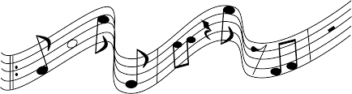
KORÇARE DISTINCTIVE SONG
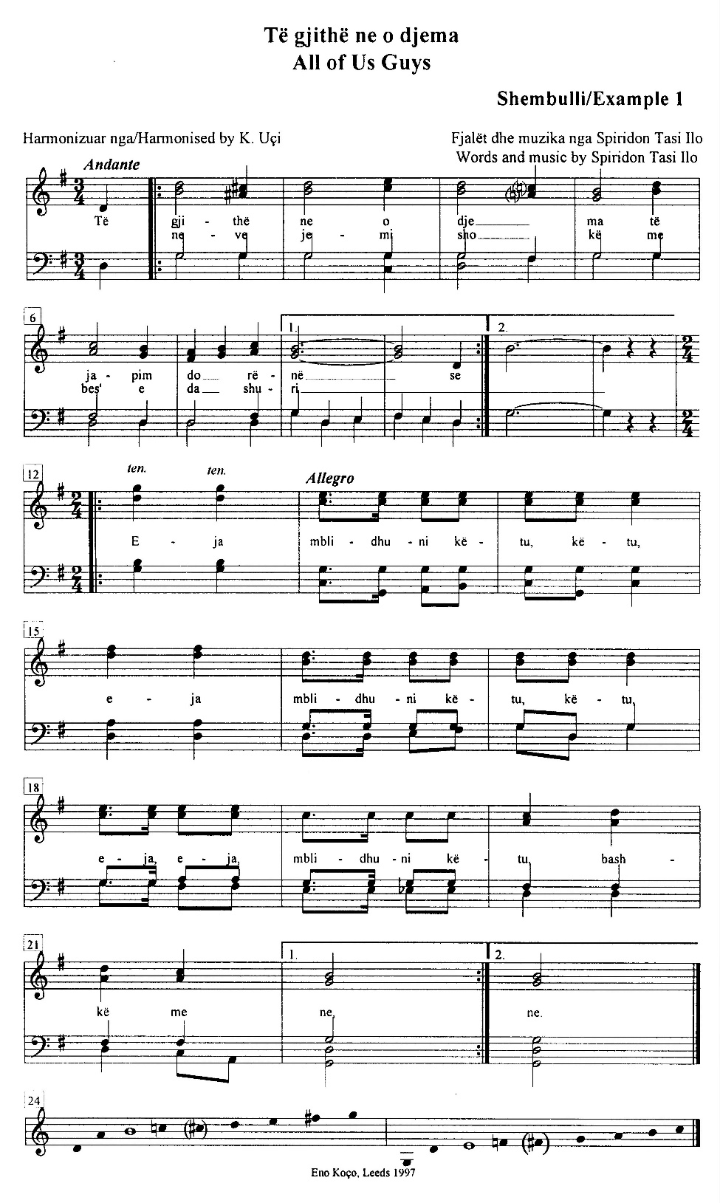
KKK—Të gjithë ne o djema/All of Us Guys;
Shembulli/Example 1

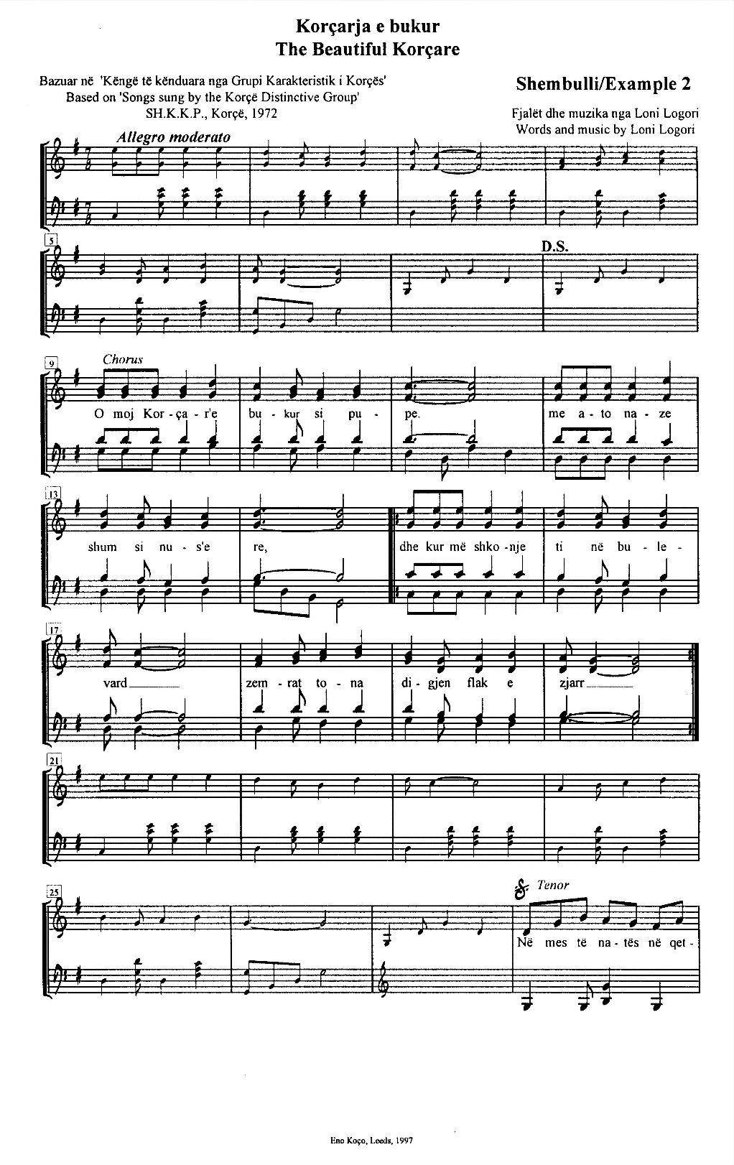
KKK—Korçarja e bukur/The Beautiful Korçare;
Shembulli/Example 2a

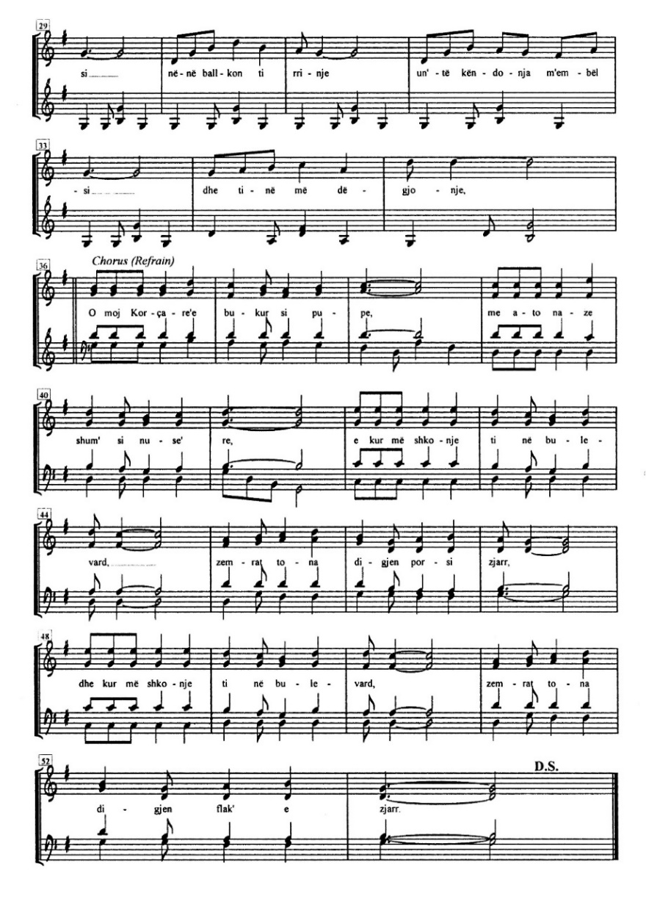
KKK—Korçarja e bukur/The Beautiful Korçare;
Shembulli/Example 2b
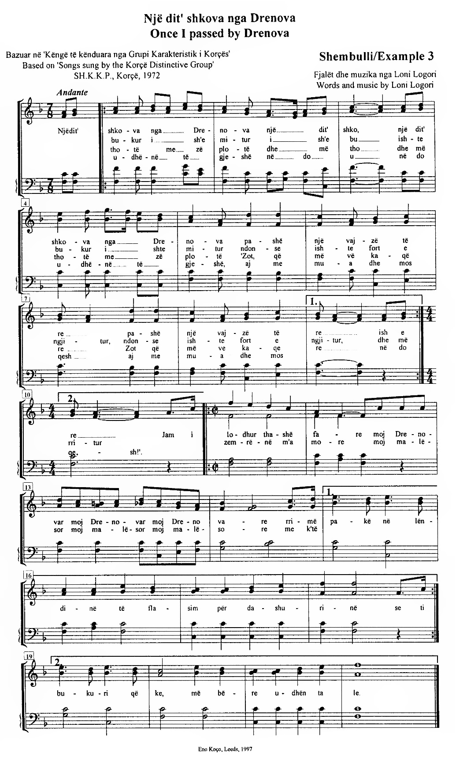
KKK—Një dit’ shkova nga Drenova/Once I Passed by Drenova;
Shembulli/Example 3

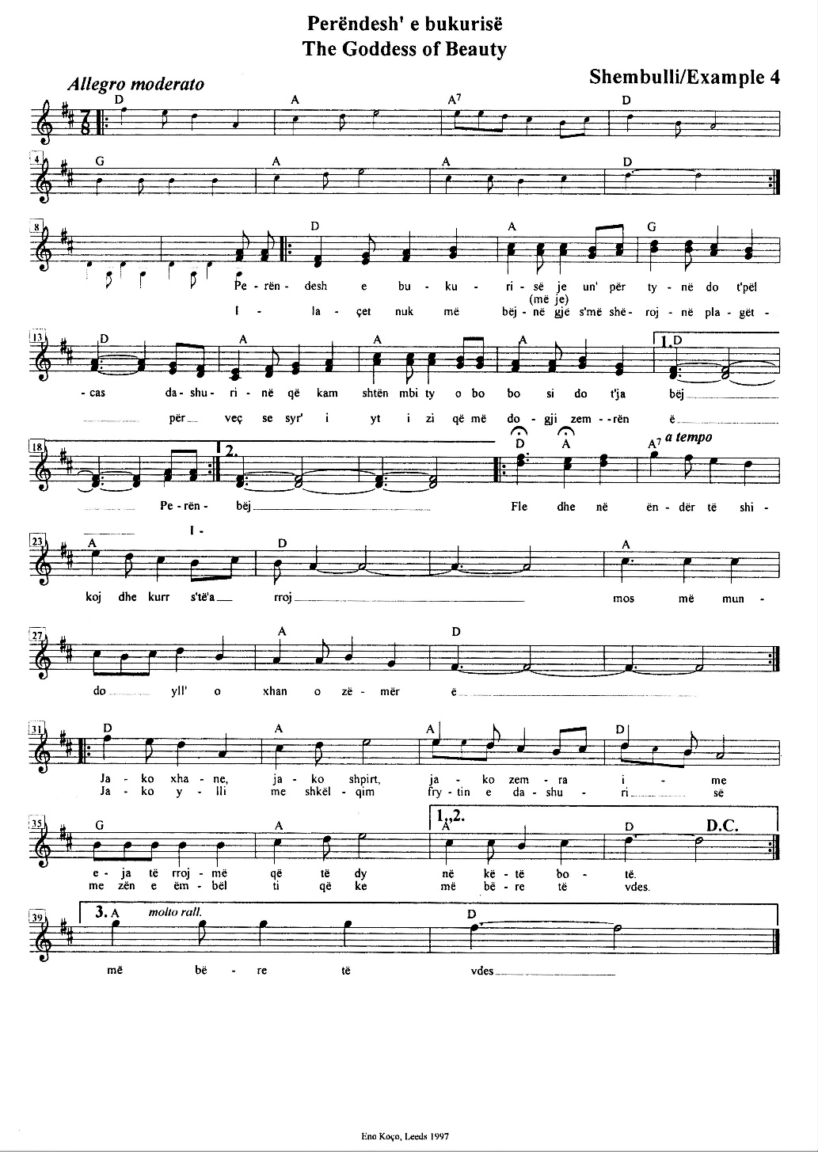
KKK—Perëndesh’ e bukurisë/The Goddess of Beauty;
Shembulli/Example 4

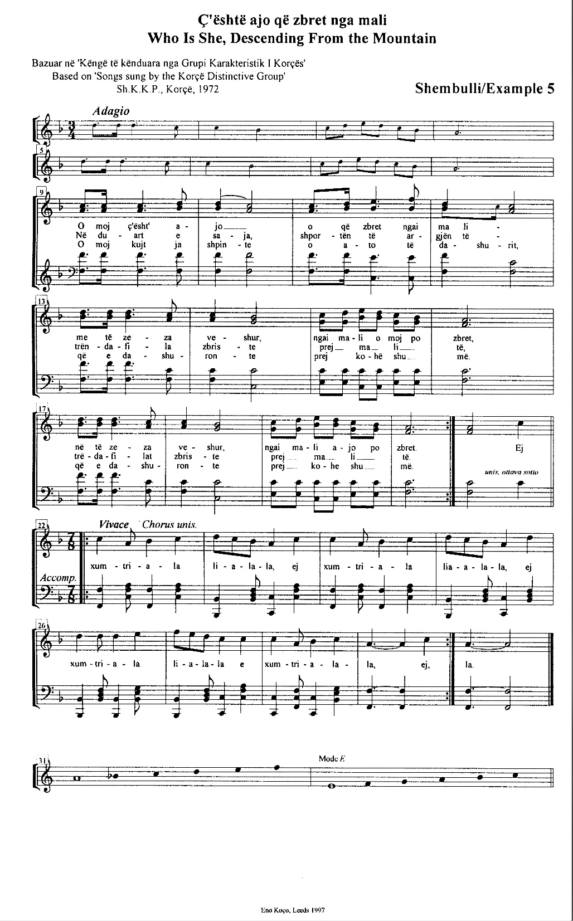
KKK—Ç’është ajo zbret nga mali/Who Is She, Descending From the Mountain;
Shembulli/Example 5

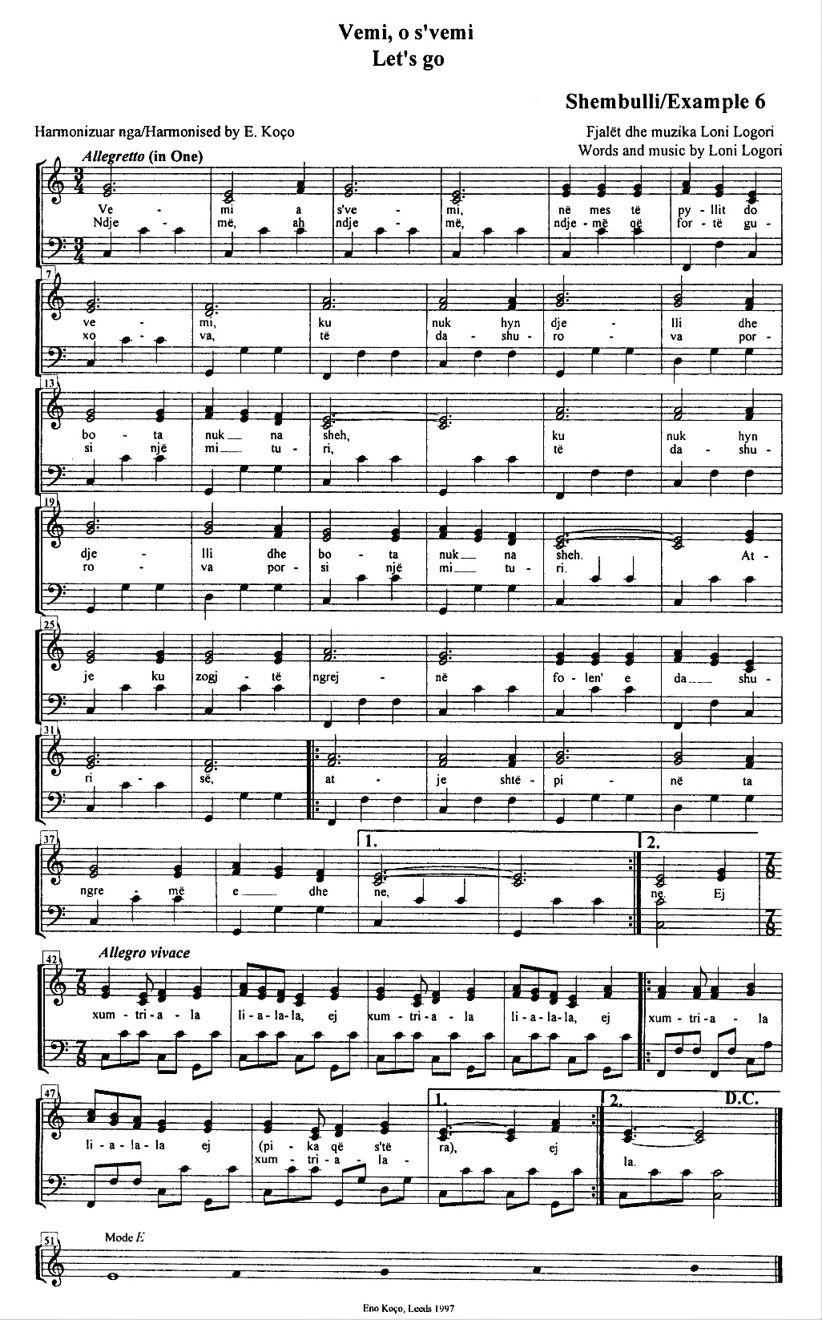
KKK—Vemi o s’vemi/Let’s Go;
Shembulli/Example 6

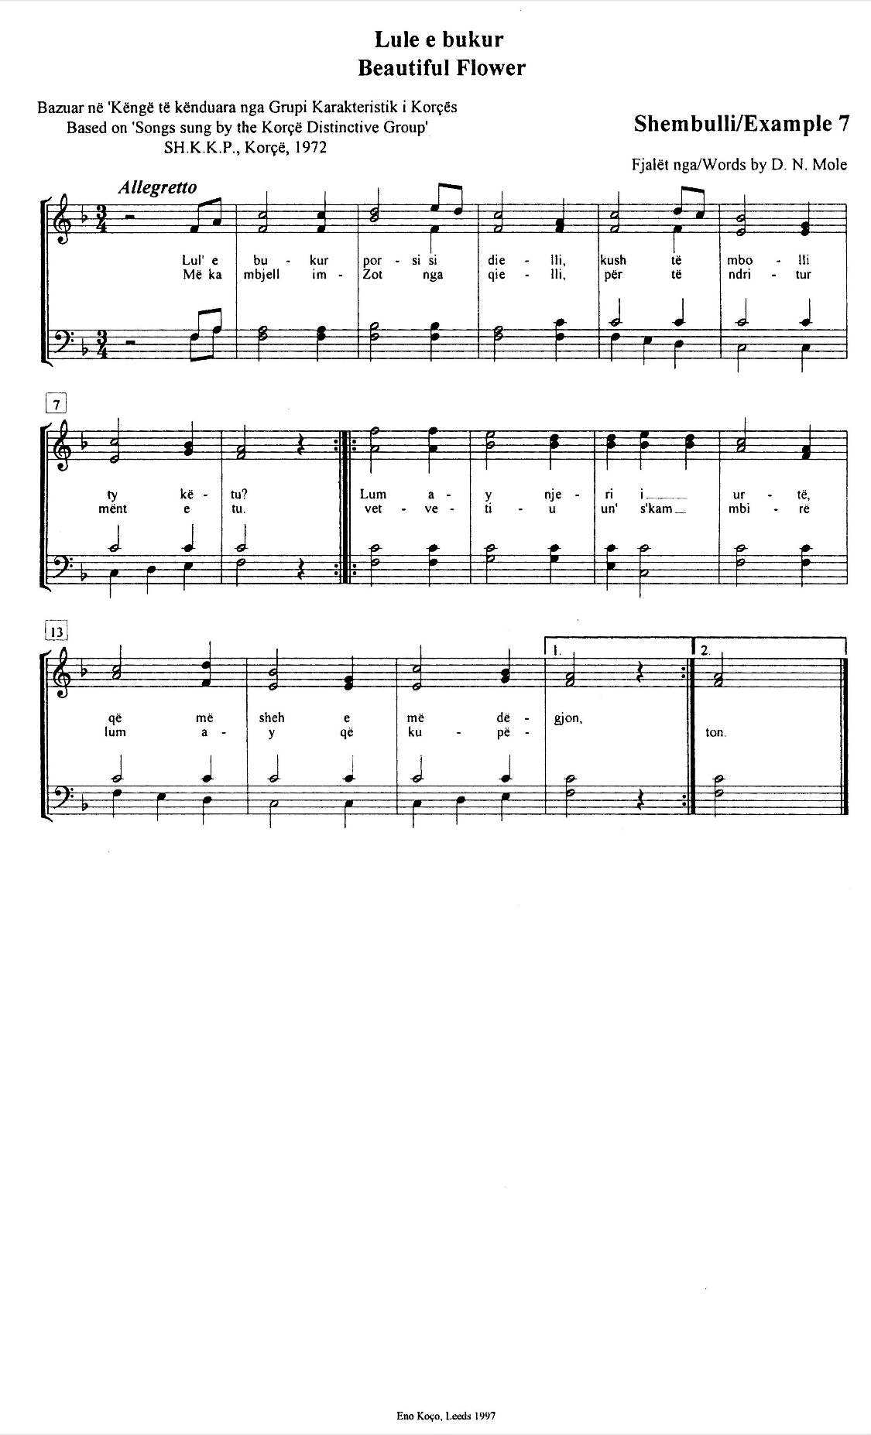
KKK—Lule e bukur/beautiful Flower;
Shembulli/Example 7

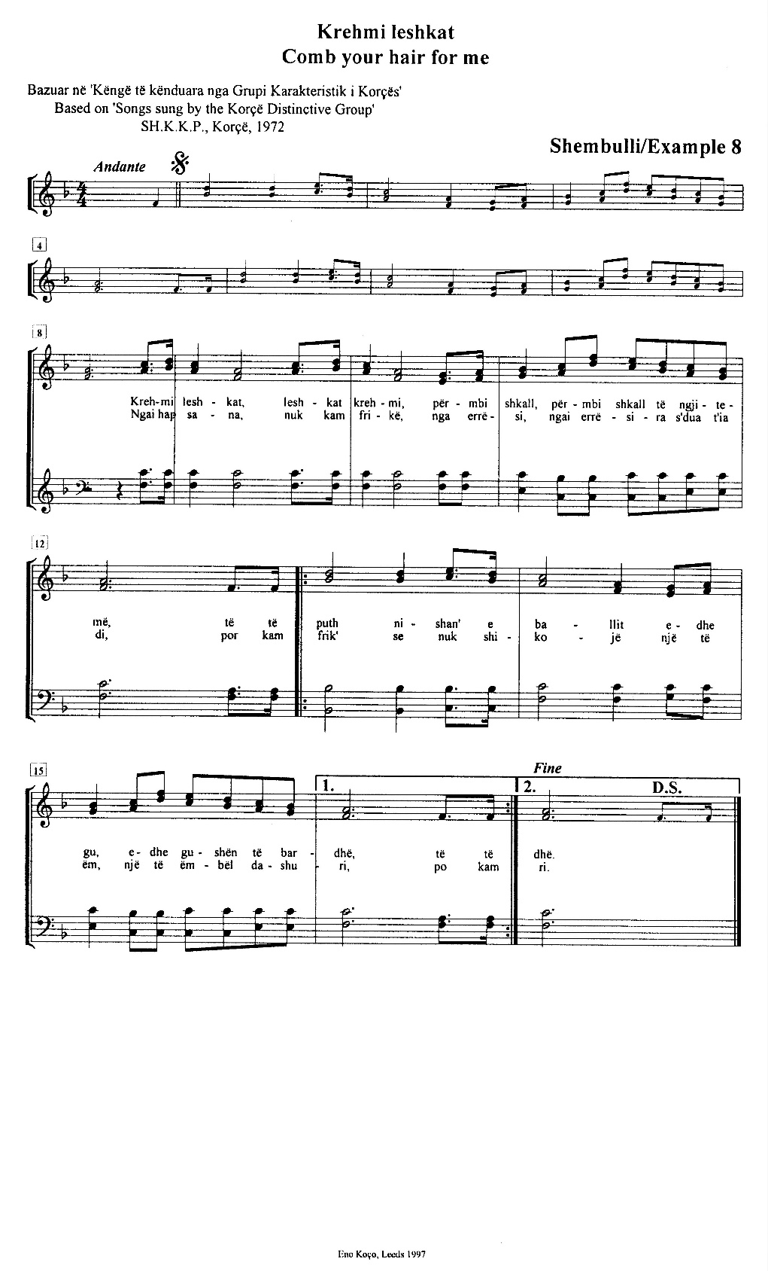
KKK—Krehmi leshkat/Comb Your Hair For Me;
Shembulli/Example 8

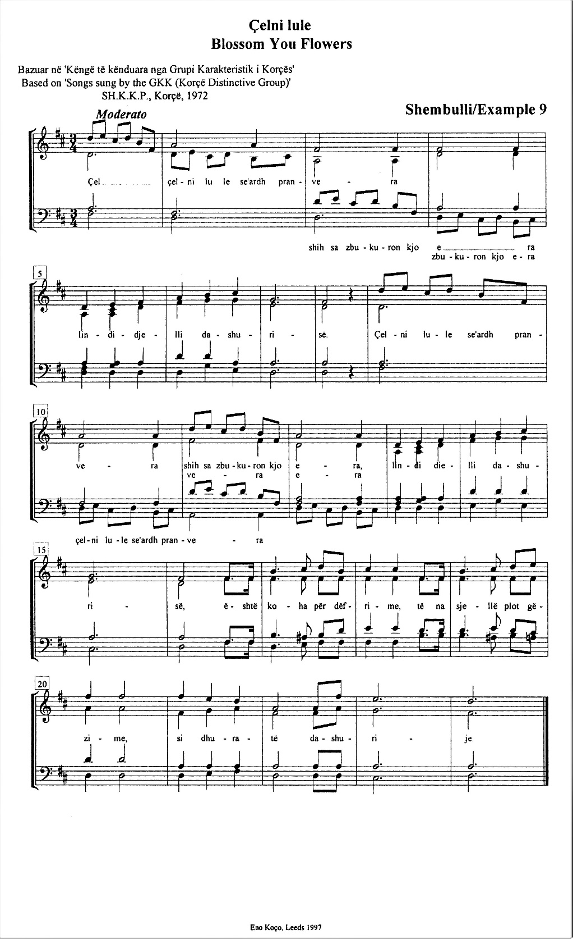
KKK—Çelni lule/Blossom You Flowers;
Shembulli/Example 9

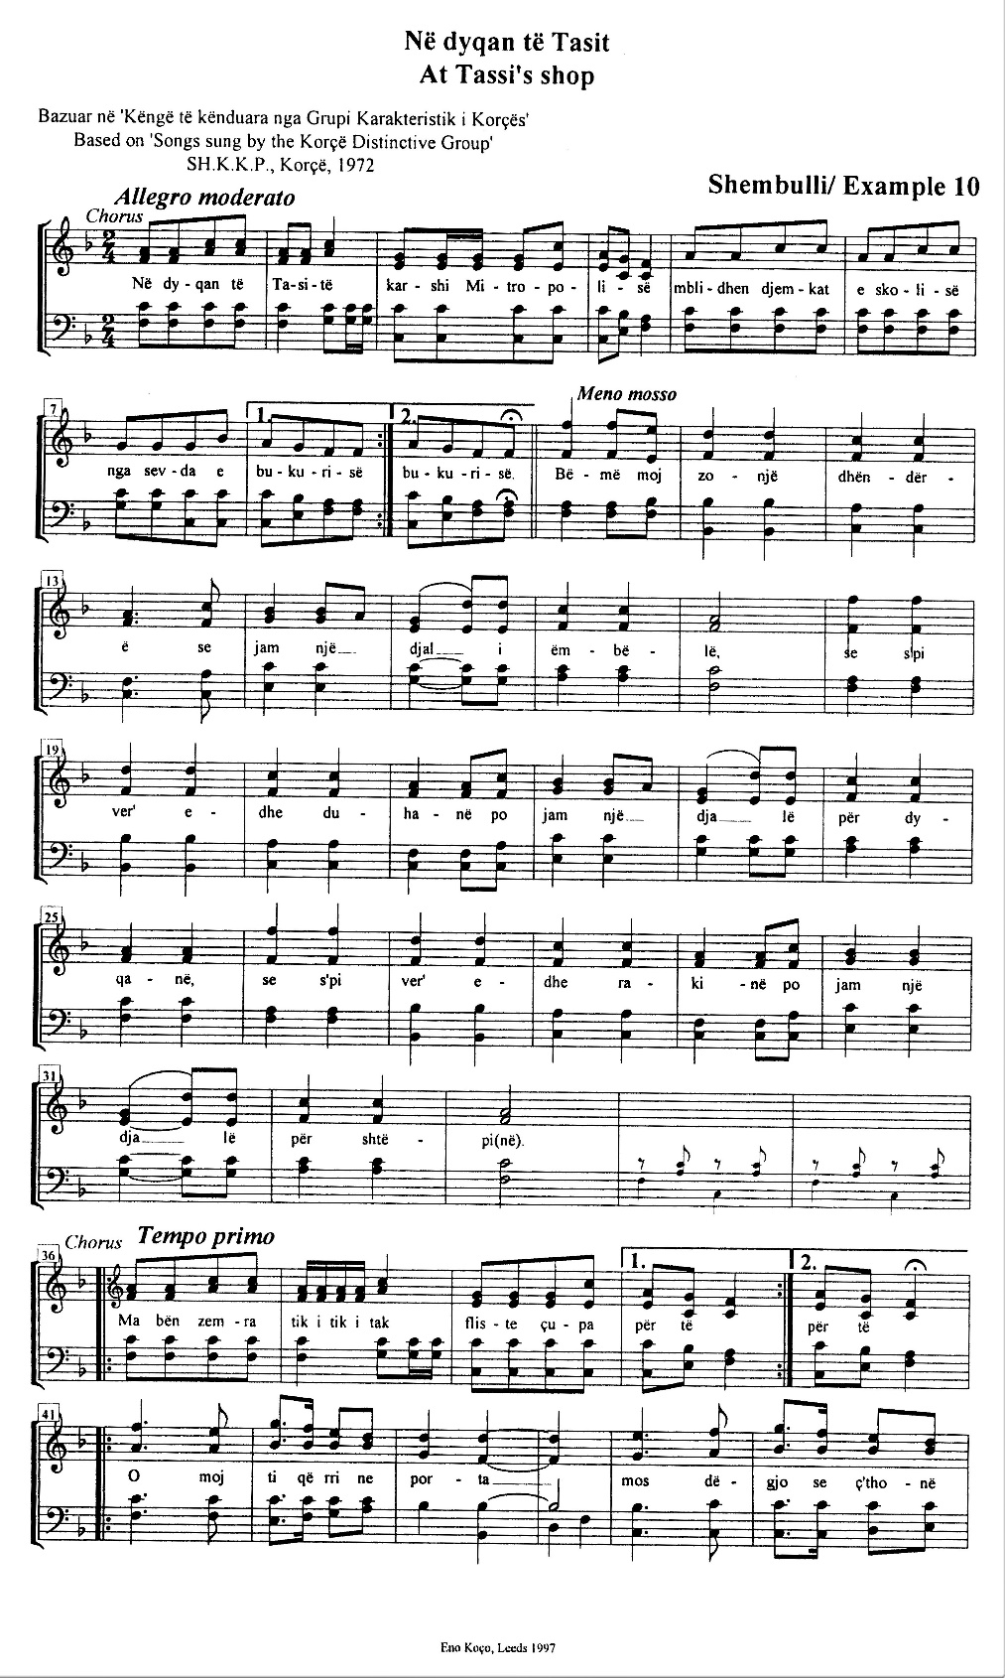
KKK—Në dyqan të Tasit/At Tassi’s Shop;
Shembulli/Example 10a

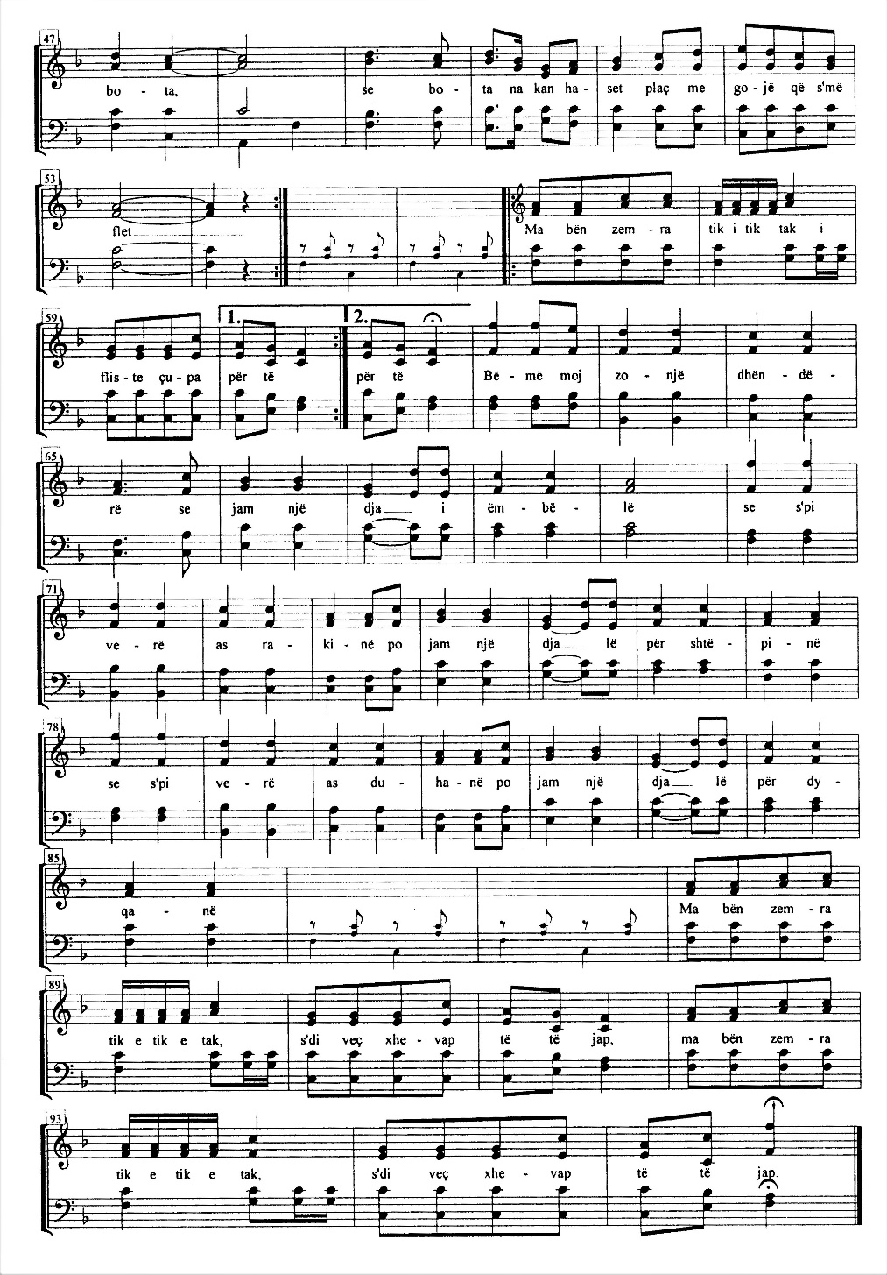
KKK—Në dyqan të Tasit/At Tassi’s Shop;
Shembulli/Example 10b

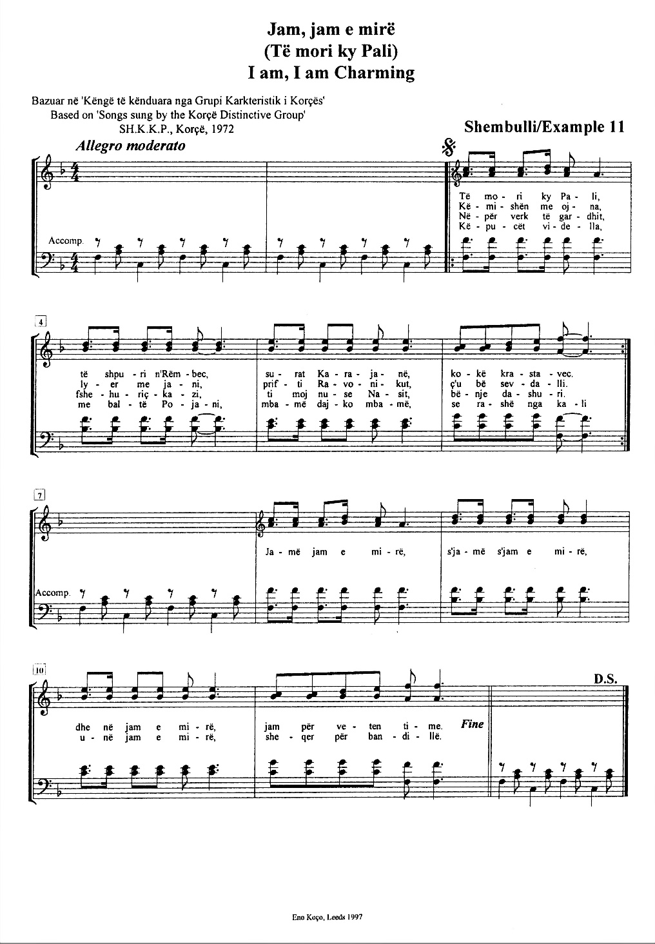
KKK—Jam, jam e mirë/I am, I’m Charming;
Shembulli/Example 11

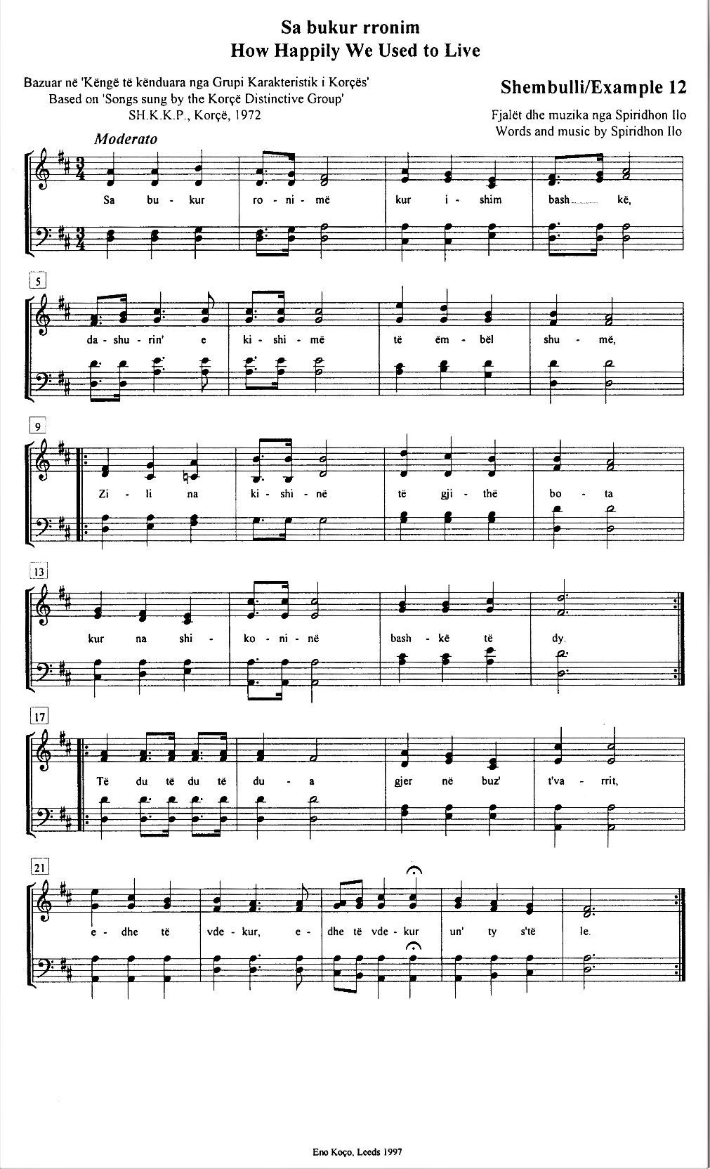
KKK—Sa bukur rronim/How Happily We Used to Live;
Shembulli/Example 12

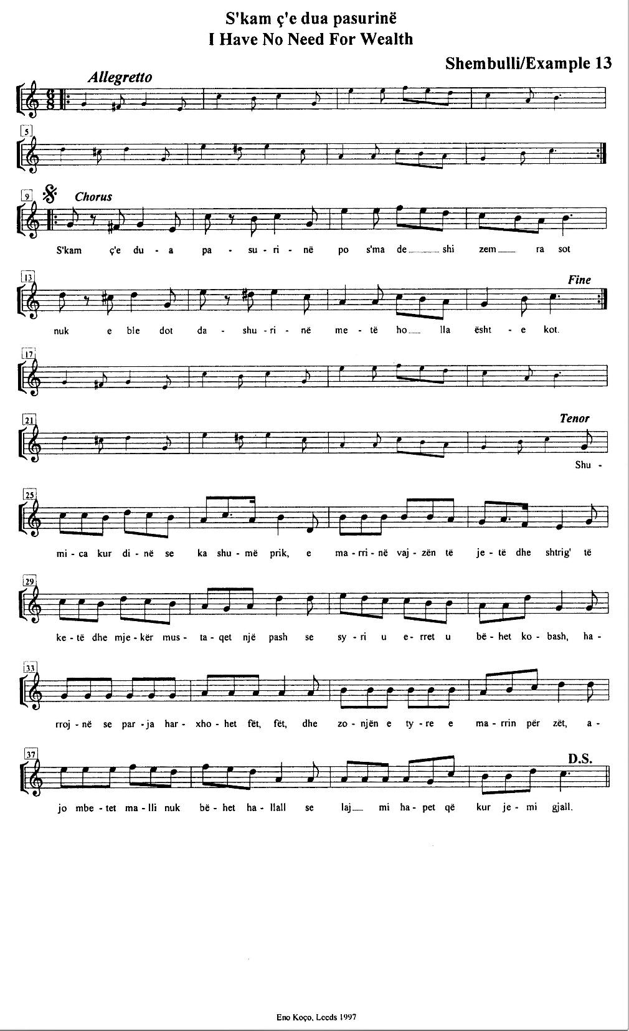
KKK—S’kam ç’e dua pasurinë/I Have No Need For Wealth;
Shembulli/Example 13

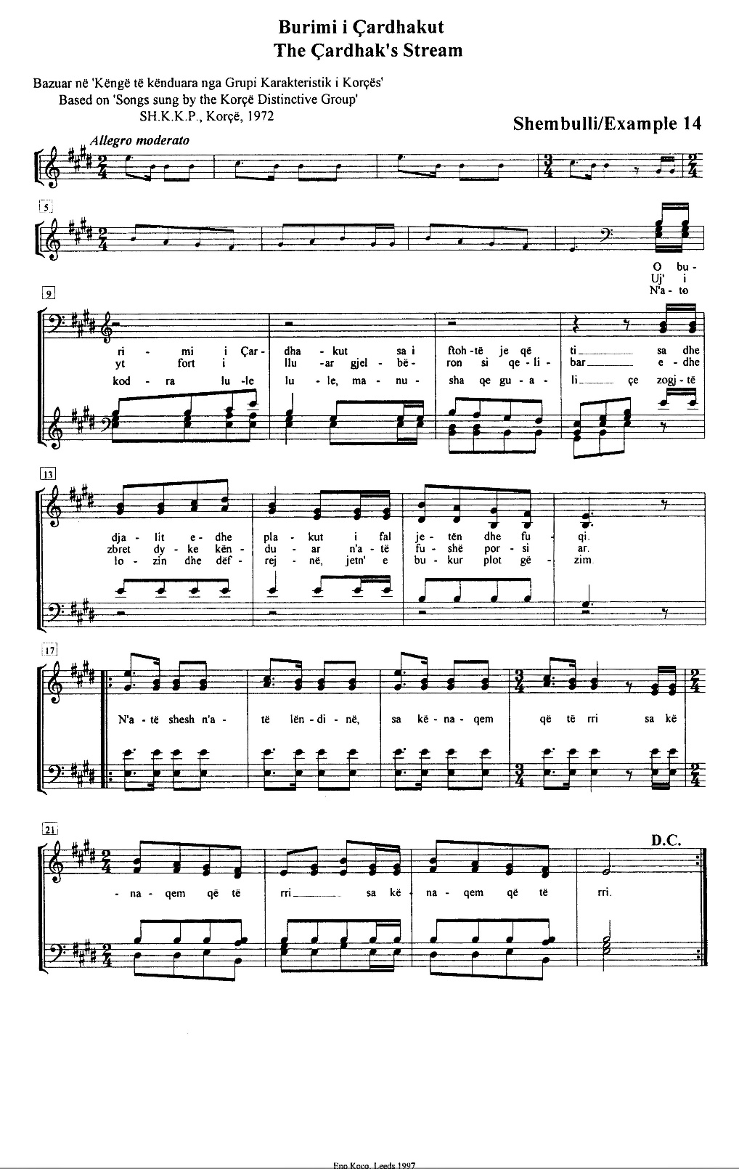
KKK—Burimi i Çardhakut/The Çardhak’s Stream;
Shembulli/Example 14

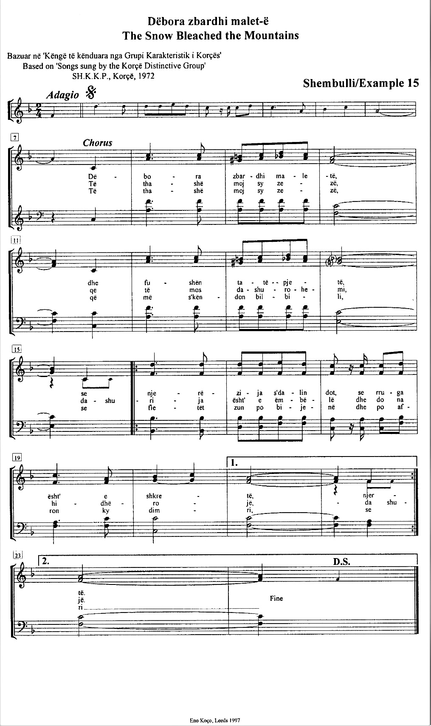
KKK—Dëbora zbardhi malet-ë/The Snow Bleached the Mountains;
Shembulli/Example 15

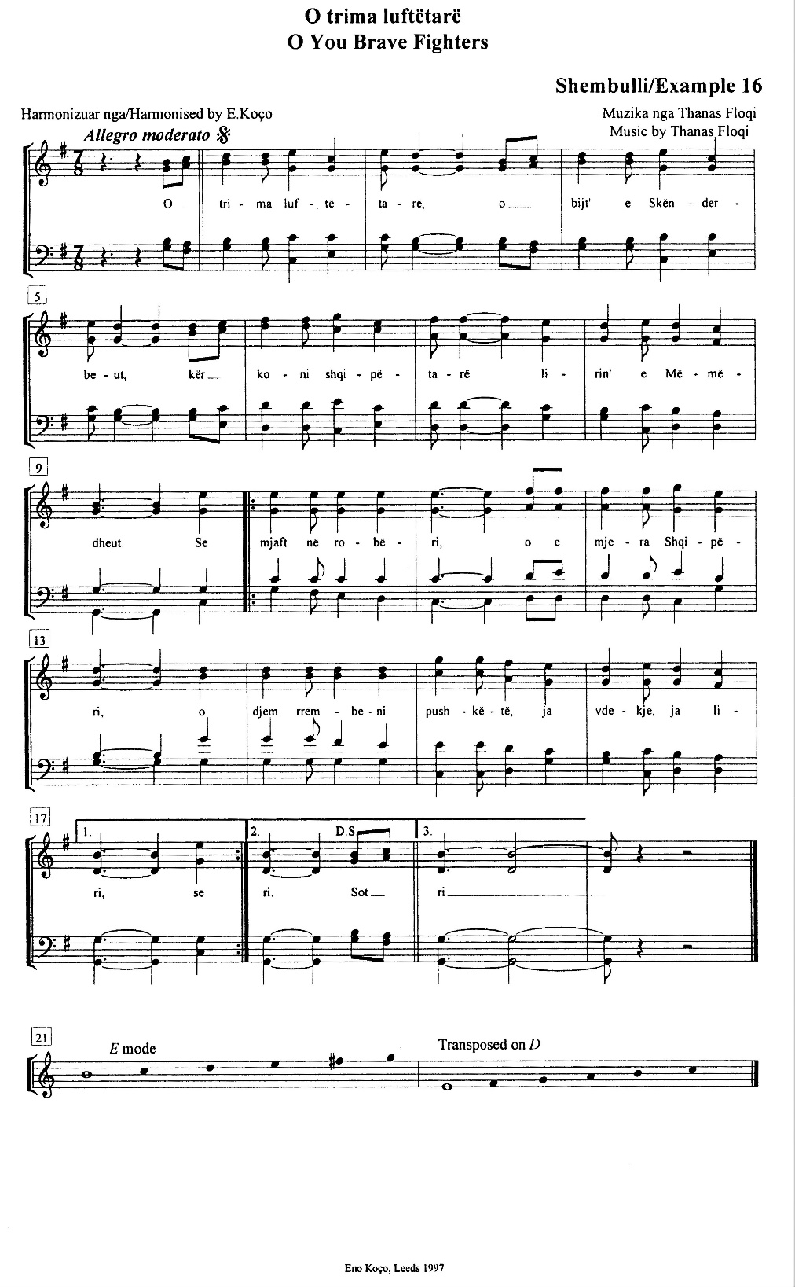
KKK—O trima luftëtarë/O You Brave Fighters;
Shembulli/Example 16

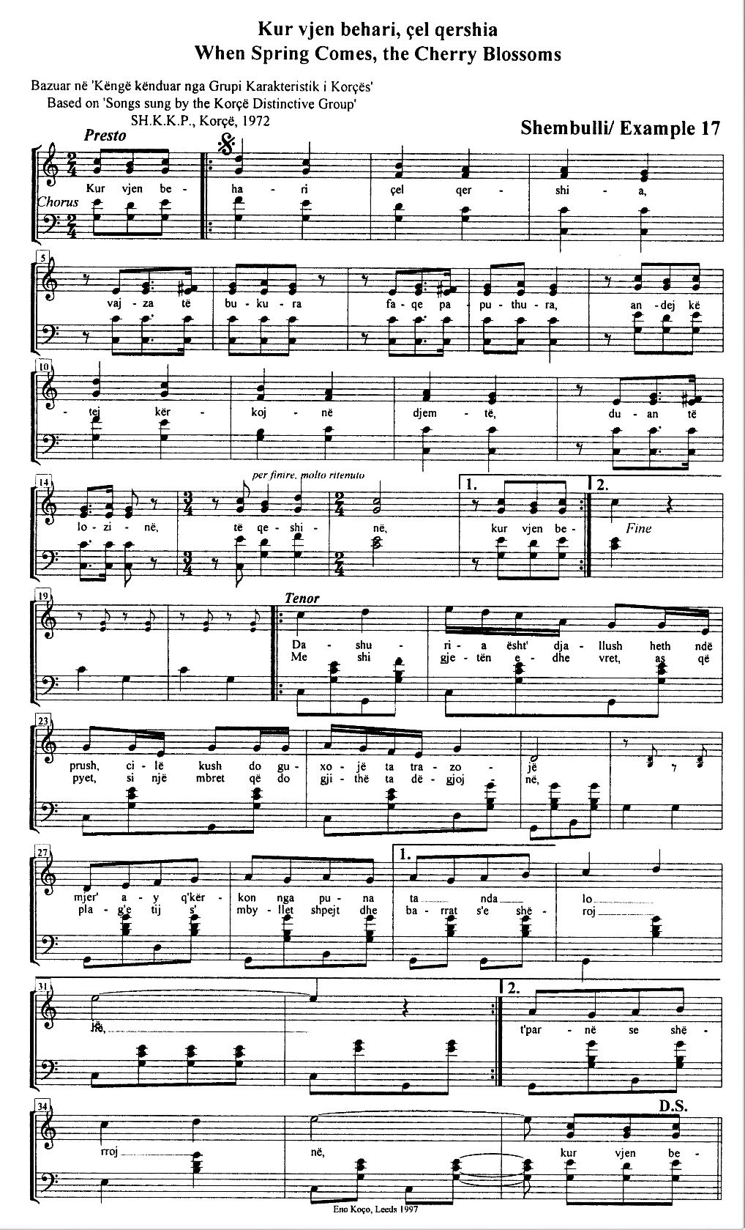
KKK—Kur vjen behari, çel qershia/When Spring Comes, the Cherry Blossoms;
Shembulli/Example 17

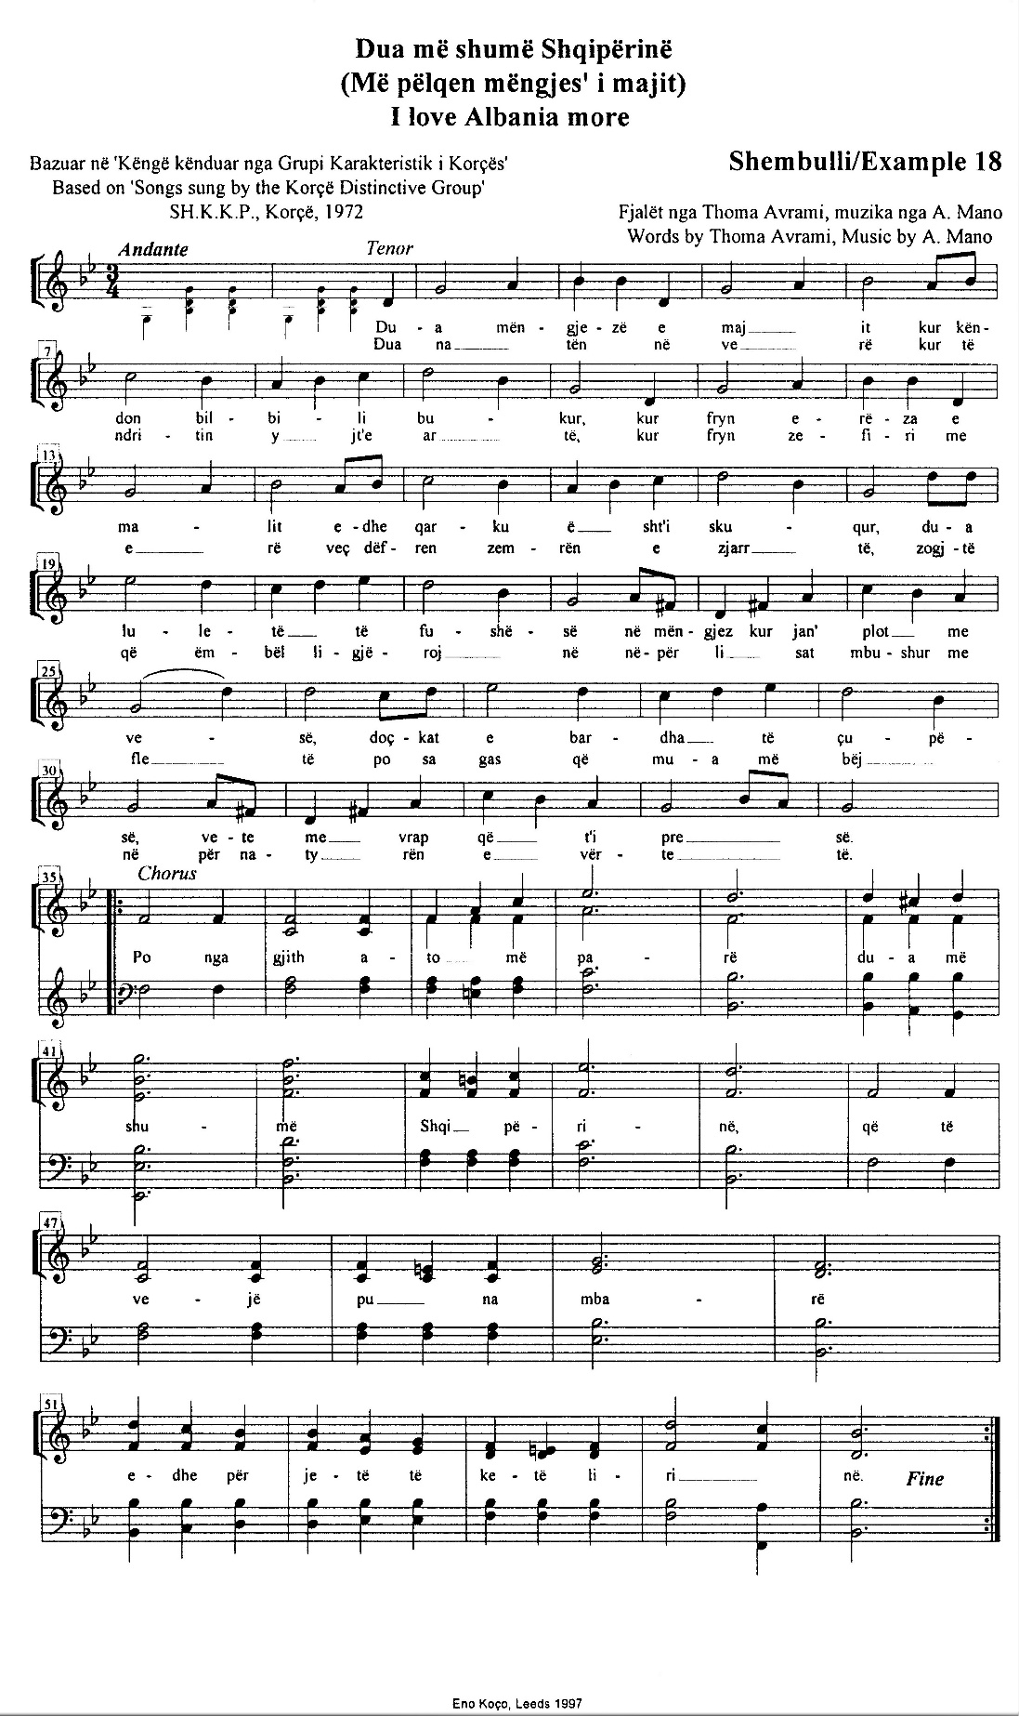
KKK—Dua më shumë Shqipërinë/I Love Albania More;
Shembulli/Example 18

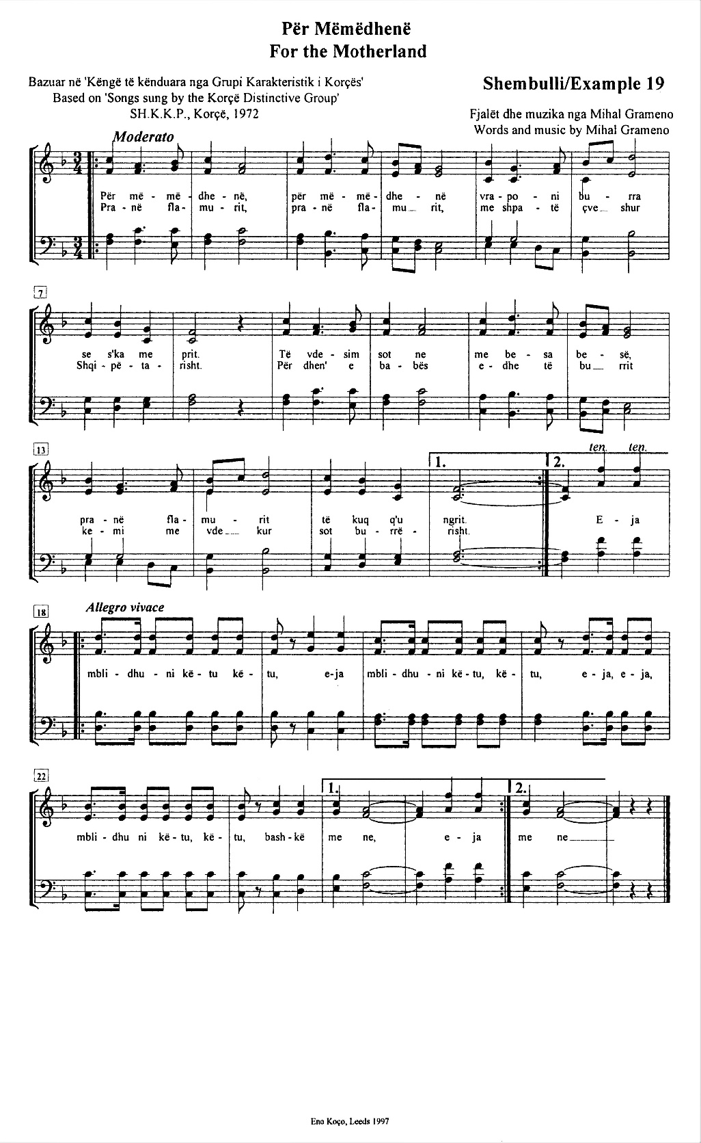
KKK—Për Mëmëdhenë/For the Motherland;
Shembulli/Example 19

KËNGËT E THOMA NASIT
THOMA NASSI’S SONGS

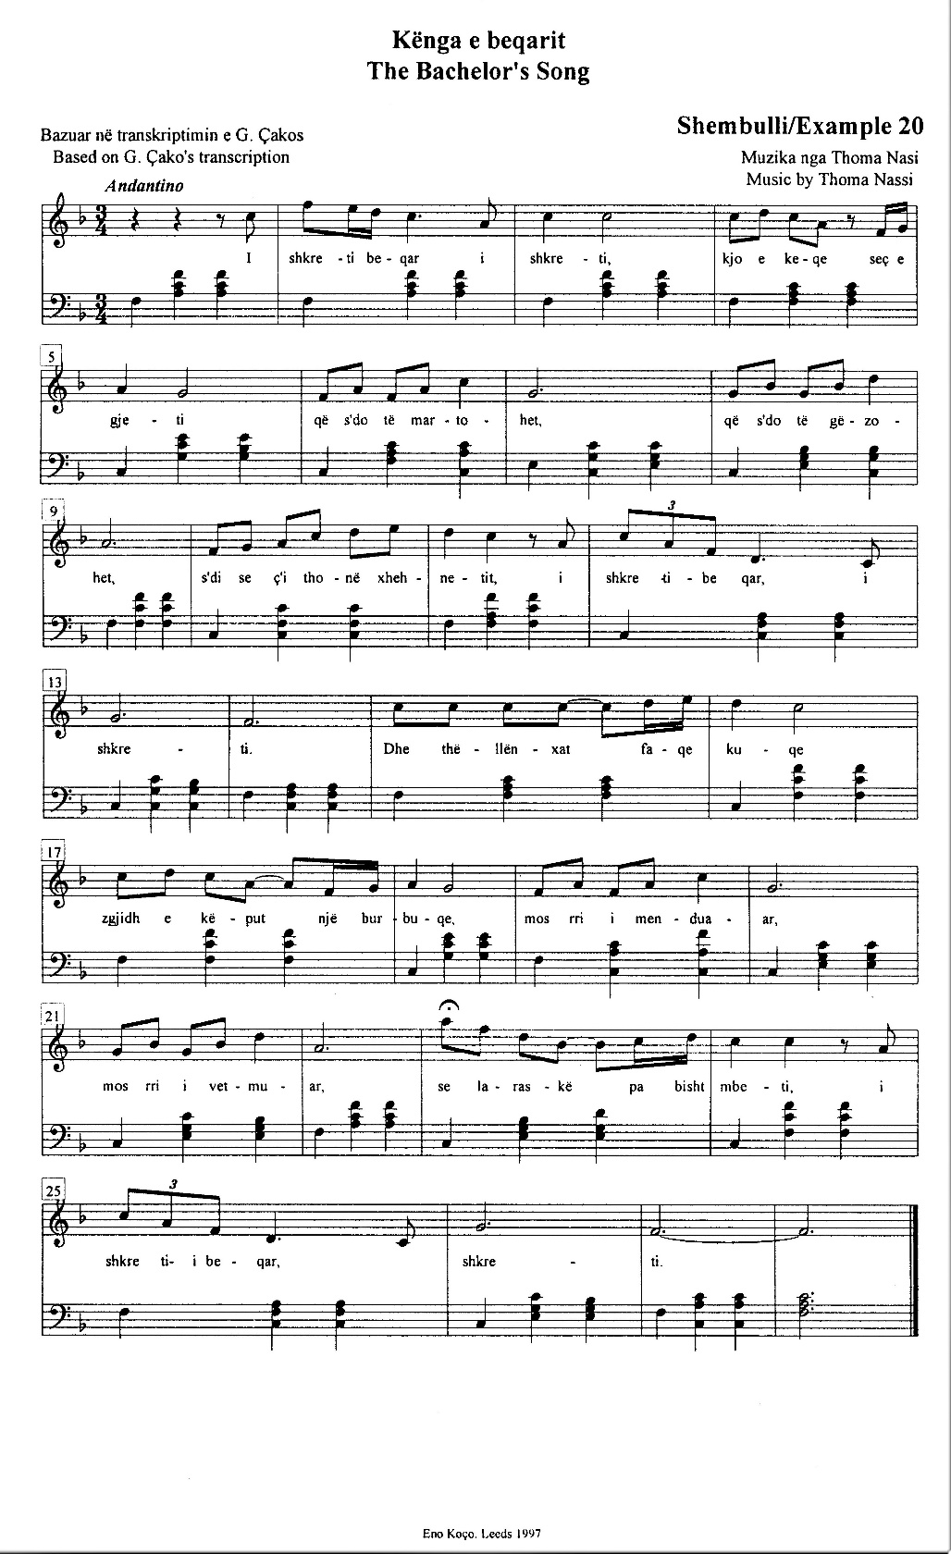
KKK—Kënga e beqarit/The Bachelor’s Song;
Shembulli/Example 20
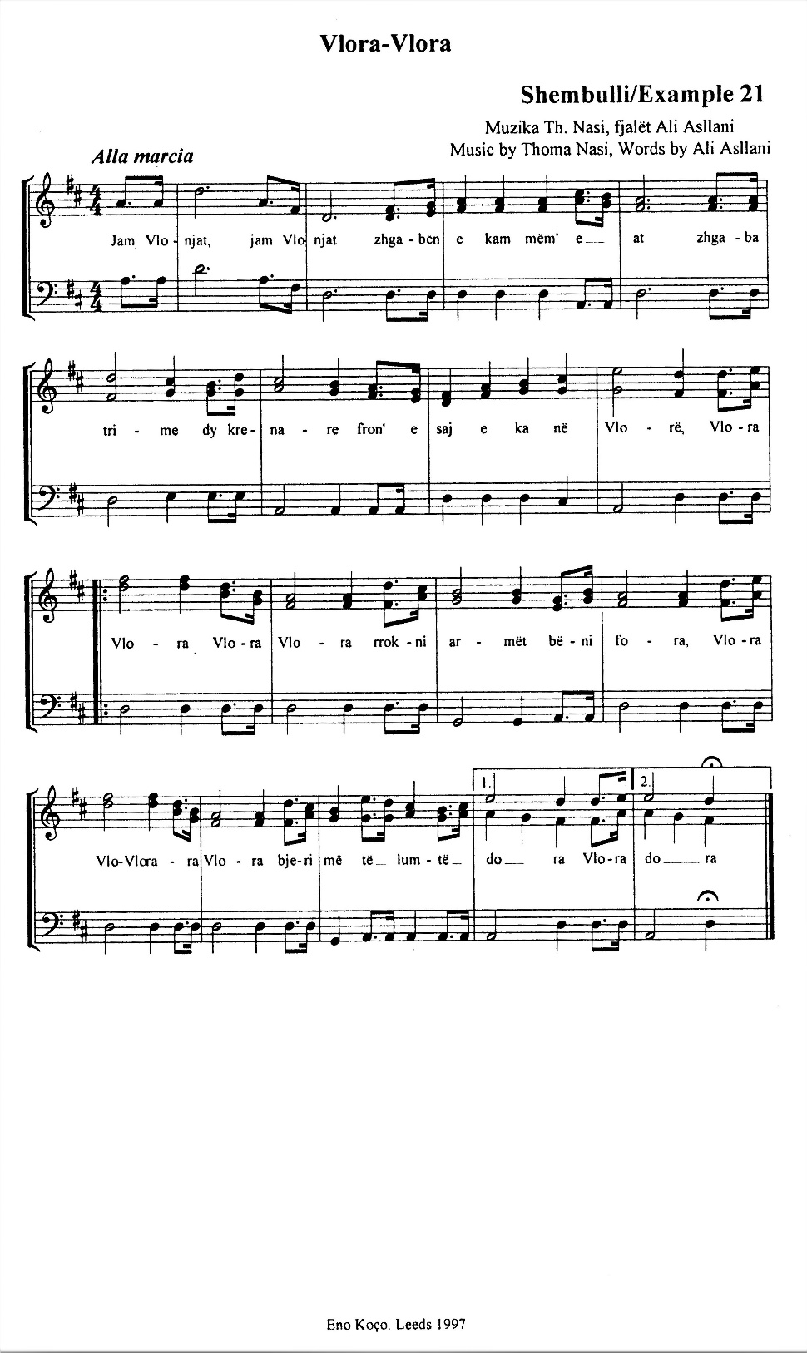
KKK—Vlora Vlora;
Shembulli/Example 21

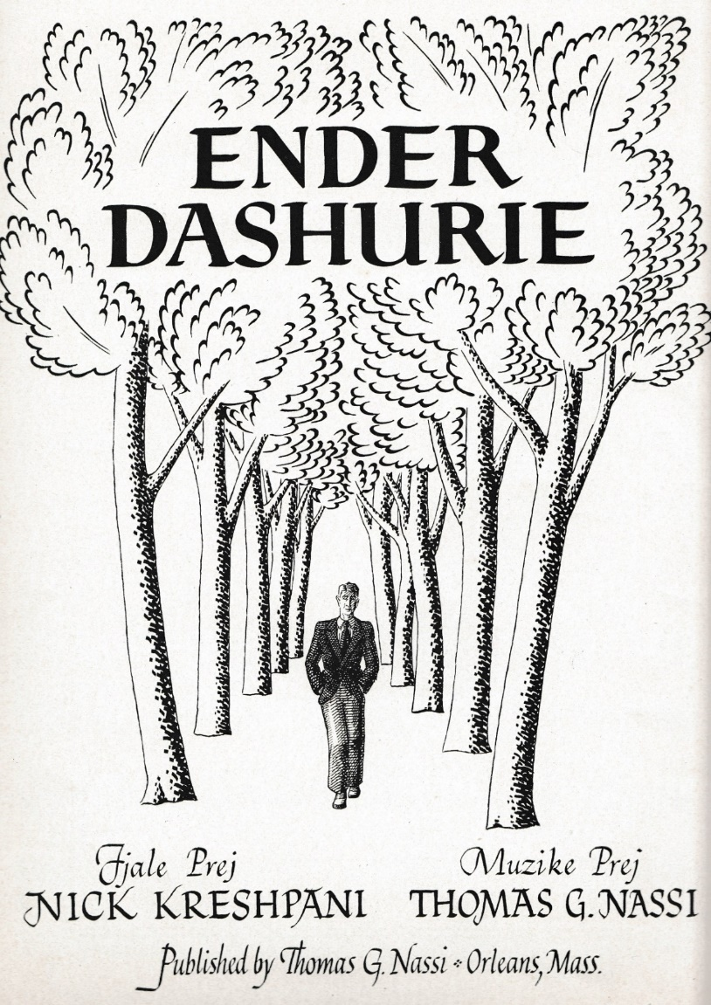
KKK—Ëndër dashurie/Love Dream;
Shembulli/Example 22a
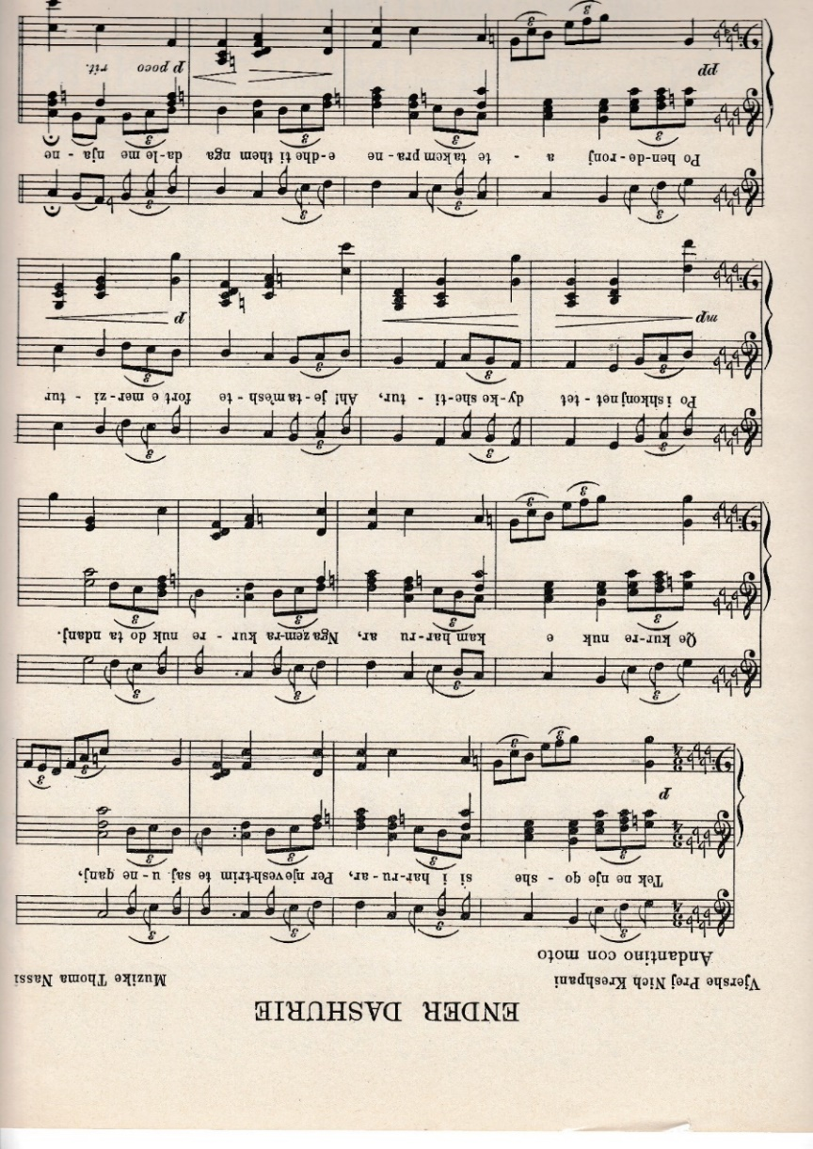

KKK—Ëndër dashurie/Love Dream;
Shembulli/Example 22b

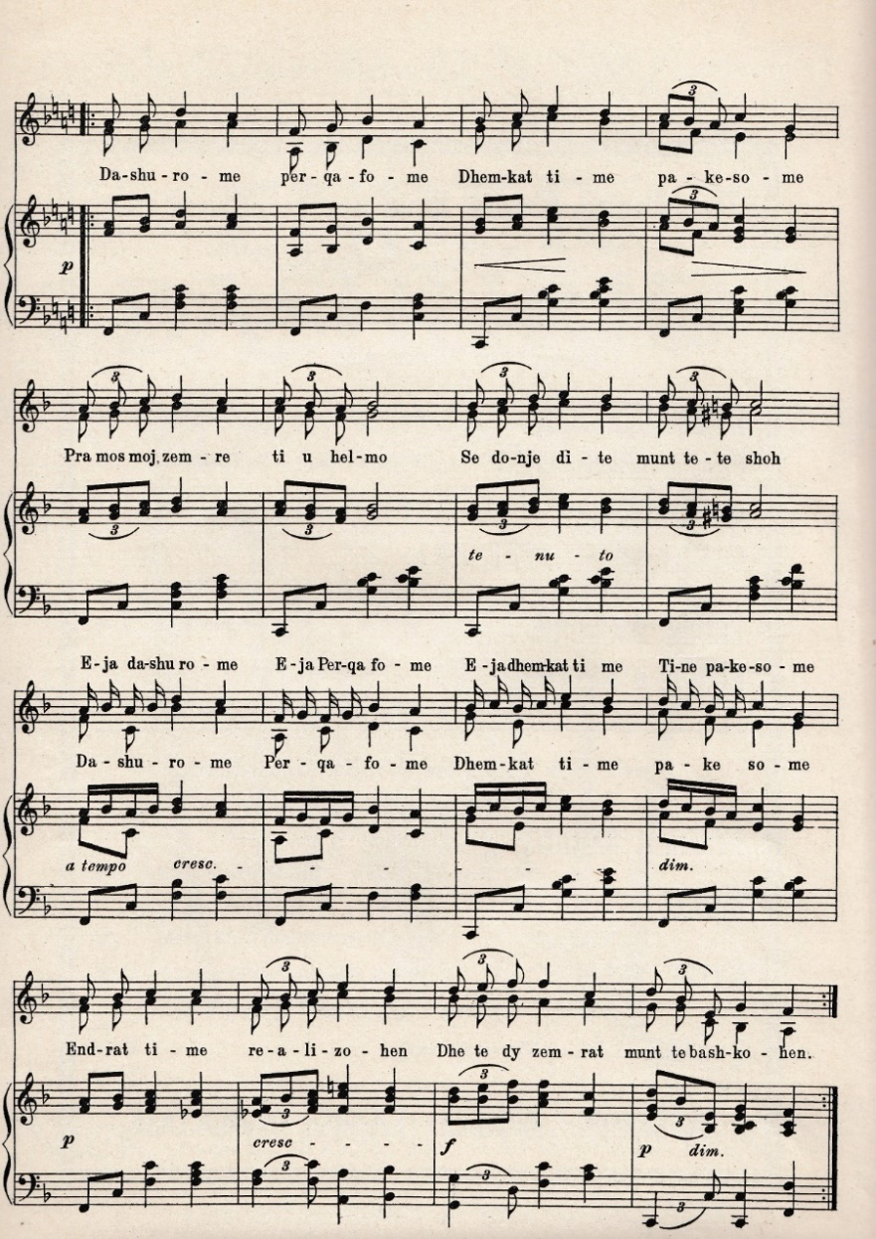

KKK—Ëndër dashurie/Love Dream;
Shembulli/Example 22c

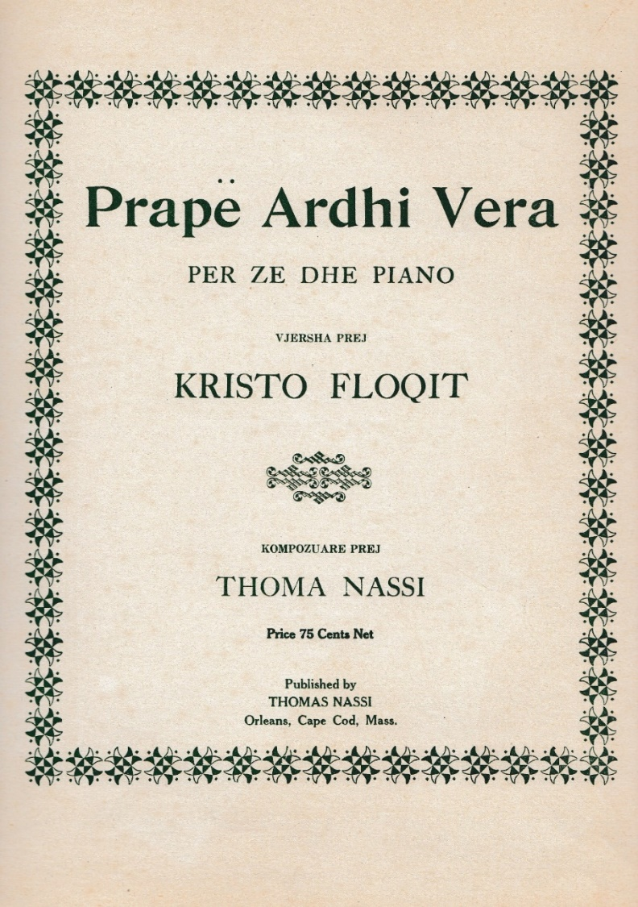
KKK—Prapë ardhi vera/The Summer Came Again;
Shembulli/Example 23a

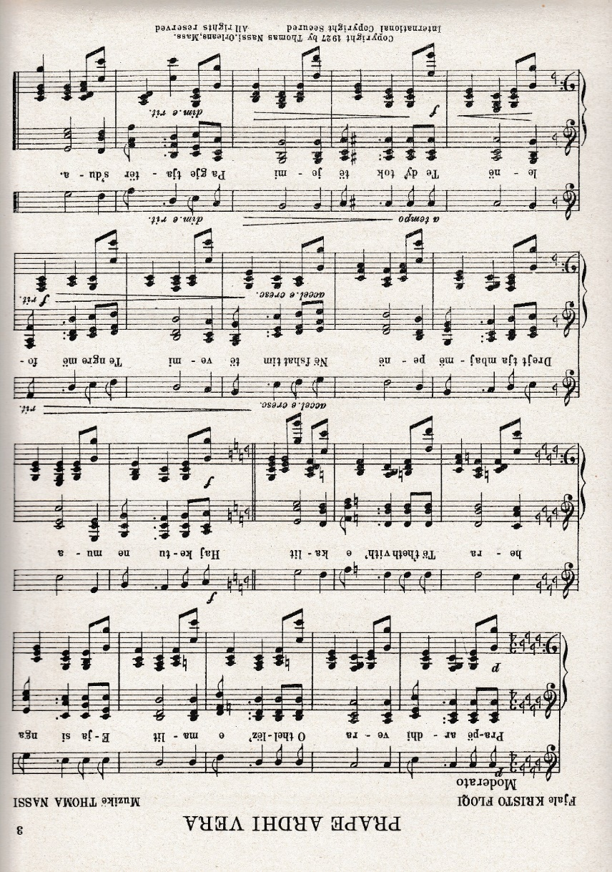
KKK—Prapë ardhi vera/The Summer Came Again;
Shembulli/Example 23b

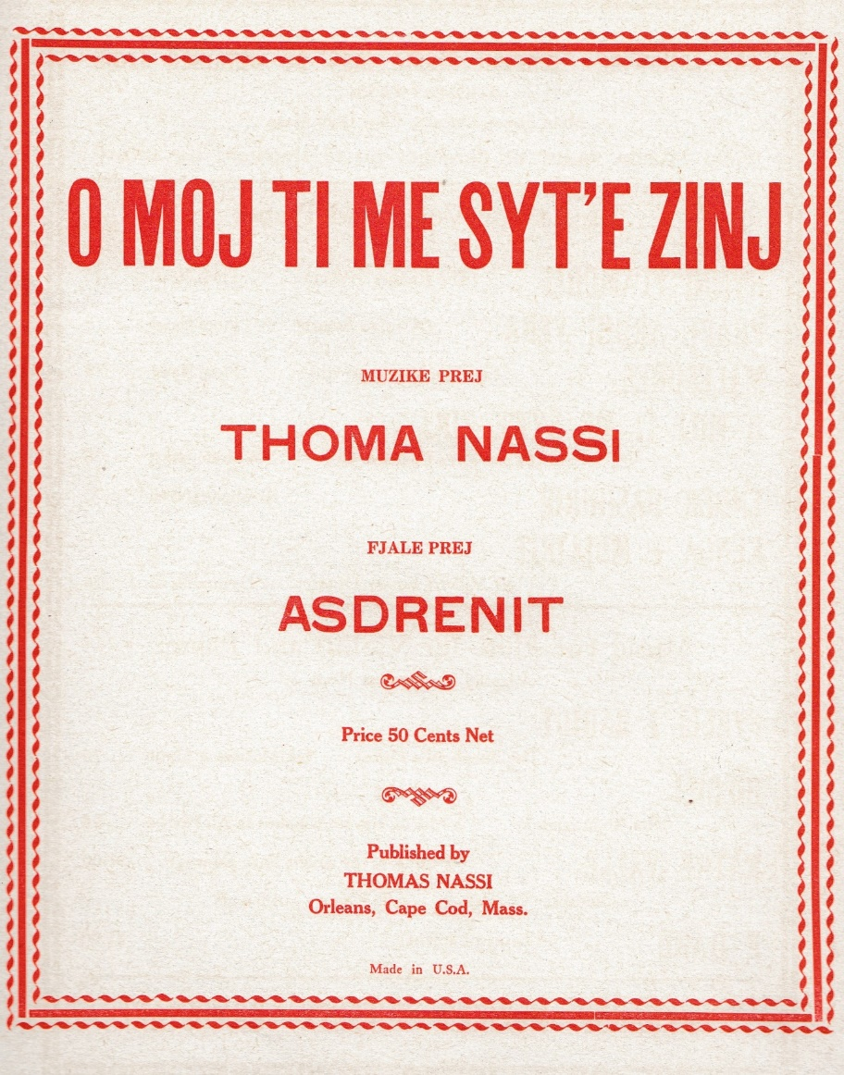
KKK—O moj ti me syt’ e zinj/‘Your Eyes Enchant Me’;
Shembulli/Example 24a

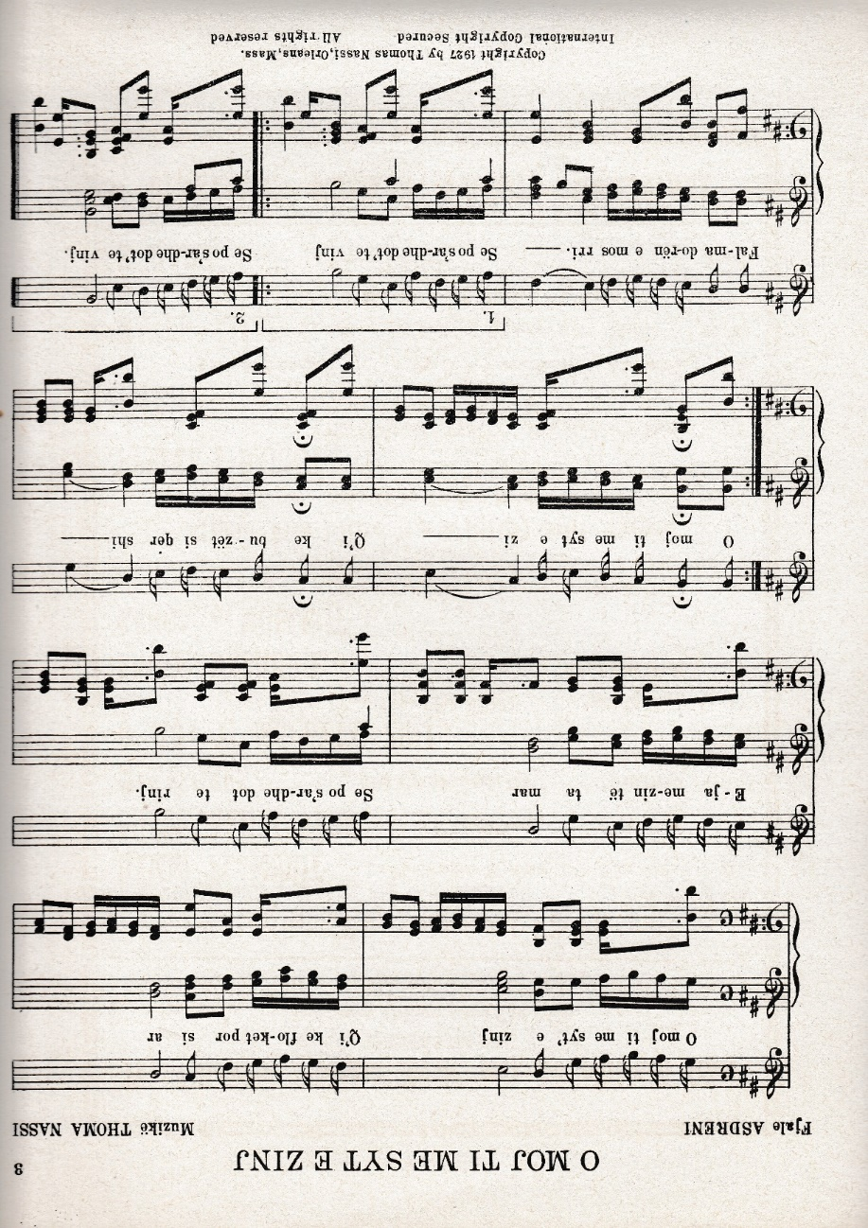
KKK—O moj ti me syt’ e zinj/‘Your Eyes Enchant Me’;
Shembulli/Example 24b

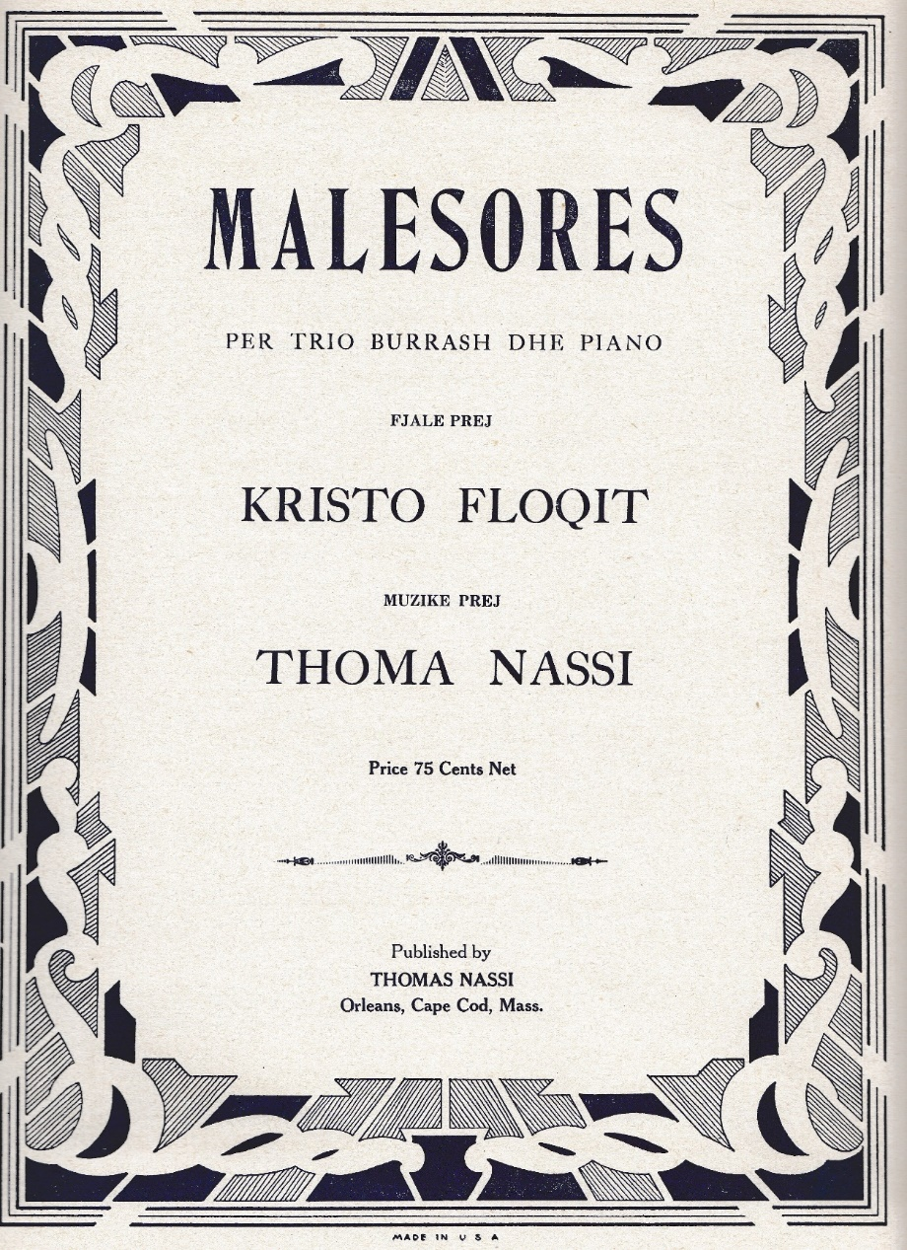
KKK—Malësores/ To the Mountain Girl;
Shembulli/Example 25a
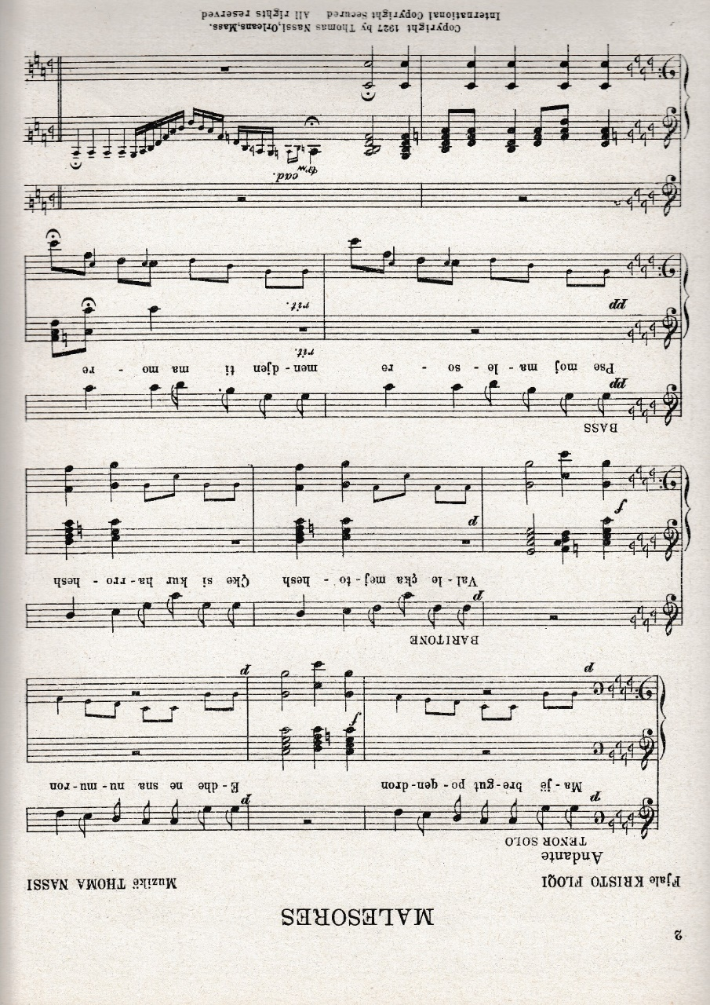
KKK—Malësores/ To the Mountain Girl;
Shembulli/Example 25b
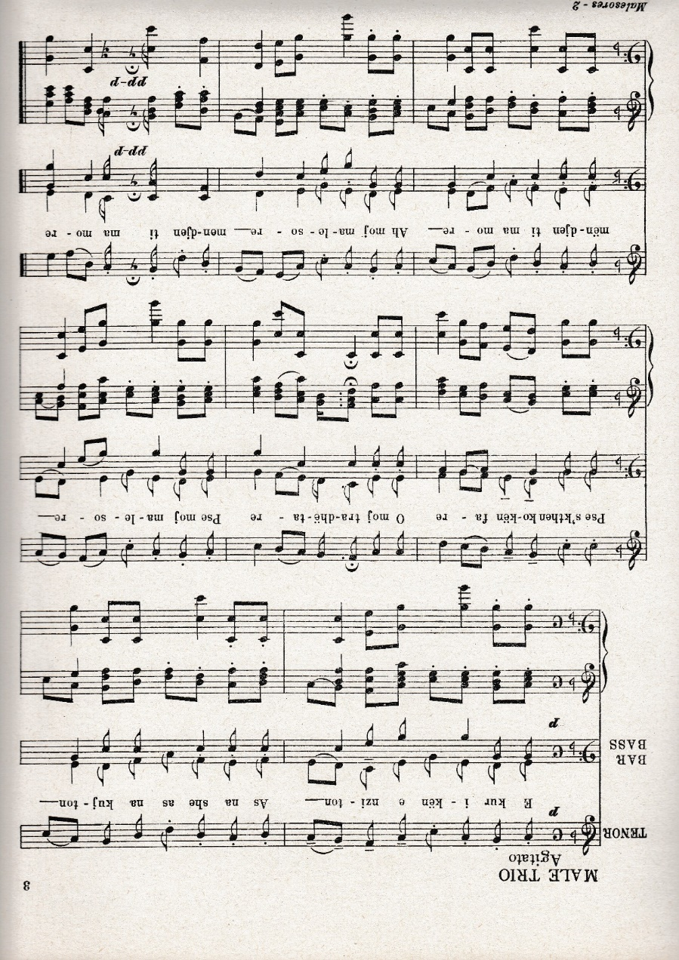
KKK—Malësores/ To the Mountain Girl;
Shembulli/Example 25c

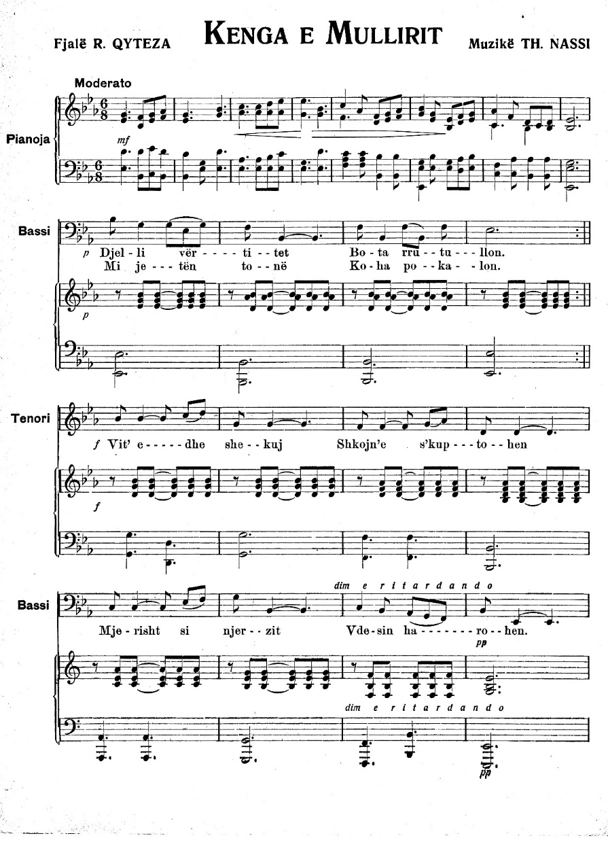
KKK—Kënga e mullirit/ The Miller’s Song;
Shembulli/Example 26a

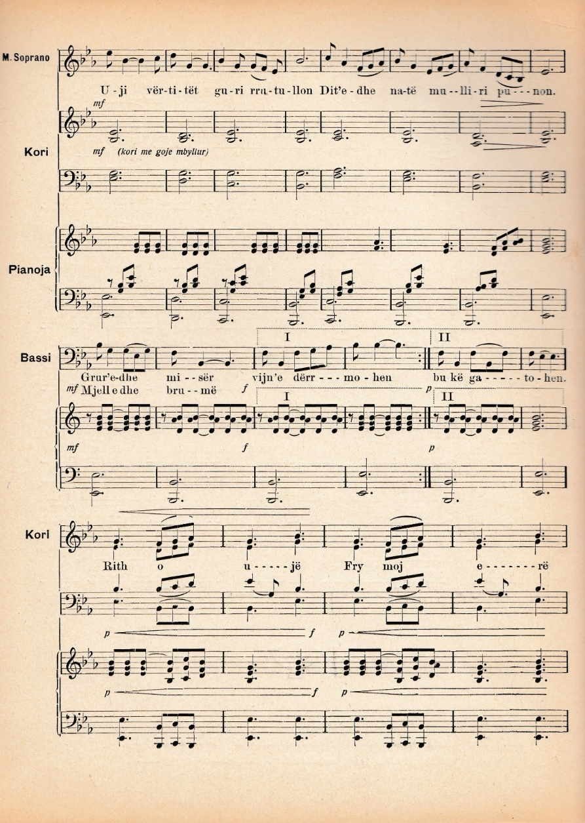
KKK—Kënga e mullirit/ The Miller’s Song;
Shembulli/Example 26b

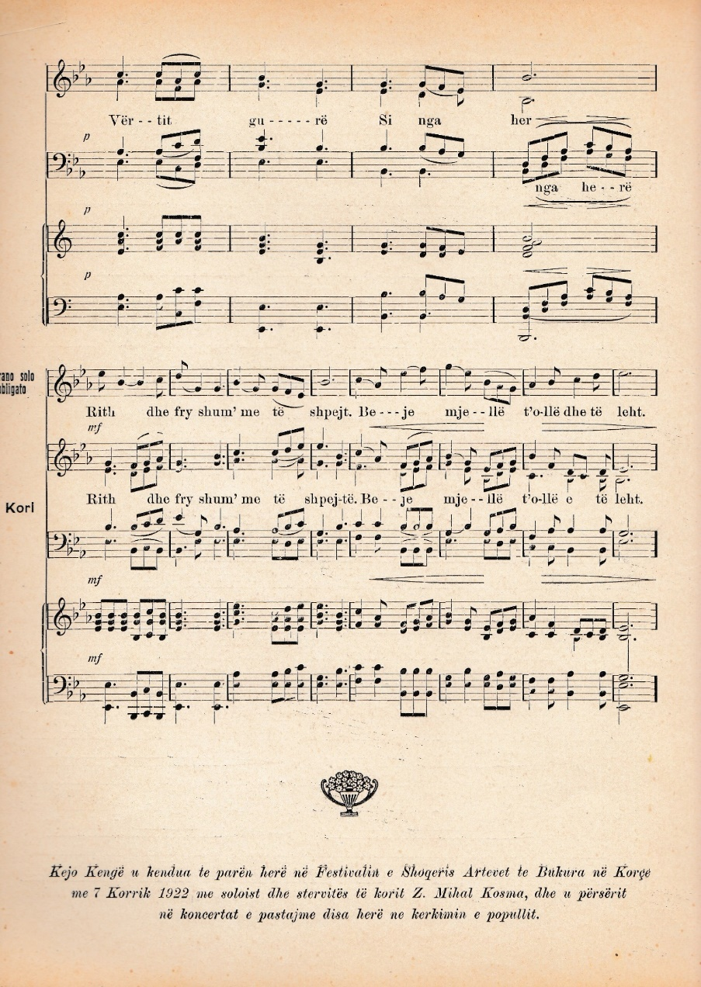
KKK—Kënga e mullirit/ The Miller’s Song;
Shembulli/Example 26c

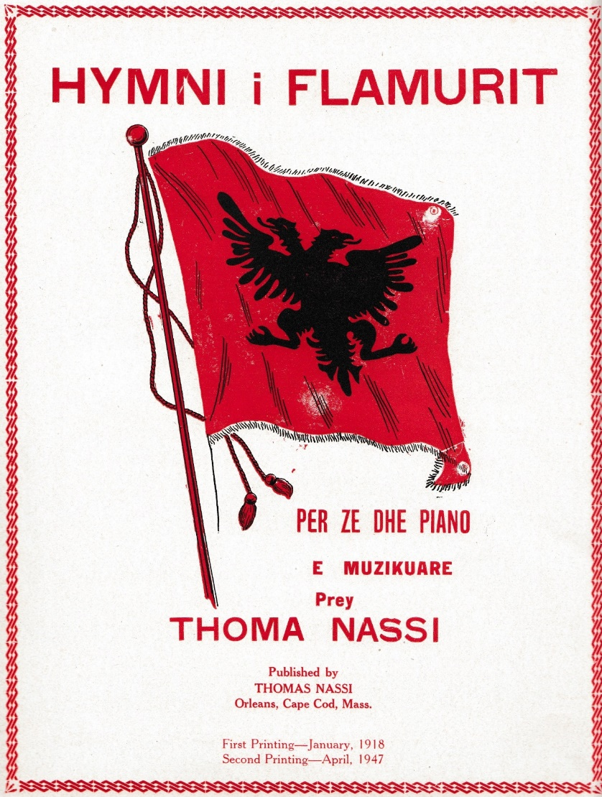
KKK—Hymni i Flamurit/Flag Anthem;
Shembulli/Example 27a
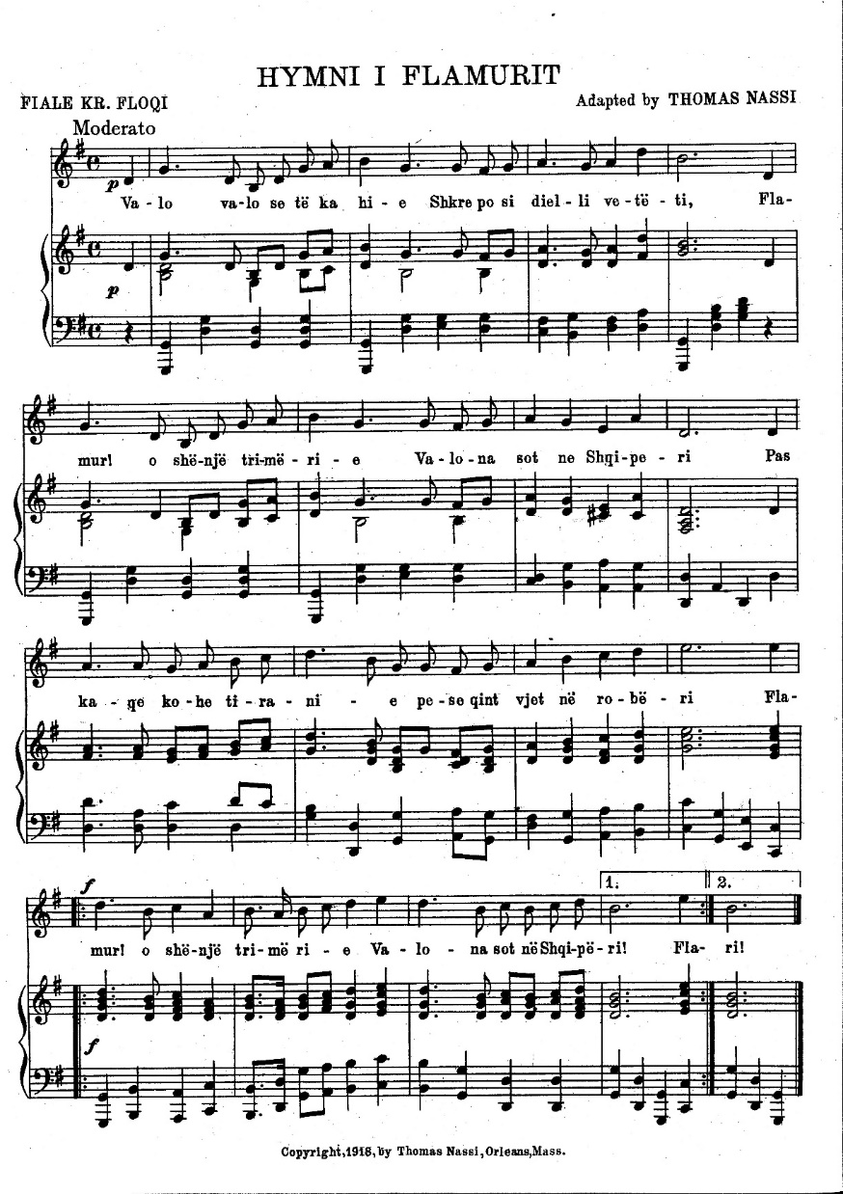
KKK—Hymni i Flamurit/Flag Anthem;
Shembulli/Example 27b

See more on The Saze Instrumental Ensembles of South East Albania.
Nikolaos Lavdas (1879–1940) is known to be the founder and director of the ‘Athenian Mandolinata’. While still a student at the Athens Conservatoire, Lavdas started working towards the formation of a mandolin ensemble and by 1901 the Mandolinata had its own conservatory, teaching various instruments (mandolin, guitar, violin, cello and flute), vocal music and music theory.
sokak is Turkish for cobbled streets.
‘Serenade’, in The New Grove Dictionary of Music and Musicians, p. 160.
Light style song (music) is often grouped with the easy listening genre.
There were several villages around Korçë, such as Dardha, Drenova, Boboshtica, Voskopoja, Vithkuq and others, which led the same social life as Korçë, even with a certain advantage, thanks to their healthy climate and the country people’s love of music.
Loni Logori (1871–1937), one of the pioneers of the light entertainment KKK (Korçare Distinctive Song). The refrain of his ‘One Time I passed by Drenova’ (Një dit’ shkova nga Drenova), KKK–Example 3, was borrowed from the French song of the 1930s, ‘La Petite Tonkinoise’. What really makes this song work is the beat which alternates between the ‘traditional’ 7/8 aksak metre in the strophe and the Western alla breve in the refrain. As far as the text is concerned, it was adapted to everyday life in Korçë and its surroundings.
Spiridon Ilo is, most likely, the first editor to record Albanian music, i.e. folk songs and dances from south-east Albania, Toskëria, accompanied by a folk instrumental group. In 1923, he issued 16 LP recordings, in which he, himself, along with the Arbëresh tenor, Giuseppe Mauro, sang several light Këngë Karakteristike Korçare (Korçare distinctive songs), of a patriotic and entertaining character. These recordings, all of which I possess, are a rare document of the rural folk music of Toskëria and KKK (Korçare Distinctive Songs) of that period. As far as the KKK are concerned, their foreign origin can clearly be seen, as can the way in which the adaptation was made.
Metropolitan church.
The term çeta (çetë) for a guerrilla unit has no political implication in Albania (according to Albania, Geographical Handbook Series, op. cit., p. 232).
Thoma Avrami (1869–1943), the editor of the fortnightly ‘Albanian Renaissance’ (1903) and a teacher of Albanian and French; his motto was ‘Albania to the Albanians’.
Mihal Grameno (1871–1931), one of the post-1905 leaders of the Albanian revolution, an able propagandist of the guerrilla warforce (çetë), editor, writer and composer.
Thanas Floqi (1884–1945) from Korçë, worked as a journalist on Kombi (The Nation), in Boston. Returning to Albania in 1908, he engaged in intensively patriotic activity in Vlorë, Korçë, Cakran and Shkodër, finally settling in Elbasan where he organised the Theatrical Society of Elbasan.
Spiridon Ilo (1876–1950), a poet, composer, singer, graphic-painter and, above all, a patriotic activist.
Hilë Mosi (1885–1933), from Shkodër, is remembered, apart from his patriotic activity, for his poems and translations which became the main source of the poetry used for the songs and romances.
Poradeci writes: ‘Mihal Grameno [1871–1931], the immortal insurgent, who left as a legacy to his compatriots a warm piece from his heart, the national song Për mëmëdhenë (For the Motherland)’. Frida Idrizi, ‘The National Anthem United around the Flag and its origins’, in Lasgush Poradeci, op. cit., p. 363.
There were several villages around Korçë which were quite well-developed, economically and culturally, thanks to the contribution of Albanian emigrants in the USA, and elsewhere.
Very Reverend Arthur E. Liolin, Mesha Shqip, Choral Masterpieces by the Albanian Orthodox Cathedral Choir of Boston, Library of Congress, Catalogue Card Number: 77-750676.
‘Speech given by Thomas Nassi in 1960 to an Albanian-American Student Organization at Harvard University’, Cambridge, Massachusetts.
One or two articles were published such as Endri Keko’s ‘The Creation of the Patriotic Song, Vlora–Vlora’ (Drita newspaper, 31st October 1982), but those were written more out of personal considerations than for the purposes of musical analysis.
A factor which might have affected Nassi’s reputation was his initial support of Zogu, as Prime Minister. Nassi composed an anthem for Zogu with lyrics by Kristo Floqi. The latter was also excluded from the literary list in the post-war periods, although he dominated Albanian drama in the early 20th century.
Letter sent to me by Nassis’s daughter, Carmen Bartlett, on 9th June 1998.
This very moment had a great impact in the struggle of Albanians for safeguarding their territories at a time when its borders and future were discussed in the Paris Peace Conference. The Vlora War was seen as a turning point in the establishment of Albanian independence.
Nassi’s slight hesitation (during the speech) about the poet’s name was right; instead of mentioning Ali Asllani, the real author of the poem, he mentions Bajram Curri, who was an eminent figure of the Albanian resistance, but not a poet.
See KKK–Example 21.
‘Koha’ newspaper, Korçë, 11th September 1920.
The official date of the foundation of the Fine Arts Society (Shoqëria e Arteve të Bukura) is generally known as the 10th of December, 1920.
Fan Noli is well known for founding the Albanian Orthodox Church in Boston, USA in 1908. He is also recognised for his arrangements and translations into Albanian, mostly based upon hymns drawn from both the Byzantine and Slavonic choral traditions. When Noli adapted his translations and set them to music, his approach owed something to more than just his love of Russian music; his Russian-inspired Albanian musical liturgy was conceived within the specific socio-historical context of early 20th century America. He understood that America offered him the freedom to draw upon several resources. His approach was also well suited to the program of Albanian national awakening, the separation of the Albanian Church from the Greek Patriarchate and the introduction of the Albanian language into its liturgy. Noli had a very broad understanding of pastoral life, just as he did in other aspects of his life’s work, and I believe it was a spiritual guidance on his part.
Returning to his adopted home, Nassi brought his rich musical experience to Cape Cod in 1928. Over the next 20 years, the Nassis and their three children built an instrumental music program in schools from Harwich to Province-town and inspired a new love for music in a grateful Cape community. From the Nassi’s three children, Albert, Madeline and Carmen, the first one, Albert, a talented violinist and Air Force pilot, was among the first killed on D-Day in 1944.
According to Lasgush Poradeci, the well-known Albanian poet, the first gathering of the choir, consisting of Albanian emigrants, was held under Kiriak, in 1907. ‘Professor Kiriak was an important figure in Romanian artistic life and, from the outset, he included not only Romanian songs, but also a march, called Come Today Albanians with lyrics written by Asdren. The choir was set up with a high national mission, to perform songs of its native land, to beautify the religious service in the Albanian church of Bucharest. Among national foundations there also is the church of the Albanian Orthodox community’; Frida Idrizi, Lasgush Poradeci, op. cit., p. 365.
The members of the choir asked Asdren, a great patriot and the soul of the Albanian Society in Bucharest, to write an Albanian anthem. ‘The veteran Asdren did not say a word because such was his modest nature, but in the second or the third meeting, he appeared with the anthem in his hands, written in Albanian, under the title ‘United around the Flag’. A member of the choir seized it from his hands and with Professor Jonescu playing on the organ, they sang altogether.…Thus the anthem became the National Anthem of the Colony of Bucharest and the choristers made a habit of singing the anthem before and after the choir’s rehearsals’ (Frida Idrizi: Lasgush Poradeci, The literary works … ibid). Korça was chosen as the town where the anthem was to be introduced. Most of the members of the Albanian Colony in Bucharest were from Korça. In 1908, the rebel poet, Hilë Mosi who used to write nationalistic verses, came to Bucharest and was closely associated with Asdren. Hilë Mosi and Tashko Ilo (the latter was the member of the above mentioned choir) arrived in Korça in 1908 with the anthem, trying to find opportunities to distribute it first in Korça and then around the whole of Albania. It was not an easy task to make the anthem known under the conditions of Turkish suzerainty, but Hilë Mosi was the right person to be chosen for this objective. Although the anthem, brought to Albania in 1909, was not composed with the aim of making a national symbol (only as a hymn for a society), it so happened that when the need for a national anthem arose, it spread through Albania with an extraordinary rapidity. The Korça Choir sang the anthem on the proclamation of the independence of Albania, in November 1912. The music of the anthem was written by the prominent Romanian composer, Ciprian Porumbescu. In fact, the music was not intended as an anthem but simply as a hymn tune, probably for the king of Romania. This tune is still sung and broadcast today in Romania but not, of course, to the same words as in the Albanian anthem. This did not disturb the official authorities, so the music of the anthem was not changed. Certainly, there were many efforts by Albanians to write music for the National anthem but the present tune is still unaffected.
CD―Albanian Music Classics (Klasikë Muzikorë Shqiptarë): Gjoka/ Nassi/ Noli/ Shehu; world premiere recordings, Kailas Records, San Petersburg, kls 037, 2005, Dolina Bartanga; see more about Thoma Nassi’s Instrumental Pieces in Notation, Examples 36–39.
Nassi’s set of compositions analysed in this study were sent to me by the Very Rev. Arthur E. Liolin, Chancellor of the Albanian Orthodox Archdiocese in America, for which I should like to extend my gratitude.
Apart from these early compositions, Nassi is said to be the author of two rhapsodies, a mass, two operettas and several marches. So far, I have not been able to see these scores, which belong to the period after 1926, when he finally migrated to America.
The manuscripts were examined by myself at Janko Pali’s home in Qeparo, near Himara, in 1982.
‘Neço Muko has been in Paris to make recordings of Albanian modern and folk songs, at his own expense. Despite difficulties he has succeeded in recording 22 songs with his own words’; Demokratia, 14th September 1929, p. 2.
Anon., Demokratia, 16th December 1934, p. 2.
The poet Lefter Çipa was born in Piluri, Himarë in 1942.
Aleksander Çipa (Lefter Çipa’s son), personal communication, May 2010.
Mikaela Minga, Këngë Korçare: Song Making and Musical Culture in the City of Korçë during the Twentieth Century, MS, Università degli studi di Milano, Dottorato in Storia e Critica dei Beni Artistici e Ambientali XXV Ciclo, 2011–2012, pp. 135–138. Permission was granted by the author to quote the passages from her book.
Pandi Bello, Tefta Tashko Koço, miti i sopranos, Flesh, Tiranë, 2012, pp. 88–91. Permission was granted by the author to quote the passages from his book.

